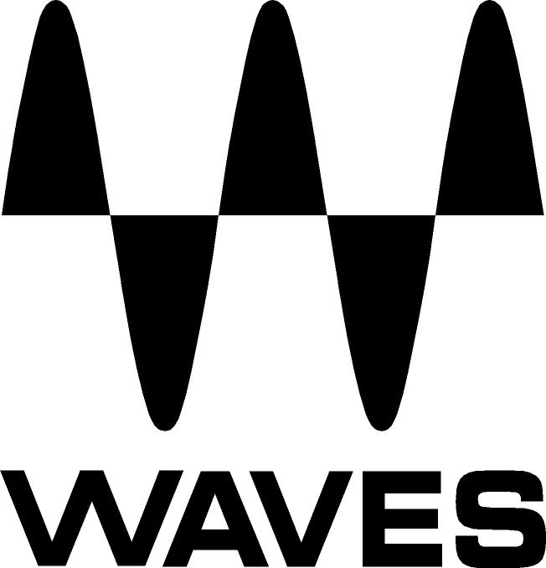
PRESS RELEASE
Contact: Clyne Media, Inc.
Tel: (615) 662-1616
Fax: (615) 662-1636

FOR IMMEDIATE RELEASE

Waves Audio Introduces the Waves SoundGrid® Proton Server

147th AES Convention, New York, NY, October 16, 2019 — Waves Audio (booth 640), the world’s leading developer of professional audio signal processing technologies and leading maker of audio plugins for mixing, music production, mastering, sound design, broadcast, post-production and live sound, introduces the SoundGrid® Proton Server, the latest in Waves’ series of SoundGrid servers that enable audio engineers to mix plugin-rich sessions in ultra-low latency.

Designed for 16-channel setups that aspire to deliver superior sound quality, the SoundGrid Proton Server is Waves’ most affordable SoundGrid server yet.

This small but mighty unit is compatible with the Waves eMotion LV1 16-stereo-channel live mixer and is ideal for adding processing power to any live environment – whether in a fixed setup or on the road.

With an Intel® Celeron® processor and 4 GB of RAM dedicated to plugin processing, you can use the eMotion LV1 16-channel mixer with eMo plugins (F2, Q4, D5) on all channels – at just 50% capacity, and at an ultra-low latency of 0.8 ms at 48 kHz. Combine the Proton server with Axis Proton and the eMotion LV1 16-stereo-channel mixer to build an eMotion LV1 Proton system – the ultimate compact live mixing system for a 16-stereo-channel setup. The half-rack 1U slick aluminum casing fits perfectly in a 1U rack shelf when paired with Waves’ Axis Proton Waves-optimized computer.

SoundGrid Proton features:
- Affordable price and exceptional performance for small venues
- Ultra-low latency: as low as 0.8 milliseconds at 48 kHz
- Use with any SoundGrid audio interface for plugin processing during recording or live mixing
- Durable aluminum casing (half rack 1U)
- CPU: Intel® Celeron®
- RAM 4 GB
- Power: DC12V 3A
- 6-month warranty
- 1x 1GbE Ethernet ports
- 1x HDMI port
- 3x USB ports

To learn more, visit https://www.waves.com/hardware/soundgrid-proton.
…ends 277 words

Photo file: ProtonServer.JPG
Photo caption: Waves SoundGrid® Proton Server

About Waves Audio Ltd.:
Waves is the world’s leading developer of audio DSP solutions for the professional, broadcast, and consumer electronics audio markets. Since its start in the early '90s with the introduction of the Q10 equalizer plugin, Waves has gone on to develop a comprehensive line of over 150 audio plugins, including industry standards like the L1 and L2 Ultramaximizers, popular vintage console models, and innovative mixing tools like Vocal Rider and the Artist Signature Series. For its accomplishments, Waves received a Technical GRAMMY® Award in 2011, and the Q10 was selected as an inductee into the TECnology Hall of Fame. In 2016, Waves released the eMotion LV1 mixer, a revolutionary live digital mixing console that provides real-time audio mixing for front-of-house, monitor, studio and broadcast engineers. Waves technologies are now used to improve sound quality in virtually every sector of the audio market, from recording, mixing, mastering and post-production to broadcast, live sound, and consumer electronics. Waves has over 25 years of expertise in the development of psychoacoustic signal processing algorithms that leverage knowledge of human auditory perception to radically improve perceived sound quality. Waves’ award-winning processors are utilized to improve sound quality in the creation of hit records, major motion pictures, and top-selling video games worldwide. Waves offers computer software and hardware-plus-software solutions for the professional and broadcast markets. The company’s WavesLive division is a market leader in all live sound sectors, spearheading the development of solutions for all live platforms. Under its Maxx brand, Waves offers semiconductor and licensable algorithms for consumer electronics applications. Waves technologies dramatically enhance audio performance and are used by industry leaders such as Dell, Google, Fitbit, Acer, Asus, Hisense and more.

North America Offices:
Waves, Inc., 2800 Merchants Drive, Knoxville, TN 37912;
Tel: 865-909-9200, Fax: 865-909-9245, Email: info@waves.com,
Web: http://www.waves.com

Corporate Headquarters Israel:
Waves Ltd., Azrieli Center, The Triangle Tower, 32nd Floor, Tel Aviv 67023, Israel;
Tel: 972-3-608-4000, Fax: 972-3-608-4056, Email: info@waves.com,
Web: http://www.waves.com

Waves Public Relations:
Clyne Media, Inc., 169-B Belle Forest Circle, Nashville, TN 37221;
Tel: 615-662-1616, Fax: 615-662-1636, Email: robert@clynemedia.com,
Web: http://www.clynemedia.com

Waves Audio is exhibiting at booth 640 at the 147th AES Convention in New York.

