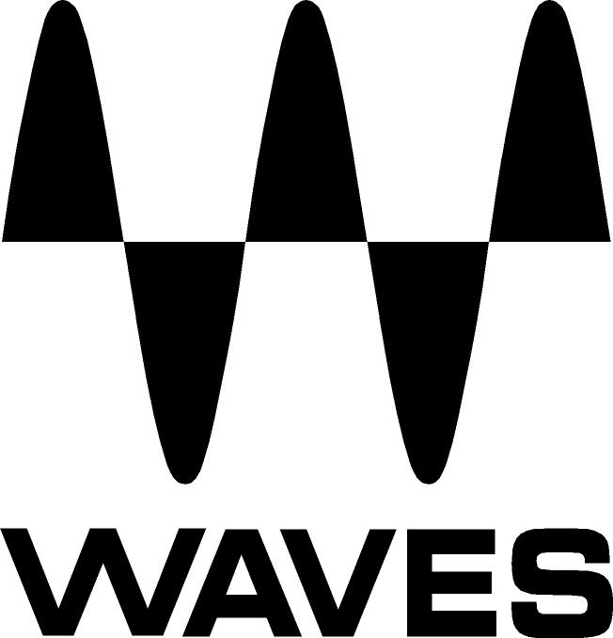
PRESS RELEASE
Contact: Clyne Media, Inc.
Tel: (615) 662-1616
Fax: (615) 662-1636

FOR IMMEDIATE RELEASE

Waves Introduces the eMotion LV1 Proton 16-Channel Live Mixing System: A Game-Changer in Sound Quality and Affordability

147th AES Convention, New York, NY, October 16, 2019 — Waves Audio (booth 640), the world’s leading developer of professional audio signal processing technologies and leading maker of audio plugins for mixing, music production, mastering, sound design, broadcast, post-production and live sound, introduces the eMotion LV1 Proton 16-Channel Live Mixing System. This is Waves’ most affordable complete live mixing system, ideal for 16-channel live setups that aspire to deliver pristine world-class sound quality.

With the eMotion LV1 Proton 16-Channel Live Mixing System, it is now the time to completely change the way you think about your live mixing system. Never before has such a system been offered for an unprecedented cost of under $5K.

Forget about heavy, cumbersome mixing boards. You can now switch to a lightweight digital system, with everything you need to deliver captivating live sound experiences at a cost-effective price, easy portability and a small footprint. Best of all: the eMotion LV1 Proton system gives you access to the world’s largest selection of audio plugins, which you can run directly inside your eMotion LV1 mixer, all for under $5000.

This complete system includes the eMotion LV1 16-channel live software mixer, a SoundStudio STG-1608 SoundGrid®-compatible stagebox, a SoundGrid Proton server, the Axis Proton Waves-optimized computer, a 24-inch Dell touchscreen, a 1U rack shelf, an 8-port network switch and network cables, plus three plugins specifically designed and optimized for live sound: eMo F2 Filter, eMo D5 Dynamics and eMo Q4 Equalizer.

The touch-optimized eMotion LV1 software mixer features 16 mono/stereo channels, each with a plugin rack that can host up to eight SoundGrid-compatible plugins for real-time processing. The included SoundStudio STG-1608 is a sturdy SoundGrid stage box, featuring 16 mic/line inputs with high-end preamps that can be controlled directly from the LV1 mixer.

All audio coming from the stage and through the plugins is processed on the included super-compact SoundGrid Proton server. Send processed audio out to the PA system and back to the stage via eight line outputs at lightning speed: Only 0.8 ms at 48 kHz.

For rock-solid stability, the Axis Proton computer is optimized to handle eMotion LV1’s processing power and perform reliably in the most challenging environments. It features an Intel Celeron processor, 4 GB of DDR4 RAM, one HDMI port, one display port, three USB ports, and a rugged 1U half-rack chassis.

Complete with a 24-inch Dell touchscreen, an eight-port SoundGrid switch, CAT6 Ethernet cables, and a 1U rack shelf, this combo gives you everything you need to run 16-channel live shows with big, pristine, studio-grade sound at an affordable price.

LV1 Proton features:
- Everything you need to set up a SoundGrid-powered live show
- Complete cost-effective mixing solution
- eMotion LV1 16-channel (mono/stereo) mixer with Waves eMo plugins
- SoundStudio STG-1608 stagebox (16-in/8-out)
- SoundGrid Proton Server
- Axis Proton Waves-optimized computer
- 1U Rack Shelf
- 24-inch Dell touchscreen
- Eight-port network switch and CAT6 Ethernet cables
- Includes MyMon – a mobile app for stage monitoring control

To learn more, visit https://www.waves.com/hardware/emotion-lv1-proton-16-ch-live-mixing-system.

…ends 481 words

Photo file: LV1_16CH_Proton.JPG
Photo caption: Waves eMotion LV1 Proton 16-Channel Live Mixing System

About Waves Audio Ltd.:
Waves is the world’s leading developer of audio DSP solutions for the professional, broadcast, and consumer electronics audio markets. Since its start in the early '90s with the introduction of the Q10 equalizer plugin, Waves has gone on to develop a comprehensive line of over 150 audio plugins, including industry standards like the L1 and L2 Ultramaximizers, popular vintage console models, and innovative mixing tools like Vocal Rider and the Artist Signature Series. For its accomplishments, Waves received a Technical GRAMMY® Award in 2011, and the Q10 was selected as an inductee into the TECnology Hall of Fame. In 2016, Waves released the eMotion LV1 mixer, a revolutionary live digital mixing console that provides real-time audio mixing for front-of-house, monitor, studio and broadcast engineers. Waves technologies are now used to improve sound quality in virtually every sector of the audio market, from recording, mixing, mastering and post-production to broadcast, live sound, and consumer electronics. Waves has over 25 years of expertise in the development of psychoacoustic signal processing algorithms that leverage knowledge of human auditory perception to radically improve perceived sound quality. Waves’ award-winning processors are utilized to improve sound quality in the creation of hit records, major motion pictures, and top-selling video games worldwide. Waves offers computer software and hardware-plus-software solutions for the professional and broadcast markets. The company’s WavesLive division is a market leader in all live sound sectors, spearheading the development of solutions for all live platforms. Under its Maxx brand, Waves offers semiconductor and licensable algorithms for consumer electronics applications. Waves technologies dramatically enhance audio performance and are used by industry leaders such as Dell, Google, Fitbit, Acer, Asus, Hisense and more.

North America Offices:
Waves, Inc., 2800 Merchants Drive, Knoxville, TN 37912;
Tel: 865-909-9200, Fax: 865-909-9245, Email: info@waves.com,
Web: http://www.waves.com

Corporate Headquarters Israel:
Waves Ltd., Azrieli Center, The Triangle Tower, 32nd Floor, Tel Aviv 67023, Israel;
Tel: 972-3-608-4000, Fax: 972-3-608-4056, Email: info@waves.com,
Web: http://www.waves.com

Waves Public Relations:
Clyne Media, Inc., 169-B Belle Forest Circle, Nashville, TN 37221;
Tel: 615-662-1616, Fax: 615-662-1636, Email: robert@clynemedia.com,
Web: http://www.clynemedia.com

Waves Audio is exhibiting at booth 640 at the 147th AES Convention in New York.

