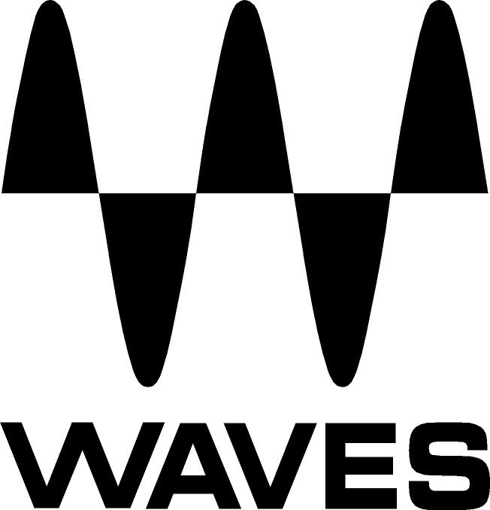
PRESS RELEASE
Contact: Clyne Media, Inc.
Tel: (615) 662-1616
Fax: (615) 662-1636

FOR IMMEDIATE RELEASE

Waves Audio Introduces the SoundGrid Axis Proton, a Custom-Designed Computer, Optimized to Run Waves Audio Applications

147th AES Convention, New York, NY, October 16, 2019 — Waves Audio (booth 640), the world’s leading developer of professional audio signal processing technologies and leading maker of audio plugins for mixing, music production, mastering, sound design, broadcast, post-production and live sound, introduces SoundGrid Axis Proton, a custom-designed computer, optimized through a meticulous selection of components to run Waves audio applications such as the 16-channel eMotion LV1 live mixer and Waves SuperRack live plugin rack, a cutting-edge plugin rack that lets users run up to 128 audio channels through multiple instances of Waves plugins with near-zero latency and offers endless customization options.

With its Waves SoundGrid connectivity, Axis Proton integrates seamlessly with SoundGrid I/Os and servers, acting as the “brain” of a SoundGrid system. Designed to perform with maximum stability, Axis Proton is optimized for use in live setups of up to 16 stereo channels.

Also available from Waves is a half-rack 1U slick aluminum casing that fits perfectly in a 1U rack shelf when paired with the Proton Server. Combine these two devices with the eMotion LV1 live 16-channel mixer, and you have the ultimate compact live mixing system for a 16-channel live sound setup.

Axis Proton features:
- Computer optimized to run Waves software applications
- Intel® Celeron® CPU
- 4GB RAM
- 128GB SSD Storage
- 2 x 1GbE Ethernet Ports
- 1 x HDMI Port
- 1 x DisplayPort
- 3 x USB Ports
- Durable aluminum casing (1U half-rack)

To learn more, visit https://www.waves.com/hardware/axis-proton.
…ends 230 words

Photo file: AxisProton.JPG
Photo caption: Waves SoundGrid Axis Proton

About Waves Audio Ltd.:
Waves is the world’s leading developer of audio DSP solutions for the professional, broadcast, and consumer electronics audio markets. Since its start in the early '90s with the introduction of the Q10 equalizer plugin, Waves has gone on to develop a comprehensive line of over 150 audio plugins, including industry standards like the L1 and L2 Ultramaximizers, popular vintage console models, and innovative mixing tools like Vocal Rider and the Artist Signature Series. For its accomplishments, Waves received a Technical GRAMMY® Award in 2011, and the Q10 was selected as an inductee into the TECnology Hall of Fame. In 2016, Waves released the eMotion LV1 mixer, a revolutionary live digital mixing console that provides real-time audio mixing for front-of-house, monitor, studio and broadcast engineers. Waves technologies are now used to improve sound quality in virtually every sector of the audio market, from recording, mixing, mastering and post-production to broadcast, live sound, and consumer electronics. Waves has over 25 years of expertise in the development of psychoacoustic signal processing algorithms that leverage knowledge of human auditory perception to radically improve perceived sound quality. Waves’ award-winning processors are utilized to improve sound quality in the creation of hit records, major motion pictures, and top-selling video games worldwide. Waves offers computer software and hardware-plus-software solutions for the professional and broadcast markets. The company’s WavesLive division is a market leader in all live sound sectors, spearheading the development of solutions for all live platforms. Under its Maxx brand, Waves offers semiconductor and licensable algorithms for consumer electronics applications. Waves technologies dramatically enhance audio performance and are used by industry leaders such as Dell, Google, Fitbit, Acer, Asus, Hisense and more.

North America Offices:
Waves, Inc., 2800 Merchants Drive, Knoxville, TN 37912;
Tel: 865-909-9200, Fax: 865-909-9245, Email: info@waves.com,
Web: http://www.waves.com

Corporate Headquarters Israel:
Waves Ltd., Azrieli Center, The Triangle Tower, 32nd Floor, Tel Aviv 67023, Israel;
Tel: 972-3-608-4000, Fax: 972-3-608-4056, Email: info@waves.com,
Web: http://www.waves.com

Waves Public Relations:
Clyne Media, Inc., 169-B Belle Forest Circle, Nashville, TN 37221;
Tel: 615-662-1616, Fax: 615-662-1636, Email: robert@clynemedia.com,
Web: http://www.clynemedia.com

Waves Audio is exhibiting at booth 640 at the 147th AES Convention in New York.

