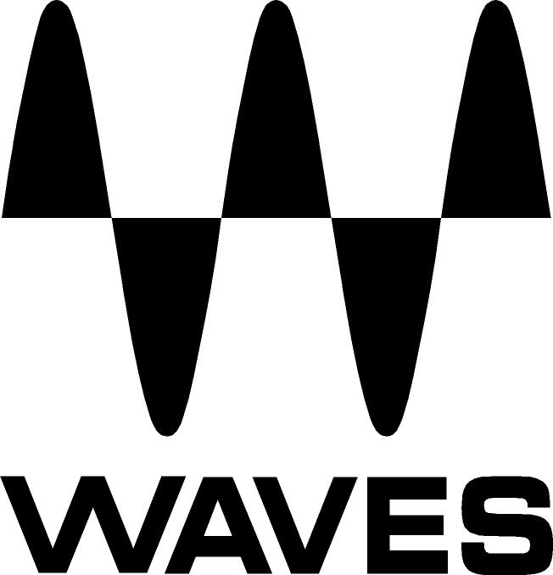

PRESS RELEASE
Contact: Clyne Media, Inc.
Tel: (615) 662-1616
Fax: (615) 662-1636

FOR IMMEDIATE RELEASE

Waves Audio Offers Waves Torque Drum Tone Shifter

AES Convention, New York, NY, October 18, 2017 — Waves Audio (booth 640), a leading provider of digital signal processing solutions and digital music production tools, offers the Waves Torque Drum Tone Shifter plugin.

The key to a great-sounding mix is rooted in the tonal balance of the drums, yet mixers don’t always get tasked with mixing tracks that were perfectly tuned or recorded. Waves Torque can enhance and re-pitch the tone of snares, toms, kicks or an entire kit, all with natural-sounding results that no traditional pitch shifter will allow.

The Waves Torque plugin is a precision drum tone shifter that will help users salvage mistuned drums, pitch them to a specific key and adjust their tone – without retriggering or replacing, without the sonic artifacts introduced by traditional pitch shifters, and without losing body, timbre, resonance or attack. Driven by Waves’ Organic ReSynthesis® technology, Torque detects and analyzes the drums’ formant, amplitude and carrier information, reassembles it, and allows users to manipulate the tonal and pitch characteristics, all while preserving the natural attack, resonance and duration of the original sound.

With intuitive controls and zero latency, Torque is perfect for the studio as well as for live shows, where FOH engineers can now have the luxury of re-pitching problematic drum tone mid-show or even mid-song.

Waves Torque Drum Tone Shifter features:
- Tone shifter for acoustic and electronic drums
- Adjusts drum timbre & pitch without retriggering or replacing
- Accurately shifts by +/- 1200 cents
- Focus section for precision formant/frequency control
- Precision threshold & trim controls
- Zero latency for studio and live mixing
- Driven by Waves’ Organic ReSynthesis technology

For more information, please visit https://www.waves.com/plugins/torque.

Intro video: Duet for Drums and Torque: https://youtu.be/elrE0x-G--E

…ends 274 words

Photo file: Torque_GUI.JPG
Photo caption: User interface for Waves Torque Drum Tone Shifter

About Waves Audio Ltd.:
Waves is the world’s leading developer of audio DSP solutions for the professional, broadcast, and consumer electronics audio markets. Since its start in the early '90s with the introduction of the Q10 equalizer plugin, Waves has gone on to develop a comprehensive line of over 200 audio plugins, including industry standards like the L1 and L2 Ultramaximizers, popular vintage console models, and innovative mixing tools like Vocal Rider and the Artist Signature Series. For its accomplishments, Waves received a Technical GRAMMY® Award in 2011, and the Q10 was selected as an inductee into the TECnology Hall of Fame. In 2016, Waves released the eMotion LV1 mixer, a revolutionary live digital mixing console that provides real-time audio mixing for front-of-house, monitor, studio and broadcast engineers. Waves technologies are now used to improve sound quality in virtually every sector of the audio market, from recording, mixing, mastering and post-production to broadcast, live sound, and consumer electronics. Waves has over 20 years of expertise in the development of psychoacoustic signal processing algorithms that leverage knowledge of human auditory perception to radically improve perceived sound quality. Waves’ award-winning processors are utilized to improve sound quality in the creation of hit records, major motion pictures, and top-selling video games worldwide. Waves offers computer software and hardware-plus-software solutions for the professional and broadcast markets. The company’s WavesLive division is a market leader in all live sound sectors, spearheading the development of solutions for all live platforms. Under its Maxx brand, Waves offers semiconductor and licensable algorithms for consumer electronics applications. Waves technologies dramatically enhance audio performance and are used by industry leaders such as Dell, Google, TCL, Fujitsu, Asus, Hisense and more.

All other product names and trademarks are the property of their respective owners, which are in no way associated or affiliated with Waves.

North America Offices:
Waves, Inc., 2800 Merchants Drive, Knoxville, TN 37912;
Tel: 865-909-9200, Fax: 865-909-9245, Email: info@waves.com,
Web: http://www.waves.com

Corporate Headquarters Israel:
Waves Ltd., Azrieli Center, The Triangle Tower, 32nd Floor, Tel Aviv 67023, Israel;
Tel: 972-3-608-4000, Fax: 972-3-608-4056, Email: info@waves.com,
Web: http://www.waves.com

Waves Public Relations:
Clyne Media, Inc., 169-B Belle Forest Circle, Nashville, TN 37221;
Tel: 615-662-1616, Fax: 615-662-1636, Email: robert@clynemedia.com,
Web: http://www.clynemedia.com

Waves Audio is exhibiting at booth 640 at AES New York 2017.

