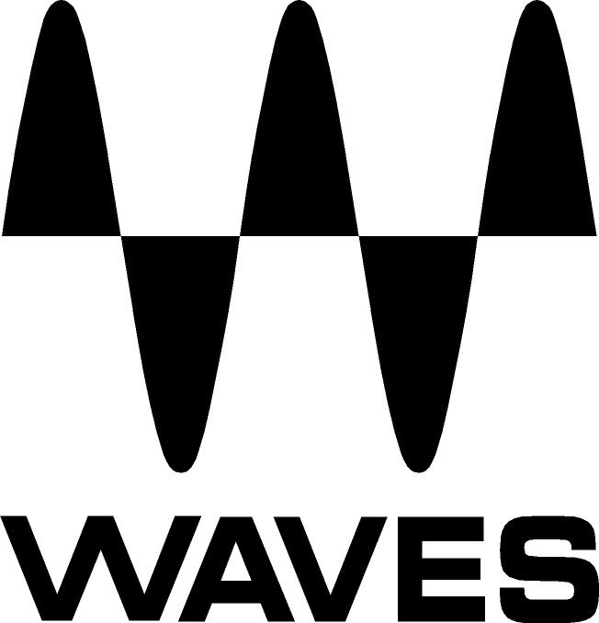

PRESS RELEASE
Contact: Clyne Media, Inc.
Tel: (615) 662-1616
Fax: (615) 662-1636

FOR IMMEDIATE RELEASE

Waves Audio Displays F6 Floating-Band Dynamic EQ

AES Convention, New York, NY, October 18, 2017 — Waves Audio (booth 640), a leading provider of digital signal processing solutions and digital music production tools, is offering the F6 plugin, a surgical dynamic equalizer with six floating, fully-adjustable parametric filter bands, advanced EQ and compression/expansion controls for each band, mid-side processing options and more.

F6 is the ultimate problem-solving EQ that can be used for diverse equalization, compression, expansion and de-essing processes, whether for mixing or mastering, in the studio or live. Each of the six floating bands features advanced EQ and dynamic controls that let users zero in on any problem spot – and treat it only when the problem arises.

Rather than treating a frequency one time and leaving it there for the entire track, F6’s EQ settings are sensitive to the dynamics of a track, so users can select not only by how much, but also precisely when a specific frequency will be boosted or cut, compressed or expanded.

With the F6, users can EQ more precisely, with filters that can be as narrow or as wide as they like, free-floating bands that can overlap, variable EQ shapes, and threshold-sensitive EQ settings. F6 is ideal for isolating specific problems on individual tracks and fixing them transparently only when they pop out. Its advanced mid-side processing capabilities give users even greater ability to carve out EQ space in a busy mix, so more life can be breathed into mixes.

Music is dynamic. The intensity of any piece of music constantly rises and falls. With the F6 dynamic EQ plugin, users finally have the perfect EQ tool to match this dynamic variation.

Waves F6 features:
- Precision EQ triggered by a built-in dynamic processor
- Six floating bands that can be placed anywhere in the spectrum
- Powerful EQ and compression/expansion controls for each band
- Advanced sidechaining, parallel compression and mid-side processing
- High and low pass filters; bell and notch EQ shapes
- Each band features a solo/sidechain monitor
- Touch-compatible
- Zero latency and low CPU consumption
- Equally effective for studio and live mixing

For more information, please visit https://www.waves.com/plugins/f6-floating-band-dynamic-eq.

…ends 337 words

Photo file: F6.JPG
Photo caption: User interface for Waves F6 Floating-Band Dynamic EQ

About Waves Audio Ltd.:
Waves is the world’s leading developer of audio DSP solutions for the professional, broadcast, and consumer electronics audio markets. Since its start in the early '90s with the introduction of the Q10 equalizer plugin, Waves has gone on to develop a comprehensive line of over 200 audio plugins, including industry standards like the L1 and L2 Ultramaximizers, popular vintage console models, and innovative mixing tools like Vocal Rider and the Artist Signature Series. For its accomplishments, Waves received a Technical GRAMMY® Award in 2011, and the Q10 was selected as an inductee into the TECnology Hall of Fame. In 2016, Waves released the eMotion LV1 mixer, a revolutionary live digital mixing console that provides real-time audio mixing for front-of-house, monitor, studio and broadcast engineers. Waves technologies are now used to improve sound quality in virtually every sector of the audio market, from recording, mixing, mastering and post-production to broadcast, live sound, and consumer electronics. Waves has over 20 years of expertise in the development of psychoacoustic signal processing algorithms that leverage knowledge of human auditory perception to radically improve perceived sound quality. Waves’ award-winning processors are utilized to improve sound quality in the creation of hit records, major motion pictures, and top-selling video games worldwide. Waves offers computer software and hardware-plus-software solutions for the professional and broadcast markets. The company’s WavesLive division is a market leader in all live sound sectors, spearheading the development of solutions for all live platforms. Under its Maxx brand, Waves offers semiconductor and licensable algorithms for consumer electronics applications. Waves technologies dramatically enhance audio performance and are used by industry leaders such as Dell, Google, TCL, Fujitsu, Asus, Hisense and more.

All other product names and trademarks are the property of their respective owners, which are in no way associated or affiliated with Waves.

North America Offices:
Waves, Inc., 2800 Merchants Drive, Knoxville, TN 37912;
Tel: 865-909-9200, Fax: 865-909-9245, Email: info@waves.com,
Web: http://www.waves.com

Corporate Headquarters Israel:
Waves Ltd., Azrieli Center, The Triangle Tower, 32nd Floor, Tel Aviv 67023, Israel;
Tel: 972-3-608-4000, Fax: 972-3-608-4056, Email: info@waves.com,
Web: http://www.waves.com

Waves Public Relations:
Clyne Media, Inc., 169-B Belle Forest Circle, Nashville, TN 37221;
Tel: 615-662-1616, Fax: 615-662-1636, Email: robert@clynemedia.com,
Web: http://www.clynemedia.com

Waves Audio is exhibiting at booth 640 at AES New York 2017.

