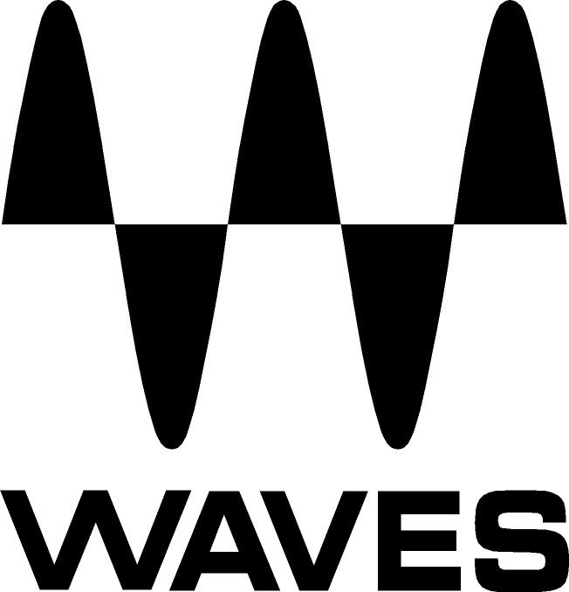

PRESS RELEASE
Contact: Clyne Media, Inc.
Tel: (615) 662-1616
Fax: (615) 662-1636

FOR IMMEDIATE RELEASE

Waves Offers Dugan Automixer + Dugan Speech Plugin Bundle

AES Convention, New York, NY, October 18, 2017 — Waves Audio (booth 640), a leading provider of digital signal processing solutions and digital music production tools, offers its Dugan Automixer + Dugan Speech plugin bundle. With Waves’ Dugan Automixer and Dugan Speech, mixing multiple microphones can be easy; the two plugins allow for auto-mixing several mics in real time (one for the eMotion LV1 mixer, one for other live consoles via MultiRack).

Dugan Speech and Dugan Automixer are the definitive solution for broadcast news panels, radio and TV talk shows, houses of prayer, motion picture dialog recording, discussion panels, and any other situation involving numerous microphones and participants.

In this high-value package, users get the Dugan Speech plugin for integrated use inside the eMotion LV1 mixing console, and the Dugan Automixer plugin for use with other major consoles via the MultiRack plugin host. Developed with pro audio inventor Dan Dugan, both Dugan plugins are powered by his patented voice-activated process.

The Dugan plugins save users the need to manually ride faders while trying to keep up with several people talking. They can auto-mix up to 64 channels simultaneously and make perfectly matched crossfades, without compression or noise gates that would cause unwanted artifacts. They also reduce noise, feedback and comb filtering from neighboring microphones, ensuring consistent overall gain even when numerous speakers are talking simultaneously.

Dugan Speech + Dugan AutoMixer features:
- Official Dugan plugins developed in association with Dan Dugan
- Includes Dugan Speech for the eMotion LV1 console + Dugan Automixer for other mixing consoles (via Waves MultiRack only)
- Auto-mix up to 64 live microphones in real time
- No need to ride faders manually
- Ideal for scenarios involving several participants and microphones
- Automatically reduces noise and feedback
- Ensures consistent overall gain
- Perfectly matched transparent crossfades

For more information, please visit https://www.waves.com/bundles/dugan-automixer-dugan-speech.

…ends 292 words

Photo file 1: DuganAutomixer.JPG
Photo caption 1: User interface for Waves Dugan Automixer

Photo file 2: DuganSpeech.JPG
Photo caption 2: User interface for Waves Dugan Speech

About Waves Audio Ltd.:
Waves is the world’s leading developer of audio DSP solutions for the professional, broadcast, and consumer electronics audio markets. Since its start in the early '90s with the introduction of the Q10 equalizer plugin, Waves has gone on to develop a comprehensive line of over 200 audio plugins, including industry standards like the L1 and L2 Ultramaximizers, popular vintage console models, and innovative mixing tools like Vocal Rider and the Artist Signature Series. For its accomplishments, Waves received a Technical GRAMMY® Award in 2011, and the Q10 was selected as an inductee into the TECnology Hall of Fame. In 2016, Waves released the eMotion LV1 mixer, a revolutionary live digital mixing console that provides real-time audio mixing for front-of-house, monitor, studio and broadcast engineers. Waves technologies are now used to improve sound quality in virtually every sector of the audio market, from recording, mixing, mastering and post-production to broadcast, live sound, and consumer electronics. Waves has over 20 years of expertise in the development of psychoacoustic signal processing algorithms that leverage knowledge of human auditory perception to radically improve perceived sound quality. Waves’ award-winning processors are utilized to improve sound quality in the creation of hit records, major motion pictures, and top-selling video games worldwide. Waves offers computer software and hardware-plus-software solutions for the professional and broadcast markets. The company’s WavesLive division is a market leader in all live sound sectors, spearheading the development of solutions for all live platforms. Under its Maxx brand, Waves offers semiconductor and licensable algorithms for consumer electronics applications. Waves technologies dramatically enhance audio performance and are used by industry leaders such as Dell, Google, TCL, Fujitsu, Asus, Hisense and more.

All other product names and trademarks are the property of their respective owners, which are in no way associated or affiliated with Waves.

North America Offices:
Waves, Inc., 2800 Merchants Drive, Knoxville, TN 37912;
Tel: 865-909-9200, Fax: 865-909-9245, Email: info@waves.com,
Web: http://www.waves.com

Corporate Headquarters Israel:
Waves Ltd., Azrieli Center, The Triangle Tower, 32nd Floor, Tel Aviv 67023, Israel;
Tel: 972-3-608-4000, Fax: 972-3-608-4056, Email: info@waves.com,
Web: http://www.waves.com

Waves Public Relations:
Clyne Media, Inc., 169-B Belle Forest Circle, Nashville, TN 37221;
Tel: 615-662-1616, Fax: 615-662-1636, Email: robert@clynemedia.com,
Web: http://www.clynemedia.com

Waves Audio is exhibiting at booth 640 at AES New York 2017.

