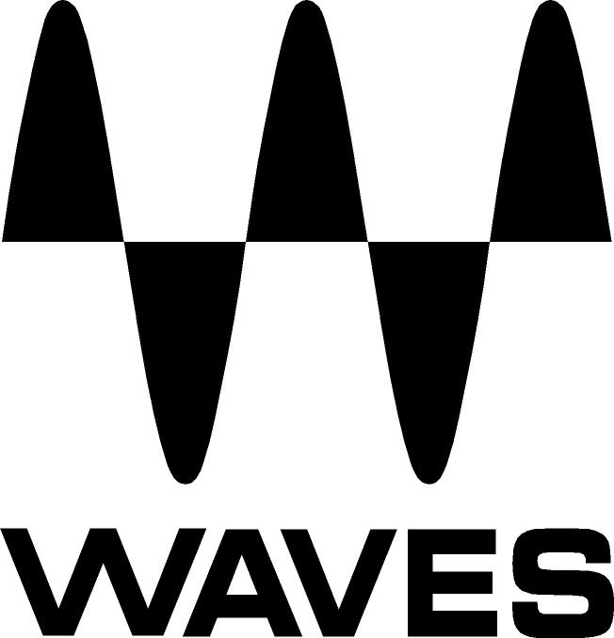

PRESS RELEASE
Contact: Clyne Media, Inc.
Tel: (615) 662-1616
Fax: (615) 662-1636

FOR IMMEDIATE RELEASE

Waves Audio Offers Brauer Motion Plugin

AES Convention, New York, NY, October 18, 2017 — Waves Audio (booth 640), a leading provider of digital signal processing solutions and digital music production tools, is exhibiting its Brauer Motion plugin. This circular stereo auto-panner designed with top mixer Michael Brauer (Coldplay) allows users to create an unprecedented world of movement inside their mixes.

Few people understand how to add emotional movement to a mix in the way that multiple GRAMMY®-winning mix engineer Michael Brauer does. As the man behind the mix on top-selling albums from Coldplay, John Mayer, James Bay, Elle King, Florence & the Machine, My Morning Jacket, Bob Dylan, Hall & Oates, Aretha Franklin and countless others, Brauer has a deep understanding of how you can use movement to energize a mix.

Brauer Motion takes Michael’s mastery of the sound spectrum and lets users control the movement of your sounds unlike anything else in their toolkit. It works especially well on rhythmic tracks such as percussion and acoustic guitar; on swelling pads and organs; or whenever a mixer wants to pull the listener in with subtle or drastic panning movement.

This super-creative plugin comes with four different panning modes to direct the motion of the sound; four different trigger modes for a variety of on/off options; two panners with full control; a dynamics section; pre-delay, motion filter, and precise control over the speed, width and depth; and a master section with gain and wet/dry controls.

Producers, mix engineers and sound designers will all have a blast creating tracks with Brauer Motion. An audio instrument designed to inject excitement and wonder into any mix, the creative limits of this plugin are as far as users can take them.

Brauer Motion includes presets from top mixing engineers including Michael Brauer, Dave Pensado, Tony Maserati, Mark Ralph, Ross Hogarth, Tom Elmhirst and Yoad Nevo.

For more information, please visit https://www.waves.com/plugins/brauer-motion.

…ends 302 words

Photo file: BrauerMotion.JPG
Photo caption: User interface for Waves Brauer Motion

About Waves Audio Ltd.:
Waves is the world’s leading developer of audio DSP solutions for the professional, broadcast, and consumer electronics audio markets. Since its start in the early '90s with the introduction of the Q10 equalizer plugin, Waves has gone on to develop a comprehensive line of over 200 audio plugins, including industry standards like the L1 and L2 Ultramaximizers, popular vintage console models, and innovative mixing tools like Vocal Rider and the Artist Signature Series. For its accomplishments, Waves received a Technical GRAMMY® Award in 2011, and the Q10 was selected as an inductee into the TECnology Hall of Fame. In 2016, Waves released the eMotion LV1 mixer, a revolutionary live digital mixing console that provides real-time audio mixing for front-of-house, monitor, studio and broadcast engineers. Waves technologies are now used to improve sound quality in virtually every sector of the audio market, from recording, mixing, mastering and post-production to broadcast, live sound, and consumer electronics. Waves has over 20 years of expertise in the development of psychoacoustic signal processing algorithms that leverage knowledge of human auditory perception to radically improve perceived sound quality. Waves’ award-winning processors are utilized to improve sound quality in the creation of hit records, major motion pictures, and top-selling video games worldwide. Waves offers computer software and hardware-plus-software solutions for the professional and broadcast markets. The company’s WavesLive division is a market leader in all live sound sectors, spearheading the development of solutions for all live platforms. Under its Maxx brand, Waves offers semiconductor and licensable algorithms for consumer electronics applications. Waves technologies dramatically enhance audio performance and are used by industry leaders such as Dell, Google, TCL, Fujitsu, Asus, Hisense and more.

All other product names and trademarks are the property of their respective owners, which are in no way associated or affiliated with Waves.

North America Offices:
Waves, Inc., 2800 Merchants Drive, Knoxville, TN 37912;
Tel: 865-909-9200, Fax: 865-909-9245, Email: info@waves.com,
Web: http://www.waves.com

Corporate Headquarters Israel:
Waves Ltd., Azrieli Center, The Triangle Tower, 32nd Floor, Tel Aviv 67023, Israel;
Tel: 972-3-608-4000, Fax: 972-3-608-4056, Email: info@waves.com,
Web: http://www.waves.com

Waves Public Relations:
Clyne Media, Inc., 169-B Belle Forest Circle, Nashville, TN 37221;
Tel: 615-662-1616, Fax: 615-662-1636, Email: robert@clynemedia.com,
Web: http://www.clynemedia.com

Waves Audio is exhibiting at booth 640 at AES New York 2017.

