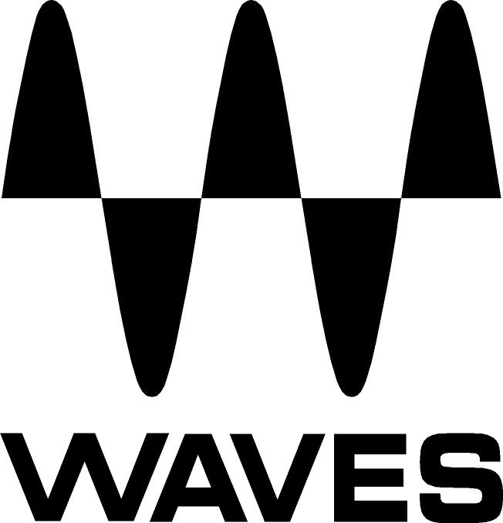

PRESS RELEASE
Contact: Clyne Media, Inc.
Tel: (615) 662-1616
Fax: (615) 662-1636

FOR IMMEDIATE RELEASE

Waves Audio Now Shipping the Waves B360 Ambisonics Encoder, Waves Nx Ambisonics and Waves 360° Ambisonics Tools

AES Convention, New York, NY, October 18, 2017 — Waves Audio (booth 640), a leading provider of digital signal processing solutions and digital music production tools, is now shipping two new tools and a combo for audio engineers mixing 360-degree and VR projects: the Waves B360 Ambisonics Encoder, a new plugin for converting mono, stereo or surround audio into 360-degree Ambisonics B-format; Waves Nx Ambisonics, a new component of the Waves Nx Virtual Mix Room over Headphones plugin, designed for monitoring 360-degree Ambisonics B-format audio on regular stereo headphones; and Waves 360° Ambisonics Tools, a combo of both plugins.

Ambisonics is currently the most popular technique for mixing audio in a full spherical 360-degree sound field. The most common Ambisonics format, used in VR as well as in Google and Facebook 360 videos, is a four-channel format called B-format. Designed to fit intuitively into a traditional mixing workflow, the Waves B360 Ambisonics Encoder allows audio engineers to convert regular mono, stereo or surround mixes into B-format, in order to deliver sound for 360-degree audio/video content.

Waves B360 can be used in two ways: You can place the plugin on each separate mono or stereo channel for precise positioning/panning of that channel in your 360-audio mix; or you can first complete your mix in a conventional stereo or surround environment, and then place B360 on the entire finished mix, simply as an Ambisonics B-format convertor. In either case, B360 lets you control the mix’s width, elevation, and rotation, as well as position the different elements in your mix inside the three-dimensional sound field.

With an intuitive GUI and streamlined controls for panning width, elevation and rotation, Waves B360 is designed to make your 360-audio workflow faster, easier and more user-friendly than ever.

B360 features:
- The industry-standard way to deliver audio for VR and 360-degree videos
- Convert mono, stereo & surround into 1st-order Ambisonics B-format
- Precisely position elements in your 360-degree audio mix
- Intuitive interface; fits into your traditional mixing workflow
- Width, rotation and elevation controls
- AmbiX-compatible
- Includes AmbiX-to-FuMa and FuMa-to-AmbiX utility convertors

To monitor your 360-degree B-format mixes in a convenient, accessible way, Waves now offers Nx Ambisonics, a new component of the popular Waves Nx Virtual Mix Room over Headphones, a plugin that recreates the three-dimensional acoustics of a professional mix room inside any set of stereo headphones.

By binauralizing the audio for headphones, Nx Ambisonics lets mixing engineers listen to their B-format mixes even when they don’t have access to an elaborate multi-directional speaker array. Nx Ambisonics also delivers pristine sound quality that mixing engineers can trust, without the distortion or artifacts often introduced by binauralization tools.

For improved accuracy, Nx Ambisonics offers full personalization to your individual head measurements, as well as a visual spatial meter representing the audio frequency content in every direction of the three-dimensional sound field. For enhanced 3D realism that embraces the VR experience, Nx Ambisonics also offers an integrated high-quality, high-speed head tracking solution, using the compact Nx Head Tracker Bluetooth device or your computer’s camera.

Waves is also offering a combo: Waves 360° Ambisonics Tools, which includes the B360 Ambisonics Encoder, the Nx Virtual Mix Room (with the Nx Ambisonics component) and the Nx Head Tracker.

Waves B360 Ambisonics Encoder, Waves Nx Ambisonics and the Waves 360° Ambisonics Tools combo are now available.

For more information, please visit:

Waves B360 Ambisonics Encoder
Waves 360° Ambisonics Tools
Waves Nx Virtual Mix Room over Headphones

Video:
- Start Mixing in Ambisonics 360° Format: https://youtu.be/mcUwiYwgBHw
- How to Mix audio for 360° videos and VR with Waves B360 and Nx: https://youtu.be/pE_4YtbAEDA
…ends 583 words

Photo file: B360_AmbisonicsTools.JPG
Photo caption: Waves 360° Ambisonics Tools

About Waves Audio Ltd.:
Waves is the world’s leading developer of audio DSP solutions for the professional, broadcast, and consumer electronics audio markets. Since its start in the early '90s with the introduction of the Q10 equalizer plugin, Waves has gone on to develop a comprehensive line of over 200 audio plugins, including industry standards like the L1 and L2 Ultramaximizers, popular vintage console models, and innovative mixing tools like Vocal Rider and the Artist Signature Series. For its accomplishments, Waves received a Technical GRAMMY® Award in 2011, and the Q10 was selected as an inductee into the TECnology Hall of Fame. In 2016, Waves released the eMotion LV1 mixer, a revolutionary live digital mixing console that provides real-time audio mixing for front-of-house, monitor, studio and broadcast engineers. Waves technologies are now used to improve sound quality in virtually every sector of the audio market, from recording, mixing, mastering and post-production to broadcast, live sound, and consumer electronics. Waves has over 20 years of expertise in the development of psychoacoustic signal processing algorithms that leverage knowledge of human auditory perception to radically improve perceived sound quality. Waves’ award-winning processors are utilized to improve sound quality in the creation of hit records, major motion pictures, and top-selling video games worldwide. Waves offers computer software and hardware-plus-software solutions for the professional and broadcast markets. The company’s WavesLive division is a market leader in all live sound sectors, spearheading the development of solutions for all live platforms. Under its Maxx brand, Waves offers semiconductor and licensable algorithms for consumer electronics applications. Waves technologies dramatically enhance audio performance and are used by industry leaders such as Dell, Google, TCL, Fujitsu, Asus, Hisense and more.

All other product names and trademarks are the property of their respective owners, which are in no way associated or affiliated with Waves.

North America Offices:
Waves, Inc., 2800 Merchants Drive, Knoxville, TN 37912;
Tel: 865-909-9200, Fax: 865-909-9245, Email: info@waves.com,
Web: http://www.waves.com

Corporate Headquarters Israel:
Waves Ltd., Azrieli Center, The Triangle Tower, 32nd Floor, Tel Aviv 67023, Israel;
Tel: 972-3-608-4000, Fax: 972-3-608-4056, Email: info@waves.com,
Web: http://www.waves.com

Waves Public Relations:
Clyne Media, Inc., 169-B Belle Forest Circle, Nashville, TN 37221;
Tel: 615-662-1616, Fax: 615-662-1636, Email: robert@clynemedia.com,
Web: http://www.clynemedia.com

Waves Audio is exhibiting at booth 640 at AES New York 2017.

