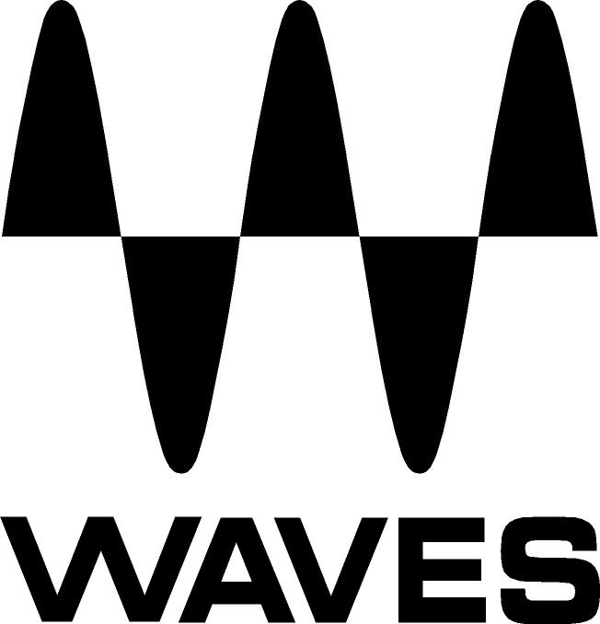

PRESS RELEASE
Contact: Clyne Media, Inc.
Tel: (615) 662-1616
Fax: (615) 662-1636

FOR IMMEDIATE RELEASE

In Honor of Its 25th Anniversary, Waves Is Now Shipping Revamped and Reskinned Versions of Three of Its Classic Plugins: the Q10, AudioTrack and the L1

AES Convention, New York, NY, October 18, 2017 — In honor of its 25th Anniversary, Waves Audio (booth 640), a leading provider of digital signal processing solutions and digital music production tools, is now shipping revamped and reskinned versions of three of its classic plugins: the Q10 Equalizer, the AudioTrack channel strip plugin and the L1 Ultramaximizer level maximizer/peak limiter. These revamped 25th Anniversary editions include new plugin features, as well as a choice between two graphic user interfaces – the classic “Legacy” interface, and the new “Modern” interface created especially for the 25th Anniversary celebrations.

Q10 Equalizer
The first plugin by Waves, the Q10, is a multiband paragraphic EQ with up to 10 bands of precision equalization for mixing and mastering. It is a go-to tool for both surgical repair and gentle coloring. With its ten bands, Q10 offers unparalleled equalization options. Each band offers six different filter types and complete control of gain, frequency and Q. And unlike most multiband equalizers, each Q10 band can use any filter type, so there is immense flexibility when shaping a signal. The Q10 offers extremely large Q values and large boosts and cuts, so you can fix and focus sounds that a conventional EQ could not touch. It is configurable as either two independent mono equalizers or as a precisely ganged stereo equalizer.

New 25th anniversary features include:
- Proportional Q filters: When selected, Q value is proportional to gain adjustment. As a band’s gain increases, Q value increases and the filter narrows.
- Selectable band control: Choose between viewing all parametric band controls in one view or focusing on a selected channel. Both views show the complete graphic display.
- Double Precision control: Lets you choose between 32-bit floating point processing and double-precision 64-bit processing.

AudioTrack
CPU-light with pristine sound quality and serving the needs of a full channel strip within a single interface, Audio Track offers the most efficient way to mix your tracks. It includes three processors – EQ, compression and gating – in one easy-to-use plugin, AudioTrack functions like a mixing console’s channel strip, serving your most essential needs on any audio track. You can open multiple instances, one per channel, and avoid the need to jump back and forth between separate equalizer, gate and compressor plugins.

The four-band paragraphic equalizer provides bell, high-pass, low-pass, and shelving filter options. Its dynamics section includes a fully adjustable compressor/expander and gate. Input and output faders allow for proper gain staging, and dynamics and output meters enable accurate visual feedback.

New 25th anniversary features include:
- Focused EQ band display: Lets you view only the selected band’s parametric controls, to let you quickly understand and control band values
- Separate meters for Comp and Gate gain reduction: For greater clarity and focus
- Double Precision: AudioTrack now executes 32-bit floating-point processing at 64 bits

L1 Ultramaximizer
A must-have plugin for mastering, the L1 is the first software unit to offer a brick wall limiter. With only two major controls, quick and simple to use, the L1 is an advanced-level maximizer, look-ahead peak limiter and high-resolution re-quantizer – a powerful industry-standard all-in-one plugin for mastering and mixing. Renowned for its transparency and punch, the L1 has been the standard tool used on countless hit recordings over the past couple of decades. When you need it loud, but without added coloration, the Waves L1 is your go-to plugin.

New 25th anniversary features include:
- True Peak domain setting: Eliminates inter-sample clipping
- Automatic Release Control: Automatically adjusts release time

To learn more, visit:
- Q10 Equalizer: https://www.waves.com/plugins/q10-equalizer
- L1 Ultramaximizer: https://www.waves.com/plugins/l1-ultramaximizer#introduction-to-the-l1-and-l2-ultramaximizers
- Audio Track: https://www.waves.com/plugins/audiotrack

Video link: https://youtu.be/G_yKkt9huvc

…ends 580 words

Photo file: Waves_25thAnniv_Plugins.JPG
Photo caption: In honor of its 25th Anniversary, Waves is now shipping revamped and reskinned versions of three of its classic plugins, the Q10, AudioTrack and the L1.

About Waves Audio Ltd.:
Waves is the world’s leading developer of audio DSP solutions for the professional, broadcast, and consumer electronics audio markets. Since its start in the early '90s with the introduction of the Q10 equalizer plugin, Waves has gone on to develop a comprehensive line of over 200 audio plugins, including industry standards like the L1 and L2 Ultramaximizers, popular vintage console models, and innovative mixing tools like Vocal Rider and the Artist Signature Series. For its accomplishments, Waves received a Technical GRAMMY® Award in 2011, and the Q10 was selected as an inductee into the TECnology Hall of Fame. In 2016, Waves released the eMotion LV1 mixer, a revolutionary live digital mixing console that provides real-time audio mixing for front-of-house, monitor, studio and broadcast engineers. Waves technologies are now used to improve sound quality in virtually every sector of the audio market, from recording, mixing, mastering and post-production to broadcast, live sound, and consumer electronics. Waves has over 20 years of expertise in the development of psychoacoustic signal processing algorithms that leverage knowledge of human auditory perception to radically improve perceived sound quality. Waves’ award-winning processors are utilized to improve sound quality in the creation of hit records, major motion pictures, and top-selling video games worldwide. Waves offers computer software and hardware-plus-software solutions for the professional and broadcast markets. The company’s WavesLive division is a market leader in all live sound sectors, spearheading the development of solutions for all live platforms. Under its Maxx brand, Waves offers semiconductor and licensable algorithms for consumer electronics applications. Waves technologies dramatically enhance audio performance and are used by industry leaders such as Dell, Google, TCL, Fujitsu, Asus, Hisense and more.

All other product names and trademarks are the property of their respective owners, which are in no way associated or affiliated with Waves.

North America Offices:
Waves, Inc., 2800 Merchants Drive, Knoxville, TN 37912;
Tel: 865-909-9200, Fax: 865-909-9245, Email: info@waves.com,
Web: http://www.waves.com

Corporate Headquarters Israel:
Waves Ltd., Azrieli Center, The Triangle Tower, 32nd Floor, Tel Aviv 67023, Israel;
Tel: 972-3-608-4000, Fax: 972-3-608-4056, Email: info@waves.com,
Web: http://www.waves.com

Waves Public Relations:
Clyne Media, Inc., 169-B Belle Forest Circle, Nashville, TN 37221;
Tel: 615-662-1616, Fax: 615-662-1636, Email: robert@clynemedia.com,
Web: http://www.clynemedia.com

Waves Audio is exhibiting at booth 640 at AES New York 2017.

