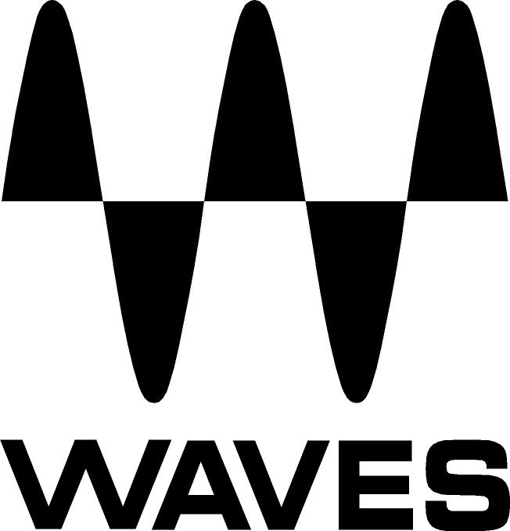

PRESS RELEASE
Contact: Clyne Media, Inc.
Tel: (615) 662-1616
Fax: (615) 662-1636

FOR IMMEDIATE RELEASE

Waves Audio Celebrates 25 Years of Leadership and Innovation in Digital Audio Signal Processing

— In honor of its 25th Anniversary, Waves is now shipping revamped and reskinned versions of three of its classic plugins, the Q10, AudioTrack, and the L1 —

AES Convention, New York, NY, October 18, 2017 — Waves Audio (booth 640), a leading provider of digital signal processing solutions and digital music production tools, now celebrates its 25th anniversary, an occasion that also marks the advent of the digital plugin itself — a concept that has revolutionized every corner of audio production over the last quarter-century.

Twenty-five years ago, Waves introduced the world’s first audio plugin, the Q10 Paragraphic Equalizer. With its introduction, Waves not only transformed the way we work in the recording studio, it also created an entirely new industry sector: software-based audio signal processing. The Q10 revolutionized the professional audio industry, transforming the way we work with audio and giving the computer a new status in music recording. For the first time, it offered high-end professional sound quality in the box that was on par with the sound provided by hardware gear.

What was then considered a surprising foray into computer-driven sound processing tools has since become a prevalent industry standard. Waves tools are now being used to improve sound quality in virtually every sector of the audio market, from recording, mixing, mastering and post-production, to broadcast, live sound, and consumer electronics – hence Waves’ motto, “Where there’s sound – there’s Waves.” For its accomplishments, Waves received a Technical GRAMMY® Award in 2011.

Propelled by an increasingly diverse and comprehensive product line, Waves quickly became a favorite of engineers worldwide and the first choice of recognized audio trendsetters. Waves has gone on to develop a comprehensive line of over 200 audio plugins, an impressive line of diverse hardware units, and an expanding line of state-of-the-art virtual instruments.

Over the past 25 years many revolutionary Waves plugins have become industry standards. Game-changing tools by Waves have included the L1 and L2 Ultramaximizers, which changed the way level maximization and peak limiting are handled by mixing and mastering engineers today; and Waves’ groundbreaking modeling of classic studio legacy hardware, which delivered to any audio engineer or home producer the sound of the SSL and API consoles as well as original rare gear from Abbey Road Studios.

Other early breakthroughs have included valuable time-saving tools like Vocal Rider and Bass Rider; pioneering early effect plugins such as the MondoMod, SuperTap, MetaFlanger; and crucial workflow processors like the S1 Stereo Imager (the first ever stereo manipulation processor) and the PS22 Stereo Maker (a pioneering mono-to-stereo converter).

Waves also spearheaded and remains a leader in noise reduction plugins dedicated to audio repair. It is hard to imagine the past two-and-a-half decades’ effort to remaster classic recordings from timeworn magnetic tape and old vinyl to digital formats without the advent of Waves’ audio restoration tools – a shining example being Disney’s old optical media, long considered lost or extremely costly to resuscitate, which were restored using Waves tools.

Of special note in Waves’ history of audio innovation are the unique Waves Signature Series plugins, created in collaboration with the world's top producers and engineers. These precision-crafted plugins capture each artist's distinctive sound and production style, using customized processing chains designed by the artists themselves, and delivering them to the end user in the form of extremely easy-to-use plugins.

In recent years Waves has also become an established, major player in the live sound market. Live mixing engineers can now bring studio sound to the stage and mix live sound with an unprecedented level of intricacy, by mixing their shows with Waves (and third-party) plugins, with all the wealth of precision control they offer. They can do this thanks to two groundbreaking software innovations by Waves: the Waves MultiRack plugin host, which lets live engineers run plugins on any live sound console; and the Waves eMotion LV1 live software mixer, which enjoys success among FOH, monitor and broadcast engineers in need a highly portable live digital mixing console providing pristine, studio-quality sound.

Most notably, Waves’ groundbreaking SoundGrid technology and applications have become an industry standard for real-time, low-latency audio processing and efficient, cost-effective audio networking. SoundGrid has entirely changed the workflow possibilities for both audio engineers and musicians: with SoundGrid, they can now run higher plugin counts than ever by offloading all plugin processing to external servers and freeing up their computers’ CPU; record with plugins in real time, allowing them to hear the true sound of the recording already during the performance; and network all audio in their studio in the most efficient way possible.

Waves’ most recent innovations have established Waves as a major player in the 360-degree, 3D and VR audio market. Waves recently introduced the Nx Virtual Mix Room plugin, a virtual monitoring tool that delivers, on headphones, the same three-dimensional depth and panoramic stereo image one would be hearing from speakers in an acoustically treated room. Together with its companion Nx Head Tracker, Nx helps audio engineers better predict how their headphone mixes will translate to speakers, finally turning headphones into a mixing tool they can trust. Waves Nx is also available as a consumer application that delivers a 3D audio experience on any set of headphones, turning them into a high-end 360° surround sound system and enabling consumers to experience movies, music and games with real-world 3D sound. Waves Nx technology is also now used in VR games such as Racket:Nx.

Finally, Waves is a market-leading innovator in the consumer electronics market, where under its Maxx brand it offers licensable algorithms for consumer electronics devices. Waves technologies dramatically enhance the audio performance of personal computers, tablets, mobile phones and applications by such industry leaders as Dell, Google, TCL, Fujitsu, Asus, Hisense and more.

Used in scores of commercial and personal recording studios and by hundreds of thousands of users worldwide, the Waves sound can be heard in the world’s most popular hit recordings, major motion pictures, hit television shows and popular video games. Waves’ strong reputation for outstanding quality and technical leadership make it not only the acknowledged market leader in professional audio software, but also the preeminent provider of intelligent audio in consumer electronics.

Celebrating its 25th Anniversary, Waves is now shipping revamped and reskinned versions of three of its classic plugins: the Q10 Equalizer, the AudioTrack channel strip plugin, and the L1 Ultramaximizer level maximizer/peak limiter. These revamped 25th Anniversary editions include new plugin features, as well as a choice between two graphic user interfaces – the classic ‘Legacy’ interface, and the new ‘Modern’ interface created especially for the 25th Anniversary celebrations.

To learn more: https://www.waves.com/.
Video: https://youtu.be/pEGiZFSMTps
…ends 1062 words

Photo file: Waves_25thAnniv_Logo.JPG
Photo caption: Waves Audio is celebrating its 25th anniversary.

About Waves Audio Ltd.:
Waves is the world’s leading developer of audio DSP solutions for the professional, broadcast, and consumer electronics audio markets. Since its start in the early '90s with the introduction of the Q10 equalizer plugin, Waves has gone on to develop a comprehensive line of over 200 audio plugins, including industry standards like the L1 and L2 Ultramaximizers, popular vintage console models, and innovative mixing tools like Vocal Rider and the Artist Signature Series. For its accomplishments, Waves received a Technical GRAMMY® Award in 2011, and the Q10 was selected as an inductee into the TECnology Hall of Fame. In 2016, Waves released the eMotion LV1 mixer, a revolutionary live digital mixing console that provides real-time audio mixing for front-of-house, monitor, studio and broadcast engineers. Waves technologies are now used to improve sound quality in virtually every sector of the audio market, from recording, mixing, mastering and post-production to broadcast, live sound, and consumer electronics. Waves has over 20 years of expertise in the development of psychoacoustic signal processing algorithms that leverage knowledge of human auditory perception to radically improve perceived sound quality. Waves’ award-winning processors are utilized to improve sound quality in the creation of hit records, major motion pictures, and top-selling video games worldwide. Waves offers computer software and hardware-plus-software solutions for the professional and broadcast markets. The company’s WavesLive division is a market leader in all live sound sectors, spearheading the development of solutions for all live platforms. Under its Maxx brand, Waves offers semiconductor and licensable algorithms for consumer electronics applications. Waves technologies dramatically enhance audio performance and are used by industry leaders such as Dell, Google, TCL, Fujitsu, Asus, Hisense and more.

All other product names and trademarks are the property of their respective owners, which are in no way associated or affiliated with Waves.

North America Offices:
Waves, Inc., 2800 Merchants Drive, Knoxville, TN 37912;
Tel: 865-909-9200, Fax: 865-909-9245, Email: info@waves.com,
Web: http://www.waves.com

Corporate Headquarters Israel:
Waves Ltd., Azrieli Center, The Triangle Tower, 32nd Floor, Tel Aviv 67023, Israel;
Tel: 972-3-608-4000, Fax: 972-3-608-4056, Email: info@waves.com,
Web: http://www.waves.com

Waves Public Relations:
Clyne Media, Inc., 169-B Belle Forest Circle, Nashville, TN 37221;
Tel: 615-662-1616, Fax: 615-662-1636, Email: robert@clynemedia.com,
Web: http://www.clynemedia.com

Waves Audio is exhibiting at booth 640 at AES New York 2017.

