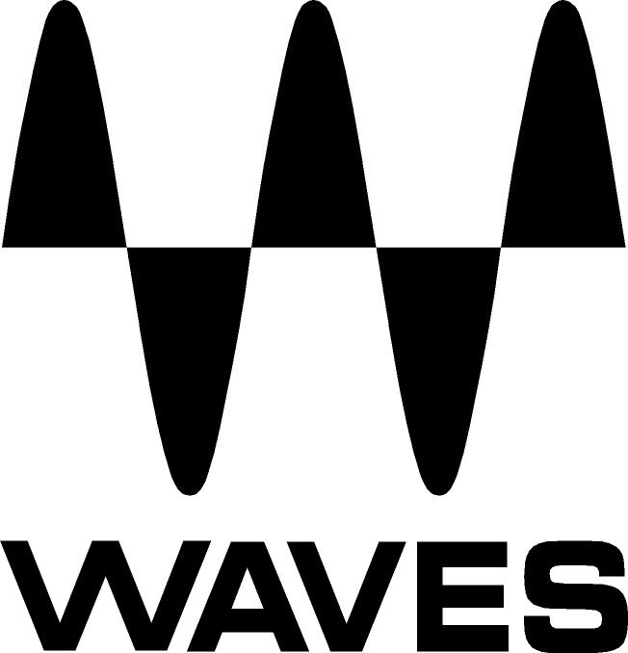

PRESS RELEASE
Contact: Clyne Media, Inc.
Tel: (615) 662-1616
Fax: (615) 662-1636

FOR IMMEDIATE RELEASE

Waves DiGiGrid MGB and Waves Tracks Live Employed by Music Mix Mobile (M3) for Tony Bennett 90th Birthday Celebration

— M3 co-founder and Engineer-in-Charge Joel Singer uses compact, high-quality recording setup to capture audio with Waves DiGiGrid MGB and Waves Tracks Live as the cornerstone of his system for this once-in-a-lifetime performance —

141st International AES Convention, Los Angeles, CA, September 29, 2016 — Music Mix Mobile (M3) co-founder and Engineer-in-Charge Joel Singer, faced with the task of capturing the broadcast audio of a duet featuring Billy Joel and Tony Bennett (a two-hour Tony Bennett Celebrates 90: The Best Is Yet to Come will air at 9 PM December 20, 2016, on NBC and features an all-star lineup including Lady Gaga, Stevie Wonder, Aretha Franklin, Elton John and others) used a compact, high-quality recording setup with DiGiGrid MGB and Waves Tracks Live to record this once-in-a-lifetime performance.

Due to severe space limitations and time constraints, Singer had to put together a compact, high-quality recording system: a Waves Audio DiGiGrid MGB interface and an Apple 15” MacBook Pro with Thunderbolt SSD drive and recording with Waves Tracks Live.

Singer comments, “Waves Tracks Live is so intuitive and easy to use, it’s almost like the cassette deck of years ago, where you’d press record and play, and just go. If you want to dive deep into it, you can, but it’s just such an easy, quick program to use; it lets you get what you need and then just go record. The combo of using Waves’ MGB interface, my MacBook Pro with the SSD drive and Waves Tracks Live simply worked. Waves Tracks Live is so simple to use – the GUI is intuitive and easy to work with.”

…ends 222 words

Photo file: M3_Bennett_Recording.JPG
Photo caption: Music Mix Mobile’s Joel Singer recently recorded the broadcast audio of a duet featuring Billy Joel and Tony Bennett for an upcoming NBC Special celebrating Mr. Bennett’s 90th birthday. Shown is his recording setup: a Waves Audio DiGiGrid MGB interface and an Apple 15” MacBook Pro with Thunderbolt SSD drive; he recorded the duet using Waves Tracks Live.

About Waves Audio Ltd.:
Waves is the world’s leading developer of audio DSP solutions for the professional, broadcast, and consumer electronics audio markets. Since its start in the early '90s with the introduction of the Q10 equalizer plugin, Waves has gone on to develop a comprehensive line of over 200 audio plugins, including industry standards like the L1 and L2 Ultramaximizers, popular vintage console models, and innovative mixing tools like Vocal Rider and the Artist Signature Series. For its accomplishments, Waves received a Technical GRAMMY® Award in 2011, and the Q10 was selected as an inductee into the TECnology Hall of Fame. In 2016, Waves released the eMotion LV1 mixer, a revolutionary live digital mixing console that provides real-time audio mixing for front-of-house, monitor, studio and broadcast engineers. Waves technologies are now used to improve sound quality in virtually every sector of the audio market, from recording, mixing, mastering and post-production to broadcast, live sound, and consumer electronics. Waves has over 20 years of expertise in the development of psychoacoustic signal processing algorithms that leverage knowledge of human auditory perception to radically improve perceived sound quality. Waves’ award-winning processors are utilized to improve sound quality in the creation of hit records, major motion pictures, and top-selling video games worldwide. Waves offers computer software and hardware-plus-software solutions for the professional and broadcast markets. The company’s WavesLive division is a market leader in all live sound sectors, spearheading the development of solutions for all live platforms. Under its Maxx brand, Waves offers semiconductor and licensable algorithms for consumer electronics applications. Waves Maxx technologies dramatically enhance audio performance and are used by industry leaders such as Dell, LG, TCL, Lenovo, Asus, Denon and more.

All other product names and trademarks are the property of their respective owners, which are in no way associated or affiliated with Waves.

North America Offices:
Waves, Inc., 2800 Merchants Drive, Knoxville, TN 37912;
Tel: 865-909-9200, Fax: 865-909-9245, Email: info@waves.com, Web: http://www.waves.com

Corporate Headquarters Israel:
Waves Ltd., Azrieli Center, The Triangle Tower, 32nd Floor
Tel Aviv 67023, Israel; Tel: 972-3-608-4000, Fax: 972-3-608-4056, Email: info@waves.com,
Web: http://www.waves.com

Waves Public Relations:
Clyne Media, Inc., 169-B Belle Forest Circle, Nashville, TN 37221;
Tel: 615-662-1616, Fax: 615-662-1636, Email: robert@clynemedia.com,
Web: http://www.clynemedia.com

Waves Audio is exhibiting at booth 721 at the 141st AES Convention in Los Angeles, CA.

