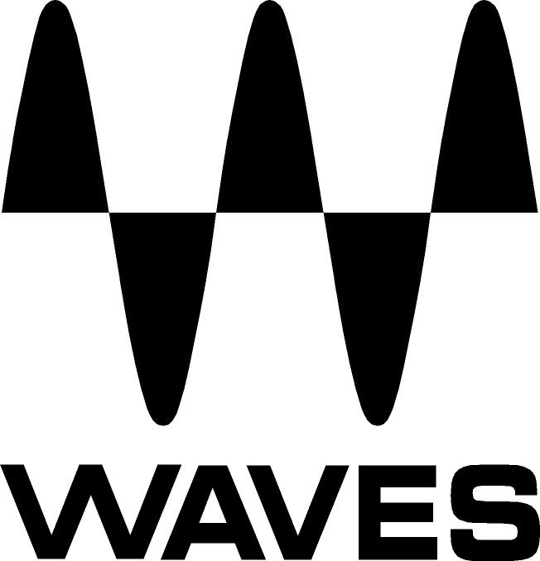

PRESS RELEASE
Contact: Clyne Media, Inc.
Tel: (615) 662-1616
Fax: (615) 662-1636

FOR IMMEDIATE RELEASE

Waves Audio Announces Upgrades to Its WLM Loudness Meter

135th AES Convention, New York, NY, October 18, 2013 — Waves Audio (booth 2839) is pleased to announce several new features and improvements to its 2012 TEC Award-winning WLM Loudness Meter plugin. The “WLM Plus” update provides precision loudness measurement, metering, correction and adjustment tools for broadcast, movie trailers, games, packaged media and more. Ideal for content creators and postproduction houses as well as cable head-end facilities, WLM Plus is an affordable, all-in-one, cross-platform, multi-format loudness metering software solution. Fully compliant with all current ITU, 1770-3, EBU and ATSC specifications, it offers comprehensive Momentary, Short Term, Long Term and True Peak readouts, plus a unique warning and logging system that keeps track of users’ levels and lets them know when they have exceeded them – or fallen short. WLM Plus features Gain and Trim controls for correction of loudness levels and a True Peak Limiter, saving you the need to utilize additional gear or plugins. Includes foreground, dialog and average loudness measurements, and an intelligent dialog sensor detects and measures speech. Mono, stereo 5.0 and 5.1 components included.

New WLM Plus correction and adjustment features include:
- Gain: To help correct loudness levels, the new Gain function enables users to get as close as possible to the target.
- Trim: Calculates the difference between the long-term and the target. By clicking the Trim button, the Gain fader automatically adjusts itself to the desired target level.
- Limiter: Featuring a gain reduction meter and a peak value display, the Limiter works prior to the True Peak meter. Threshold is taken from the True Max parameter and does not include make up gain.
- In Audio Suite, Long Term results can now be viewed without the measurement display reverting to its default measurement reading.
- When in LM1/Dialogue mode: Additional ability to choose the duration of short-term measurement blocks.

WLM Plus is Native- and SoundGrid®-compatible. WLM Plus will be available at a U.S. MSRP of $400 Native and $600 SoundGrid.

Visit www.waves.com for more information.
...ends 263 words

Photo File: WLM.JPG

About Waves Ltd.:
From its start in the early '90s with the introduction of the Q10 equalizer plugin, Waves, the world’s leading developer of audio DSP solutions for professional, broadcast, and consumer electronics audio markets, has gone on to develop a comprehensive line of over 130 audio plugins including industry standards like the L1 and L2 Ultramaximizers, popular vintage console models, and innovative mixing tools like Vocal Rider and the Artist Signature Series. For its accomplishments, in 2011 Waves received a Technical GRAMMY® award, and the Q10 was selected as an inductee into the TECnology Hall of Fame. Waves technologies are now used to improve sound quality in virtually every sector of the audio market, from recording, mixing, mastering and post-production to broadcast, live sound, and consumer electronics. Waves has over 20 years of expertise in the development of psycho-acoustic signal processing algorithms that leverage knowledge on the human perception of hearing to radically improve perceived sound quality. Waves’ award-winning processors are utilized to improve sound quality in the creation of hit records, major motion pictures, and top-selling video games worldwide. Waves offers computer software solutions, as well as hardware-plus-software solutions, for the professional and broadcast markets. Under its Maxx brand, Waves offers semiconductor and licensable algorithms for consumer electronics applications. Waves Maxx technologies dramatically enhance audio performance and are used by industry leaders such as Dell, ASUS, JVC and many others.

All other product names and trademarks are the property of their respective owners, which are in no way associated or affiliated with Waves.

North America Offices:
Waves, Inc., 2800 Merchants Drive, Knoxville, TN 37912;
Tel: 865-909-9200, Fax: 865-909-9245, Email: info@waves.com, Web: http://www.waves.com

Corporate Headquarters Israel:
Waves Ltd., Azrieli Center, The Triangle Tower, 32nd Floor
Tel Aviv 67023, Israel; Tel: 972-3-608-4000, Fax: 972-3-608-4056, Email: info@waves.com,
Web: http://www.waves.com

Waves Public Relations:
Clyne Media, Inc., 169-B Belle Forest Circle, Nashville, TN 37221;
Tel: 615-662-1616, Fax: 615-662-1636, Email: robert@clynemedia.com,
Web: http://www.clynemedia.com

Waves Audio is exhibiting at booth 2839 at the 135th AES Convention in New York, NY.

