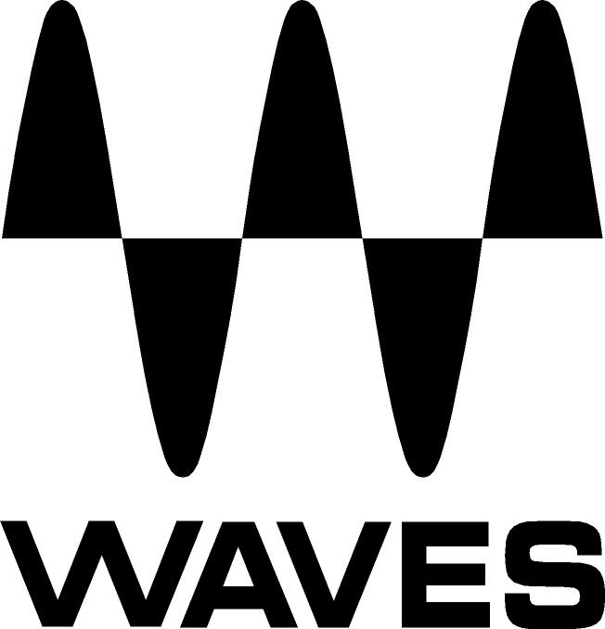

PRESS RELEASE
Contact: Clyne Media, Inc.
Tel: (615) 662-1616
Fax: (615) 662-1636

FOR IMMEDIATE RELEASE

Waves Audio Debuts SoundGrid® Studio

135th AES Convention, New York, NY, October 18, 2013 — Waves Audio (booth 2839) now offers SoundGrid® Studio, a suite of software applications for managing SoundGrid network components, enabling network configuration, device management, plugin chaining, routing and more.

SoundGrid Studio includes:
- SoundGrid ASIO/Core Audio Driver, which offers dynamic I/O mapping for the configuration of SoundGrid devices.
- StudioRack application, which lets you run plugin chains of up to eight plugins within your Native DAW or Pro Tools, and lets you choose whether to process on your host computer or offload processing to a SoundGrid DSP server.
- eMotion ST, a low latency monitoring mixer which lets you send an audio signal from a SoundGrid device, through StudioRack inside your DAW, and out to your monitors, with super-low latency of only 0.8 milliseconds.

eMotion ST specs:
- 8 multi-purpose mono/stereo input channels
- 2 stereo FX Aux Bus/ Return and 6 Stereo Aux Bus/Return
- 64 Mono Channel feeds from StudioRack plugins
- 8 insert slots per channel for each SoundGrid plugin
- Connect up to eight IOs and eight DAWs

For Live sound, Waves introduces the eMotion LV1 for FOH and monitor applications designed to integrate seamlessly with SoundGrid-compatible I/Os. The eMotion Mixer engine is powered by low-latency SoundGrid DSP Servers, with real-time Waves plugin processing on every channel and support for multiple mixers, I/O boxes and SoundGrid DSP servers over a single network. eMotion LV1 also offers hardware scalability using standard network components; compatibility with standard control surfaces; Multi-Touch support; Windows and Mac compatibility; and preset sharing across consoles and platforms.

Visit www.waves.com for more information.
...ends 250 words

Photo File: eMotion_ST.JPG
Photo Caption: Waves SoundGrid® Studio eMotion™ Control interface

About Waves Ltd.:
From its start in the early '90s with the introduction of the Q10 equalizer plugin, Waves, the world’s leading developer of audio DSP solutions for professional, broadcast, and consumer electronics audio markets, has gone on to develop a comprehensive line of over 130 audio plugins including industry standards like the L1 and L2 Ultramaximizers, popular vintage console models, and innovative mixing tools like Vocal Rider and the Artist Signature Series. For its accomplishments, in 2011 Waves received a Technical GRAMMY® award, and the Q10 was selected as an inductee into the TECnology Hall of Fame. Waves technologies are now used to improve sound quality in virtually every sector of the audio market, from recording, mixing, mastering and post-production to broadcast, live sound, and consumer electronics. Waves has over 20 years of expertise in the development of psycho-acoustic signal processing algorithms that leverage knowledge on the human perception of hearing to radically improve perceived sound quality. Waves’ award-winning processors are utilized to improve sound quality in the creation of hit records, major motion pictures, and top-selling video games worldwide. Waves offers computer software solutions, as well as hardware-plus-software solutions, for the professional and broadcast markets. Under its Maxx brand, Waves offers semiconductor and licensable algorithms for consumer electronics applications. Waves Maxx technologies dramatically enhance audio performance and are used by industry leaders such as Dell, ASUS, JVC and many others.

All other product names and trademarks are the property of their respective owners, which are in no way associated or affiliated with Waves.

North America Offices:
Waves, Inc., 2800 Merchants Drive, Knoxville, TN 37912;
Tel: 865-909-9200, Fax: 865-909-9245, Email: info@waves.com, Web: http://www.waves.com

Corporate Headquarters Israel:
Waves Ltd., Azrieli Center, The Triangle Tower, 32nd Floor
Tel Aviv 67023, Israel; Tel: 972-3-608-4000, Fax: 972-3-608-4056, Email: info@waves.com,
Web: http://www.waves.com

Waves Public Relations:
Clyne Media, Inc., 169-B Belle Forest Circle, Nashville, TN 37221;
Tel: 615-662-1616, Fax: 615-662-1636, Email: robert@clynemedia.com,
Web: http://www.clynemedia.com

Waves Audio is exhibiting at booth 2839 at the 135th AES Convention in New York, NY.

