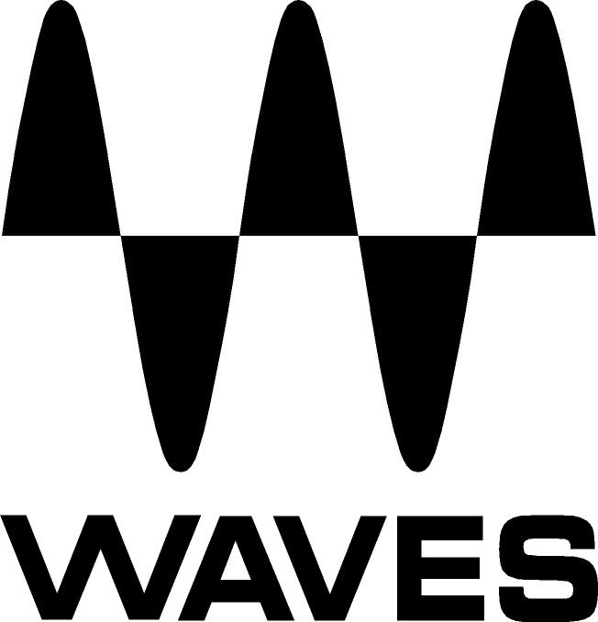

PRESS RELEASE
Contact: Clyne Media, Inc.
Tel: (615) 662-1616
Fax: (615) 662-1636

FOR IMMEDIATE RELEASE

DiGiGrid MGB Coaxial and MGO Optical MADI Interfaces Are Now Available from Waves Audio and DiGiCo

135th AES Convention, New York, NY, October 18, 2013 — Waves Audio (booth 2839) now offers DiGiGrid MGB Coaxial and MGO Optical MADI Interfaces for its SoundGrid® protocol. For artists like Beyoncé, Rihanna, Shakira, Bruno Mars, Bruce Springsteen, Coldplay and countless others, Waves SoundGrid is the live sound networking and processing platform of choice. The compact and portable DiGiGrid MGB coaxial and MGO optical MADI interfaces let you plug any MADI-enabled device into the power of the Waves SoundGrid networking and processing platform.

Record, process and play back up to 128 audio channels, using literally hundreds of Waves and third-party plugins, with super-low latency, clocking in at only 0.8 milliseconds! You can even record to two computers simultaneously: One for virtual soundcheck, the other for backup. So if you’re on the tour bus, in your hotel room, at the airport – wherever – you can quickly and conveniently setup your next show, using only your laptop.

With a DiGiGrid MGB or MGO MADI-to-SoundGrid interface, real-time low-latency networking and processing is only an Ethernet cable away

MGO and MGB are now available with a U.S. MSRP of $2000. Visit http://www.digigrid.net/ and www.waves.com for more information.
...ends 182 words

Photo File: MGB.JPG

About Waves Ltd.:
From its start in the early '90s with the introduction of the Q10 equalizer plugin, Waves, the world’s leading developer of audio DSP solutions for professional, broadcast, and consumer electronics audio markets, has gone on to develop a comprehensive line of over 130 audio plugins including industry standards like the L1 and L2 Ultramaximizers, popular vintage console models, and innovative mixing tools like Vocal Rider and the Artist Signature Series. For its accomplishments, in 2011 Waves received a Technical GRAMMY® award, and the Q10 was selected as an inductee into the TECnology Hall of Fame. Waves technologies are now used to improve sound quality in virtually every sector of the audio market, from recording, mixing, mastering and post-production to broadcast, live sound, and consumer electronics. Waves has over 20 years of expertise in the development of psycho-acoustic signal processing algorithms that leverage knowledge on the human perception of hearing to radically improve perceived sound quality. Waves’ award-winning processors are utilized to improve sound quality in the creation of hit records, major motion pictures, and top-selling video games worldwide. Waves offers computer software solutions, as well as hardware-plus-software solutions, for the professional and broadcast markets. Under its Maxx brand, Waves offers semiconductor and licensable algorithms for consumer electronics applications. Waves Maxx technologies dramatically enhance audio performance and are used by industry leaders such as Dell, ASUS, JVC and many others.

All other product names and trademarks are the property of their respective owners, which are in no way associated or affiliated with Waves.

North America Offices:
Waves, Inc., 2800 Merchants Drive, Knoxville, TN 37912;
Tel: 865-909-9200, Fax: 865-909-9245, Email: info@waves.com, Web: http://www.waves.com

Corporate Headquarters Israel:
Waves Ltd., Azrieli Center, The Triangle Tower, 32nd Floor
Tel Aviv 67023, Israel; Tel: 972-3-608-4000, Fax: 972-3-608-4056, Email: info@waves.com,
Web: http://www.waves.com

Waves Public Relations:
Clyne Media, Inc., 169-B Belle Forest Circle, Nashville, TN 37221;
Tel: 615-662-1616, Fax: 615-662-1636, Email: robert@clynemedia.com,
Web: http://www.clynemedia.com

Waves Audio is exhibiting at booth 2839 at the 135th AES Convention in New York, NY.

