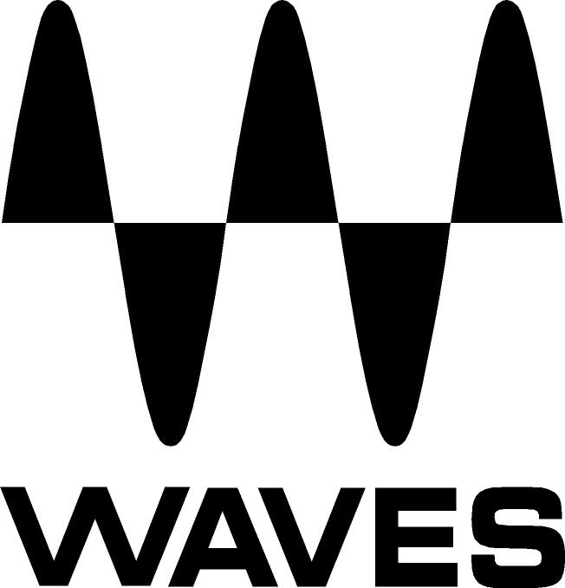

PRESS RELEASE
Contact: Clyne Media, Inc.
Tel: (615) 662-1616
Fax: (615) 662-1636

FOR IMMEDIATE RELEASE

Waves Audio and Abbey Road Studios Unveil

J37 Tape Saturation Plugin

135th AES Convention, New York, NY, October 18, 2013 — Waves Audio (booth 2839) and Abbey Road Studios present the J37 tape saturation plugin: a precision model of the very machine used to record many of the greatest masterpieces in modern music. With a variety of user-adjustable controls including Tape Speed, Bias, Noise, Saturation, Wow and Flutter, the Waves: Abbey Road J37 faithfully recreates the inimitable sonic signature of the original machine. In addition to the J37 itself, three exclusive oxide tape formulas have been modeled. Specially developed by EMI during the 60s and 70s, each formula has its own unique frequency response and harmonic distortion behavior.

The Waves: Abbey Road J37 tape emulation plugin delivers a level of hardware realism never before experienced ‘in the box’, bringing stunning analogue warmth to your digital recordings.

While the J37 was used on many famous recordings, it is perhaps best known for its innovative use on The Beatles’ Sgt. Pepper’s Lonely Hearts Club Band. Producer George Martin utilized the machine not only for recording but also as a creative production tool, bouncing tracks between two J37s and creating layer upon layer of sound to achieve ground-breaking sonic textures.

“The winning combination of Abbey Road Studios' Studer J37 Four-Track machine and EMI Tape has been used to create some of the most important recordings of all time,” says Mirek Stiles, Head of Audio Products, Abbey Road Studios. “As well as modeling the J37, with the amazing warmth of 52 valves, Waves has teamed it with the last remaining blank 60s and 70s tape stock from the EMI archives. EMI Tape has stood the test of time; it never needs baking and sounds wonderful. Abbey Road Studios’ technical staff from the J37's heyday were consulted on the line-up procedures that they used over 50 years ago, with the end results sounding simply stunning. Waves has given us yet another unique example of Abbey Road Studios' heritage, available for the first time as a software plugin.”

J37 tape saturation plugin features:
- Created in association with Abbey Road Studios
- Modeled on the machine used to create countless classic 60s tracks
- Adds analog warmth to digital recordings
- Controls for Bias, Wow, Flutter, Tape Speed and more
- Comprehensive Tape Delay including three different delay types, Sync, LP and HP filter controls and more.

The J37 is Native and SoundGrid-compatible. It is not included in any Waves bundle; it is only available separately. The Waves: Abbey Road J37 Tape Saturation plugin is now available with a U.S. MSRP of Native $249 and SoundGrid $375.

Visit www.waves.com for more information.

Abbey Road Studios and their associated logos are trademarks of EMI (IP) Limited.

...ends 263 words

Photo File: J37_Stereo.JPG
Photo Caption: J37 Stereo Component

About Abbey Road Studios:
Abbey Road Studios are the most famous recording studios in the world and an iconic symbol of British music. They have been home to countless landmark recordings and pioneering advances in recording technology. Opened in November 1931, Abbey Road Studios were the world’s first purpose built recording studios. The hallowed building has a phenomenal 80 year history working with many of the world’s most famous artists including The Beatles, Pink Floyd, The Hollies, Kate Bush, Oasis, Florence and the Machine, Adele and Lady Gaga. Also one of the world’s premiere locations for movie scoring, since the 1980s films such as Raiders of the Lost Ark, the Lord of The Rings Trilogy, Braveheart and The King’s Speech have been recorded there. The list continues with many other major titles, including Shrek, Prometheus, Harry Potter, Skyfall and The Hobbit. www.AbbeyRoad.com.

About Waves Ltd.:
From its start in the early '90s with the introduction of the Q10 equalizer plugin, Waves, the world’s leading developer of audio DSP solutions for professional, broadcast, and consumer electronics audio markets, has gone on to develop a comprehensive line of over 130 audio plugins including industry standards like the L1 and L2 Ultramaximizers, popular vintage console models, and innovative mixing tools like Vocal Rider and the Artist Signature Series. For its accomplishments, in 2011 Waves received a Technical GRAMMY® award, and the Q10 was selected as an inductee into the TECnology Hall of Fame. Waves technologies are now used to improve sound quality in virtually every sector of the audio market, from recording, mixing, mastering and post-production to broadcast, live sound, and consumer electronics. Waves has over 20 years of expertise in the development of psycho-acoustic signal processing algorithms that leverage knowledge on the human perception of hearing to radically improve perceived sound quality. Waves’ award-winning processors are utilized to improve sound quality in the creation of hit records, major motion pictures, and top-selling video games worldwide. Waves offers computer software solutions, as well as hardware-plus-software solutions, for the professional and broadcast markets. Under its Maxx brand, Waves offers semiconductor and licensable algorithms for consumer electronics applications. Waves Maxx technologies dramatically enhance audio performance and are used by industry leaders such as Dell, ASUS, JVC and many others.

All other product names and trademarks are the property of their respective owners, which are in no way associated or affiliated with Waves.

North America Offices:
Waves, Inc., 2800 Merchants Drive, Knoxville, TN 37912;
Tel: 865-909-9200, Fax: 865-909-9245, Email: info@waves.com, Web: http://www.waves.com

Corporate Headquarters Israel:
Waves Ltd., Azrieli Center, The Triangle Tower, 32nd Floor
Tel Aviv 67023, Israel; Tel: 972-3-608-4000, Fax: 972-3-608-4056, Email: info@waves.com,
Web: http://www.waves.com

Waves Public Relations:
Clyne Media, Inc., 169-B Belle Forest Circle, Nashville, TN 37221;
Tel: 615-662-1616, Fax: 615-662-1636, Email: robert@clynemedia.com,
Web: http://www.clynemedia.com

Waves Audio is exhibiting at booth 2839 at the 135th AES Convention in New York, NY.

