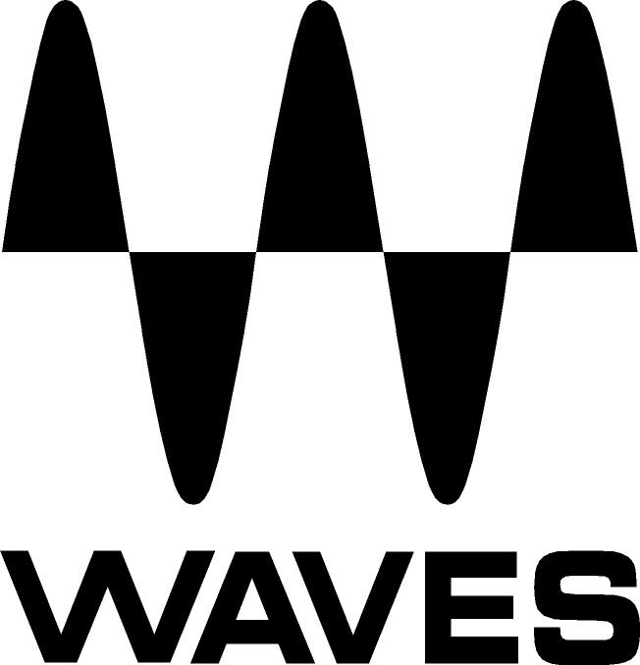

PRESS RELEASE
Contact: Clyne Media, Inc.
Tel: (615) 662-1616
Fax: (615) 662-1636

FOR IMMEDIATE RELEASE

Waves Audio Announces the Waves Dugan Automixer

135th AES Convention, New York, NY, October 18, 2013 — Waves Audio (booth 2839) announces its new Dugan Automixer plugin. Developed in association with sound engineering legend Dan Dugan, the Waves Dugan Automixer is a software emulation of the popular Dugan Speech System Automatic Mixing Controllers used the world over. It is MultiRack SoundGrid®- and MultiRack Native-compatible and works on 32 or 64 channels.

Using Dugan's proprietary voice-activated process, the Waves Dugan Automatic Mixing Controller plugin automatically controls the gains of multiple live microphones in real time, while simultaneously preventing feedback and excessive noise pickup. It maintains the gain of one mic in the room, even when multiple speakers are talking simultaneously, making perfectly-matched transparent cross-fades.

Says Dan Dugan, “People have been asking for a Dugan plug-in for a long time. I'm very pleased be able to realize it with the premier publisher of plug-ins.”

Ideal for:
- Broadcast news panels & discussion programs
- Television talk shows & game shows
- Conference sound reinforcement and video trucks
- Dialogue recording for film and television
- Multiple wireless mics on stage
- Houses of worship
- Boardrooms and civic meeting rooms
- Community television
- Teleconferencing
- Distance learning

The Dan Dugan Automixer is MultiRack only, Native- and SoundGrid-compatible. It is not included in any Waves bundle; it is only available separately. The Dan Dugan Automixer will be available with a U.S. MSRP of Native $500 and SoundGrid $750. Visit www.waves.com for more information.
...ends 224 words

Photo File: DuganAutomixer.JPG

About Dan Dugan Sound Design:
Dan Dugan, the inventor of the automatic microphone mixer, has been actively involved in the audio industry since the 1960’s. The Dugan Speech System, Dugan Music System and Dugan Gain Limiting technologies have formed the basis of the best automatic microphone mixing and mixing controller systems available. Dugan mixers are essential components of network television talk shows, public affairs programs, houses of worship, courtrooms, and staged events. www.dandugan.com

About Waves Ltd.:
From its start in the early '90s with the introduction of the Q10 equalizer plugin, Waves, the world’s leading developer of audio DSP solutions for professional, broadcast, and consumer electronics audio markets, has gone on to develop a comprehensive line of over 130 audio plugins including industry standards like the L1 and L2 Ultramaximizers, popular vintage console models, and innovative mixing tools like Vocal Rider and the Artist Signature Series. For its accomplishments, in 2011 Waves received a Technical GRAMMY® award, and the Q10 was selected as an inductee into the TECnology Hall of Fame. Waves technologies are now used to improve sound quality in virtually every sector of the audio market, from recording, mixing, mastering and post-production to broadcast, live sound, and consumer electronics. Waves has over 20 years of expertise in the development of psycho-acoustic signal processing algorithms that leverage knowledge on the human perception of hearing to radically improve perceived sound quality. Waves’ award-winning processors are utilized to improve sound quality in the creation of hit records, major motion pictures, and top-selling video games worldwide. Waves offers computer software solutions, as well as hardware-plus-software solutions, for the professional and broadcast markets. Under its Maxx brand, Waves offers semiconductor and licensable algorithms for consumer electronics applications. Waves Maxx technologies dramatically enhance audio performance and are used by industry leaders such as Dell, ASUS, JVC and many others.

All other product names and trademarks are the property of their respective owners, which are in no way associated or affiliated with Waves.

North America Offices:
Waves, Inc., 2800 Merchants Drive, Knoxville, TN 37912;
Tel: 865-909-9200, Fax: 865-909-9245, Email: info@waves.com, Web: http://www.waves.com

Corporate Headquarters Israel:
Waves Ltd., Azrieli Center, The Triangle Tower, 32nd Floor
Tel Aviv 67023, Israel; Tel: 972-3-608-4000, Fax: 972-3-608-4056, Email: info@waves.com,
Web: http://www.waves.com

Waves Public Relations:
Clyne Media, Inc., 169-B Belle Forest Circle, Nashville, TN 37221;
Tel: 615-662-1616, Fax: 615-662-1636, Email: robert@clynemedia.com,
Web: http://www.clynemedia.com

Waves Audio is exhibiting at booth 2839 at the 135th AES Convention in New York, NY.

