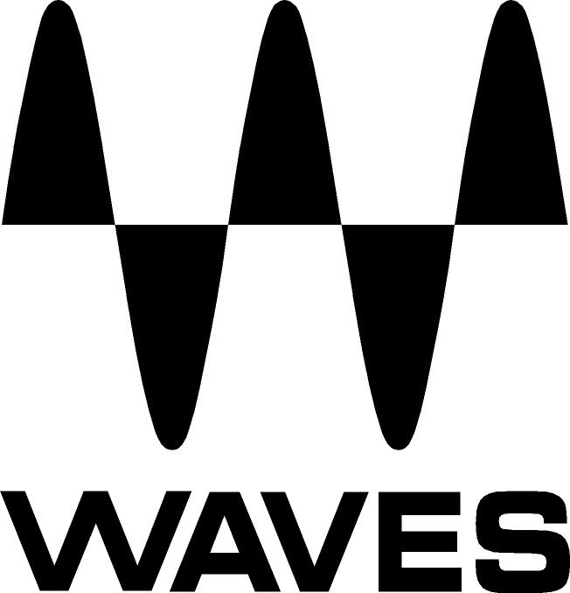

PRESS RELEASE
Contact: Clyne Media, Inc.
Tel: (615) 662-1616
Fax: (615) 662-1636

FOR IMMEDIATE RELEASE

Waves Audio and DiGiCo Offer DiGiGrid Studio Solutions

135th AES Convention, New York, NY, October 18, 2013 — Waves Audio (booth 2839) offers DiGiGrid, a collaboration between Waves and DiGiCo. Following implementation of Waves SoundGrid® for the DiGiCo SD consoles, DiGiCo recognized the potential and created SoundGrid-based studio hardware. In addition to integrated networking capabilities, upcoming DiGiGrid studio solutions will include a full line of I/Os with world-class converters, pre-amps, headphone amplification, built-in DSP Servers and network switches. With solutions for users of Native DAWs, Pro Tools and MADI-enabled consoles, DiGiGrid is poised to take plugin processing to a whole new level.

Usage notes:
- For Native DAW users, DiGiGrid provides real-time low-latency processing using SoundGrid-compatible plugins during recording, delivering a monitor mix that sounds remarkably like a finished product.
- For Pro Tools users, DiGiGrid increases processing power, accommodating higher track counts and networking capabilities with the Waves SoundGrid platform. Operates via super-efficient Cat 5e/6 cables.
- For users of MADI-enabled devices, DiGiGrid opens up the world of studio-quality sound with its MGO (optical) and MGB (BNC) MADI-to-SoundGrid interfaces. Compact and portable, they offer the ability to record performances direct-to-DAW with world-class processing and simultaneous recording and playback of up to 128 channels. With a DiGiGrid SWI SoundGrid-certified network switch, a SoundGrid DSP server and the Waves MultiRack host application, any MADI-compatible live or broadcast console can access the seemingly limitless world of real-time low-latency studio-quality processing.
- Waves will be presenting DiGiGrid at the135th AES Convention (Waves booth (2839).

Visit http://www.digigrid.net/ and www.waves.com for more information.
...ends 236 words

Photo File: DiGiGrid_iOS.JPG

About Waves Ltd.:
From its start in the early '90s with the introduction of the Q10 equalizer plugin, Waves, the world’s leading developer of audio DSP solutions for professional, broadcast, and consumer electronics audio markets, has gone on to develop a comprehensive line of over 130 audio plugins including industry standards like the L1 and L2 Ultramaximizers, popular vintage console models, and innovative mixing tools like Vocal Rider and the Artist Signature Series. For its accomplishments, in 2011 Waves received a Technical GRAMMY® award, and the Q10 was selected as an inductee into the TECnology Hall of Fame. Waves technologies are now used to improve sound quality in virtually every sector of the audio market, from recording, mixing, mastering and post-production to broadcast, live sound, and consumer electronics. Waves has over 20 years of expertise in the development of psycho-acoustic signal processing algorithms that leverage knowledge on the human perception of hearing to radically improve perceived sound quality. Waves’ award-winning processors are utilized to improve sound quality in the creation of hit records, major motion pictures, and top-selling video games worldwide. Waves offers computer software solutions, as well as hardware-plus-software solutions, for the professional and broadcast markets. Under its Maxx brand, Waves offers semiconductor and licensable algorithms for consumer electronics applications. Waves Maxx technologies dramatically enhance audio performance and are used by industry leaders such as Dell, ASUS, JVC and many others.

All other product names and trademarks are the property of their respective owners, which are in no way associated or affiliated with Waves.

North America Offices:
Waves, Inc., 2800 Merchants Drive, Knoxville, TN 37912;
Tel: 865-909-9200, Fax: 865-909-9245, Email: info@waves.com, Web: http://www.waves.com

Corporate Headquarters Israel:
Waves Ltd., Azrieli Center, The Triangle Tower, 32nd Floor
Tel Aviv 67023, Israel; Tel: 972-3-608-4000, Fax: 972-3-608-4056, Email: info@waves.com,
Web: http://www.waves.com

Waves Public Relations:
Clyne Media, Inc., 169-B Belle Forest Circle, Nashville, TN 37221;
Tel: 615-662-1616, Fax: 615-662-1636, Email: robert@clynemedia.com,
Web: http://www.clynemedia.com

Waves Audio is exhibiting at booth 2839 at the 135th AES Convention in New York, NY.

