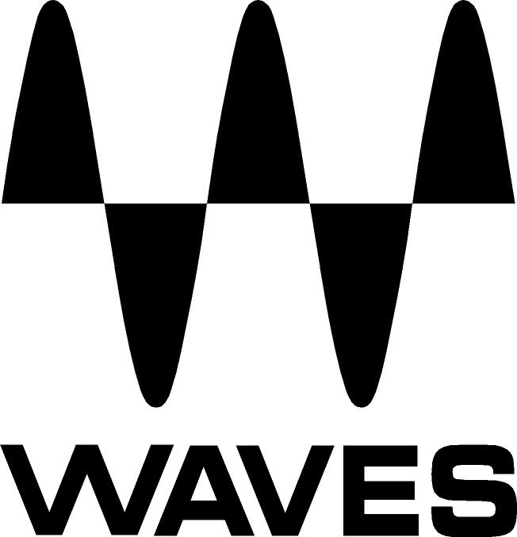

PRESS RELEASE
Contact: Clyne Media, Inc.
Tel: (615) 662-1616
Fax: (615) 662-1636

FOR IMMEDIATE RELEASE

Waves Audio Teams with Eddie Kramer for

New Tape, Tubes & Transistors Bundle

— Together, these plugins recreate Kramer’s golden audio chain —

131st AES CONVENTION, NEW YORK, NY, October 21, 2011 — Waves Audio (booth 728), the industry-leading developer of professional audio digital signal processing technologies and the recipient of a 2011 Technical GRAMMY® Award, announces Tape, Tubes & Transistors, a new bundle of plugins recreating the audio chain of legendary producer/engineer Eddie Kramer (Jimi Hendrix, Led Zeppelin, Kiss). Tape, Tubes & Transistors features three meticulously-modeled vintage plugins: Kramer Master Tape, HLS Channel, and PIE Compressor. All three of these plugins have been developed in association with Kramer as part of an ongoing series of collaborations. Together, they recreate Eddie’s golden audio chain, which he used to record musical icons like Jimi Hendrix, Led Zeppelin, and The Beatles. Now, the legendary sound of the processing Kramer used at London's Olympic Studios is available to users.

Over the course of a production and engineering career that has spanned more than four decades, Eddie Kramer was the man behind the board for the biggest names in music history. His work brought forth music which continues to influence rock musicians and producers to this day. In modeling the Helios console channel, the Pye compressor and the rare vintage 1/4" reel-to-reel machine, Waves has recreated three essential elements of the recording chain at Olympic Studios, where Eddie participated in so many historic recordings which are now considered part of the classic rock DNA. Eddie Kramer, the Kramer Master Tape, the HLS Channel, and the PIE Compressor: Together, they truly capture the spirits of a generation.

Waves Kramer Tape, tubes & Transistors is now available at a U.S. MSRP of Native $400/ TDM $500. Special intro price is Native $199/ TDM $299. For more information, please visit www.waves.com.
...ends 272 words
Photo File: Waves_KramerTTT_BoxJPG

About Waves Ltd.:
From its start in the early '90s with the introduction of the Q10 equalizer plugin, Waves, a leading provider of audio DSP solutions for professional, broadcast, and consumer electronics audio markets, has gone on to develop a comprehensive line of over 100 audio plugins including industry standards like the L1 and L2 Ultramaximizers, popular vintage console models, and innovative mixing tools like Vocal Rider and the Artist Signature Series. For its accomplishments, in 2011 Waves received a Technical GRAMMY®, and the Q10 was selected as an inductee into the TECnology Hall of Fame. Waves technologies are now used to improve sound quality in virtually every sector of the audio market, from recording, mixing, mastering and post production to broadcast, live sound, and consumer electronics. Waves has over 15 years of expertise in the development of psycho-acoustic signal processing algorithms that leverage knowledge on the human perception of hearing to radically improve perceived sound quality. Waves’ award-winning processors are utilized to improve sound quality in the creation of hit records, major motion pictures, and popular video games worldwide. Waves offers computer software solutions, as well as hardware-plus-software solutions, for the professional and broadcast markets. Under its Maxx brand, Waves offers semiconductor and licensable algorithms for consumer electronics applications. Waves’ Maxx technologies dramatically enhance audio performance and are used by industry leaders such as Dell, Sony, Sanyo, JVC, Toshiba, and many others. For more information, visit the Waves web site at http://www.waves.com.

All other product names and trademarks are the property of their respective owners, which are in no way associated or affiliated with Waves.

Waves Contacts:
North America Offices:
Waves, Inc., 2800 Merchants Drive, Knoxville, TN 37912;
Tel: 865-909-9200, Fax: 865-909-9245, Email: info@waves.com, Web: http://www.waves.com

Corporate Headquarters Israel:
Waves Ltd., Azrieli Center, The Triangle Tower, 32nd Floor
Tel Aviv 67023, Israel; Tel: 972-3-608-4000, Fax: 972-3-608-4056, Email: info@waves.com,
Web: http://www.waves.com

Waves Public Relations:
Clyne Media, Inc., 169-B Belle Forest Circle, Nashville, TN 37221;
Tel: 615-662-1616, Fax: 615-662-1636, Email: robert@clynemedia.com,
Web: http://www.clynemedia.com

Waves is exhibiting at booth 728 at AES 2011 in New York, NY.

