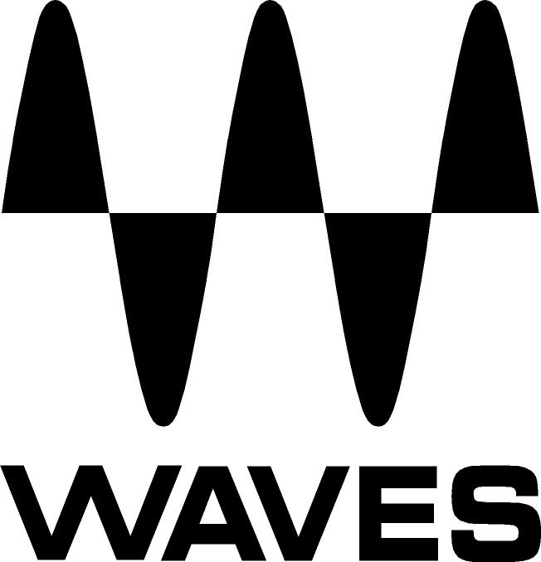

PRESS RELEASE
Contact: Clyne Media, Inc.
Tel: (615) 662-1616
Fax: (615) 662-1636

FOR IMMEDIATE RELEASE

Waves Audio Introduces Kramer Master Tape Plugin

— The Kramer Master Tape plugin is modeled on an Ampex 350/351 tape machine,
the final link in Eddie Kramer’s Olympic Studios signal chain from the 1960s —

131st AES CONVENTION, NEW YORK, NY, October 21, 2011 — Waves Audio (booth 728), the industry leader in professional audio digital signal processing technologies, unveils the Kramer Master Tape plugin. Developed in association with legendary producer/engineer Eddie Kramer (Jimi Hendrix, Led Zeppelin, Kiss) as part of an ongoing series of collaborations, the Kramer Master Tape plugin is modeled on a rare machine consisting of an Ampex 350 transport and 351 electronics. With adjustable tape speed, bias, flux, wow and flutter, along with noise parameters, the plugin provides comprehensive control over the contours of any sound. To top it off, Waves has added a flexible slap and feedback delay, ideal for rock, dance, dub and countless other styles. For recording, mixing, mastering and more, Kramer Master Tape brings the richness and warmth of real tape saturation to any DAW setup.

When Waves started their hardware modeling project with Eddie Kramer, it was always their intention to create a model of the original recording chain from Olympic Studios in London that Kramer used on his great recordings of Led Zeppelin, The Rolling Stones and Jimi Hendrix. The first two plugins resulting from this project were the successful HLS Channel and PIE Compressor. The last piece of the chain was the Kramer Master Tape plugin. The Ampex 350 and 351 valve tape machines were mainstays of the recording industry and were used for literally thousands of hit albums and singles over more than two decades of recording. Waves tracked down a perfectly maintained machine (owned by veteran mixer/engineer Eric Schilling), and began the long, complex modeling process. Assisting Waves were Bob Olhsson (Stevie Wonder, Marvin Gaye, Diana Ross) and co-developer John Haeny (Jim Morrison and the Doors, John Coltrane, Joni Mitchell, Jackson Browne). Waves used 3M Scotch 206/207 tape for the modeling, as it was considered an almost ideal match for this machine.

Features
Modeled on the Ampex 350/351 ¼" reel-to-reel
Adjustable tape speed, bias, flux, wow and flutter
Slap and feedback delay
Up to 24-bit 96kHz resolution
Mono and Stereo components
Supports TDM, RTAS, Audio Suite, VST, AU
PC- and Mac®-compatible

Controls
SPEED selects the simulated tape speed
MONITOR selects the monitoring mode
BIAS controls the level of the ultrasonic bias signal
VU METER displays input or output level
VU CALIBRATION controls the VU meter headroom calibration
DELAY TIME controls the time of the tape delay effect, with settings for 7.5 ips (266
milliseconds) and 15 ips (133 ms)
DELAY TYPE toggles between delay modes
FEEDBACK controls the amount of the delayed output signal
LOWPASS controls the LP cutoff frequency on the delay path
RECORD LEVEL controls the input level
LINK I/O links Record and Playback Levels controls
PLAYBACK LEVEL controls the total signal output level
FLUX controls the level of simulated magnetic radiation emitted from the record head
WOW & FLUTTER controls the speed and gain modulations and fluctuations
NOISE controls the level of added modeled noise but not noise modulations and signal
additive noise

Kramer Master Tape co-developer John Haeny stated, “Do you want to impart warmth, sweetness and clarity without any muddiness to your entire mix or just an element or two in your mix? Would you like to offset the harshness and clinical quality of digital? Would you like a good and easy way to ‘glue’ your mix together? The Kramer Master Tape is the answer to all of these questions. I take great pride in having been a part of the development team for this particular product. It’s a plugin I’ve been dreaming of for decades, and I think Waves has finally accomplished what so many have tried to do and failed. Not only has Waves done it, they’ve done it in spades! I am confident that many will find uses for Kramer Master Tape in mixes, sub-mixes, mastering or across the final bus of their mixes. This is the real, original Ampex sound I remember, and this is a real game changer.”

The Waves Kramer Master Tape plugin is now available at a U.S. MSRP of $200 Native/$300 TDM, with special introductory prices of $99 Native/$149 TDM being offered for a limited time. It is also available at no additional charge to owners of Waves Mercury with current Waves Update Plan coverage. For more information, please visit www.waves.com.

About Eddie Kramer
Over the course of a production and engineering career that has spanned more than four decades, Eddie Kramer was the man behind the board for the biggest names in music history. His work with Jimi Hendrix, Led Zeppelin and Kiss brought forth music which continues to influence rock musicians and producers to this day.

...ends 750 words
Photo File: KramerMasterTape_Mono_Screencap.JPG

About Waves Ltd.:
From its start in the early '90s with the introduction of the Q10 equalizer plugin, Waves, a leading provider of audio DSP solutions for professional, broadcast, and consumer electronics audio markets, has gone on to develop a comprehensive line of over 100 audio plugins including industry standards like the L1 and L2 Ultramaximizers, popular vintage console models, and innovative mixing tools like Vocal Rider and the Artist Signature Series. For its accomplishments, in 2011 Waves received a Technical GRAMMY, and the Q10 was selected as an inductee into the TECnology Hall of Fame. Waves technologies are now used to improve sound quality in virtually every sector of the audio market, from recording, mixing, mastering and post production to broadcast, live sound, and consumer electronics. Waves has over 15 years of expertise in the development of psycho-acoustic signal processing algorithms that leverage knowledge on the human perception of hearing to radically improve perceived sound quality. Waves’ award-winning processors are utilized to improve sound quality in the creation of hit records, major motion pictures, and popular video games worldwide. Waves offers computer software solutions, as well as hardware-plus-software solutions, for the professional and broadcast markets. Under its Maxx brand, Waves offers semiconductor and licensable algorithms for consumer electronics applications. Waves’ Maxx technologies dramatically enhance audio performance and are used by industry leaders such as Sony, Sanyo, JVC, Toshiba, Dell and many others. For more information, visit the Waves web site at http://www.waves.com.

All other product names and trademarks are the property of their respective owners, which are in no way associated or affiliated with Waves.

Waves Contacts:
North America Offices:
Waves, Inc., 2800 Merchants Drive, Knoxville, TN 37912;
Tel: 865-909-9200, Fax: 865-909-9245, Email: info@waves.com, Web: http://www.waves.com

Corporate Headquarters Israel:
Waves Ltd., Azrieli Center, The Triangle Tower, 32nd Floor
Tel Aviv 67023, Israel; Tel: 972-3-608-4000, Fax: 972-3-608-4056, Email: info@waves.com,
Web: http://www.waves.com

Waves Public Relations:
Clyne Media, Inc., 169-B Belle Forest Circle, Nashville, TN 37221;
Tel: 615-662-1616, Fax: 615-662-1636, Email: robert@clynemedia.com,
Web: http://www.clynemedia.com

Waves is exhibiting at booth 728 at AES 2011 in New York, NY.

