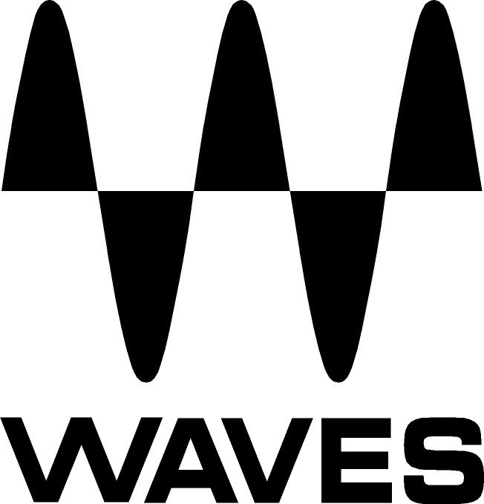

PRESS RELEASE
Contact: Clyne Media, Inc.
Tel: (615) 662-1616
Fax: (615) 662-1636

FOR IMMEDIATE RELEASE

Waves Audio Introduces H-EQ Hybrid Equalizer

131st AES CONVENTION, NEW YORK, NY, October 21, 2011 — Waves Audio (booth 728), the industry-leading developer of professional audio digital signal processing technologies and the recipient of a 2011 Technical GRAMMY® Award, announces its H-EQ Hybrid Equalizer. H-EQ is a uniquely powerful plugin for mixing and mastering, featuring vintage and modern EQ inspired by the finest British and American consoles.

Included are seven different filter types per band: US Vintage, UK Vintage 1, UK Vintage 2, US Modern, UK Modern, Digital 1 and Digital 2, in addition to a newly-developed, one-of-a-kind asymmetrical bell filter. An intuitive keyboard graphic lets users choose frequencies by clicking on notes, and an exclusive MS Mode allows users to apply different EQ to Mid and Side content. Also featured is a flexible real-time frequency spectrum analyzer with multiple display options.

Waves H-EQ is now available at a U.S. MSRP of Native $200/ TDM $300. Special intro price is Native $99/ TDM $149. It is also available at no additional charge to owners of Waves Mercury with current Waves Update Plan coverage.

...ends 169 words
Photo File: Waves_HEQ_Screenshot.JPG

About Waves Ltd.:
From its start in the early '90s with the introduction of the Q10 equalizer plugin, Waves, a leading provider of audio DSP solutions for professional, broadcast, and consumer electronics audio markets, has gone on to develop a comprehensive line of over 100 audio plugins including industry standards like the L1 and L2 Ultramaximizers, popular vintage console models, and innovative mixing tools like Vocal Rider and the Artist Signature Series. For its accomplishments, in 2011 Waves received a Technical GRAMMY®, and the Q10 was selected as an inductee into the TECnology Hall of Fame. Waves technologies are now used to improve sound quality in virtually every sector of the audio market, from recording, mixing, mastering and post production to broadcast, live sound, and consumer electronics. Waves has over 15 years of expertise in the development of psycho-acoustic signal processing algorithms that leverage knowledge on the human perception of hearing to radically improve perceived sound quality. Waves’ award-winning processors are utilized to improve sound quality in the creation of hit records, major motion pictures, and popular video games worldwide. Waves offers computer software solutions, as well as hardware-plus-software solutions, for the professional and broadcast markets. Under its Maxx brand, Waves offers semiconductor and licensable algorithms for consumer electronics applications. Waves’ Maxx technologies dramatically enhance audio performance and are used by industry leaders such as Dell, Sony, Sanyo, JVC, Toshiba, and many others. For more information, visit the Waves web site at http://www.waves.com.

All other product names and trademarks are the property of their respective owners, which are in no way associated or affiliated with Waves.

Waves Contacts:
North America Offices:
Waves, Inc., 2800 Merchants Drive, Knoxville, TN 37912;
Tel: 865-909-9200, Fax: 865-909-9245, Email: info@waves.com, Web: http://www.waves.com

Corporate Headquarters Israel:
Waves Ltd., Azrieli Center, The Triangle Tower, 32nd Floor
Tel Aviv 67023, Israel; Tel: 972-3-608-4000, Fax: 972-3-608-4056, Email: info@waves.com,
Web: http://www.waves.com

Waves Public Relations:
Clyne Media, Inc., 169-B Belle Forest Circle, Nashville, TN 37221;
Tel: 615-662-1616, Fax: 615-662-1636, Email: robert@clynemedia.com,
Web: http://www.clynemedia.com

Waves is exhibiting at booth 728 at AES 2011 in New York, NY.

