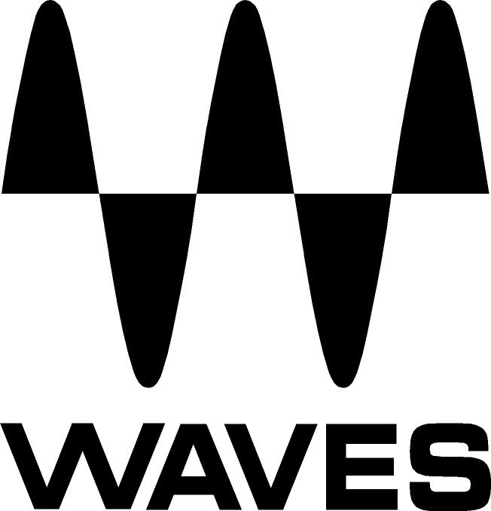

PRESS RELEASE
Contact: Clyne Media, Inc.
Tel: (615) 662-1616
Fax: (615) 662-1636

FOR IMMEDIATE RELEASE

Waves Audio and Phil Manchester Launch

New Audio Forensics Package

— New plugin bundle is ideally suited for law enforcement agencies to use covert audio evidence to fight crime and terrorism —

131st AES CONVENTION, NEW YORK, NY, October 21, 2011 — Waves Audio (booth 728), the world’s leading developer of professional audio signal processing technologies and recipients of a 2011 Technical GRAMMY® award, in association with international covert audio specialist Phil Manchester, announces the release of the Phil Manchester / Waves Audio Forensics Package. A collection of nine audio plugins chosen especially for their precision in covert audio investigation, this package is ideally suited for law enforcement agencies.

Covert audio evidence, made possible by Waves plugins, was an indispensable part of the prosecution’s case against Parviz Khan and four others convicted in an infamous 2007 plot to kill a British Muslim soldier. “Waves Audio tools are used to identify, restore and evidentially provide critical audio for bringing to justice those responsible for high level criminality,” stated Phil Manchester. “Thanks to Waves, I was able to succeed where other law enforcement agencies had failed.”

The Phil Manchester / Waves Audio Forensics Package includes:
1. W43 Noise Reduction Plugin
2. X-Noise
3. X-Crackle
4. X-Hum
5. X-Click
6. C1 Compressor/Expander
7. Q10 Paragraphic Equalizer
8. PAZ Frequency Analyzer
9. L1 Ultramaximizer™

With over 20 years of technical experience as an international covert audio specialist, Phil Manchester is the originator of the West Midlands Police Forensic Audio Laboratory and currently the only full time covert audio specialist in the U.K. Working with law enforcement and military agencies, Manchester has conducted audio forensics on more than 750 major criminal investigations involving national security, counter-terrorism, murder, kidnap, international drug smuggling and other serious criminal offenses. One of 30 technical specialists serving on the Audio Engineering Society’s Technical Committee on Audio Forensics, he has served as a forensic audio consultant to U.K. Police Forces, Serious Organized Crime Agencies, government agencies, international police forces and other law enforcement agencies, as well as associated forensic audio and speech specialists.

For more information, please visit www.waves.com.
...ends 308 words

Photo File: Waves_Forensics_Box.JPG

About Waves Ltd.:
From its start in the early '90s with the introduction of the Q10 equalizer plugin, Waves, a leading provider of audio DSP solutions for professional, broadcast, and consumer electronics audio markets, has gone on to develop a comprehensive line of over 100 audio plugins including industry standards like the L1 and L2 Ultramaximizers, popular vintage console models, and innovative mixing tools like Vocal Rider and the Artist Signature Series. For its accomplishments, in 2011 Waves received a Technical GRAMMY®, and the Q10 was selected as an inductee into the TECnology Hall of Fame. Waves technologies are now used to improve sound quality in virtually every sector of the audio market, from recording, mixing, mastering and post production to broadcast, live sound, and consumer electronics. Waves has over 15 years of expertise in the development of psycho-acoustic signal processing algorithms that leverage knowledge on the human perception of hearing to radically improve perceived sound quality. Waves’ award-winning processors are utilized to improve sound quality in the creation of hit records, major motion pictures, and popular video games worldwide. Waves offers computer software solutions, as well as hardware-plus-software solutions, for the professional and broadcast markets. Under its Maxx brand, Waves offers semiconductor and licensable algorithms for consumer electronics applications. Waves’ Maxx technologies dramatically enhance audio performance and are used by industry leaders such as Sony, Sanyo, JVC, Toshiba, and many others. For more information, visit the Waves web site at http://www.waves.com.

All other product names and trademarks are the property of their respective owners, which are in no way associated or affiliated with Waves.

Waves Contacts:
North America Offices:
Waves, Inc., 2800 Merchants Drive, Knoxville, TN 37912;
Tel: 865-909-9200, Fax: 865-909-9245, Email: info@waves.com, Web: http://www.waves.com

Corporate Headquarters Israel:
Waves Ltd., Azrieli Center, The Triangle Tower, 32nd Floor
Tel Aviv 67023, Israel; Tel: 972-3-608-4000, Fax: 972-3-608-4056, Email: info@waves.com,
Web: http://www.waves.com

Waves Public Relations:
Clyne Media, Inc., 169-B Belle Forest Circle, Nashville, TN 37221;
Tel: 615-662-1616, Fax: 615-662-1636, Email: robert@clynemedia.com,
Web: http://www.clynemedia.com

Waves is exhibiting at booth 728 at AES 2011 in New York, NY.

