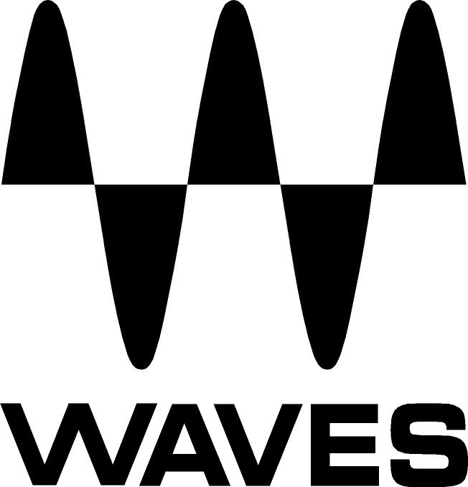

PRESS RELEASE
Contact: Clyne Media, Inc.
Tel: (615) 662-1616
Fax: (615) 662-1636

FOR IMMEDIATE RELEASE

Waves Audio Unveils Bass Rider

131st AES CONVENTION, NEW YORK, NY, October 21, 2011 — Waves Audio (booth 728), the industry-leading developer of professional audio digital signal processing technologies and the recipient of a 2011 Technical GRAMMY® Award, unveils its Bass Rider, an innovative, easy-to-use plugin that rides bass levels automatically. A companion to Waves’ popular Vocal Rider plugin, Bass Rider delivers perfect bass levels, without changing the natural sound of users’ bass. Optimized especially for the frequency range and envelope characteristics of bass instruments, Bass Rider covers all the “basses”: DI, amplified, acoustic, synth, upright, etc.

A real timesaver with dedicated studio and live components, Bass Rider keeps bass levels in check and solid throughout a mix. Unlike a compressor, Bass Rider works note by note, without disturbing their inner dynamics, so they sustain and decay naturally. Best of all, since Bass Rider keeps levels steady with automatic gain adjustment, now users can focus on the feel and flow of their bass, and use compression if desired to add color and character.

Features:
- Rides bass levels automatically
- Optimized for bass instruments
- Retains the natural character of the bass
- Dedicated studio and live components
- Up to 24-bit 192kHz resolution
- Mono and Stereo components
- Supports TDM, RTAS, Audio Suite, VST, AU
- PC- and Mac®-compatible

Controls:
- Target Energy Meter shows the energy of the input signal.
- Target Slider sets the desired bass level range and calibrates the Rider Fader “0” position.
- Sensitivity controls the note detector sensitivity.
- Response controls the note detector response.
- Spill controls the amount of spill that the detector should ignore.
- Artifacts controls the note detector’s tolerance to artifacts.
- Max Range sets the upper boundary of the Rider Fader movement.
- Min Range sets the lower boundary of the Rider Fader movement.
- Rider Fader is Bass Rider’s automatic fader control.
- Output trims the vocal output gain, post-auto riding.
- Idle Arrow sets the Rider Fader value when there is no bass activity.
- Effective Range displays the total gain range available for automatic riding.

Waves Bass Rider is now available at a U.S. MSRP of Native $200/TDM $300. Special intro price is Native $99/TDM $149. It is also available at no additional charge to owners of Waves Mercury with current Waves Update Plan coverage. For more information, please visit www.waves.com.
...ends 384 words

Photo File: Waves_BassRider_Screenshot.JPG

About Waves Ltd.:
From its start in the early '90s with the introduction of the Q10 equalizer plugin, Waves, a leading provider of audio DSP solutions for professional, broadcast, and consumer electronics audio markets, has gone on to develop a comprehensive line of over 100 audio plugins including industry standards like the L1 and L2 Ultramaximizers, popular vintage console models, and innovative mixing tools like Vocal Rider and the Artist Signature Series. For its accomplishments, in 2011 Waves received a Technical GRAMMY®, and the Q10 was selected as an inductee into the TECnology Hall of Fame. Waves technologies are now used to improve sound quality in virtually every sector of the audio market, from recording, mixing, mastering and post production to broadcast, live sound, and consumer electronics. Waves has over 15 years of expertise in the development of psycho-acoustic signal processing algorithms that leverage knowledge on the human perception of hearing to radically improve perceived sound quality. Waves’ award-winning processors are utilized to improve sound quality in the creation of hit records, major motion pictures, and popular video games worldwide. Waves offers computer software solutions, as well as hardware-plus-software solutions, for the professional and broadcast markets. Under its Maxx brand, Waves offers semiconductor and licensable algorithms for consumer electronics applications. Waves’ Maxx technologies dramatically enhance audio performance and are used by industry leaders such as Dell, Sony, Sanyo, JVC, Toshiba, and many others. For more information, visit the Waves web site at http://www.waves.com.

All other product names and trademarks are the property of their respective owners, which are in no way associated or affiliated with Waves.

Waves Contacts:
North America Offices:
Waves, Inc., 2800 Merchants Drive, Knoxville, TN 37912;
Tel: 865-909-9200, Fax: 865-909-9245, Email: info@waves.com, Web: http://www.waves.com

Corporate Headquarters Israel:
Waves Ltd., Azrieli Center, The Triangle Tower, 32nd Floor
Tel Aviv 67023, Israel; Tel: 972-3-608-4000, Fax: 972-3-608-4056, Email: info@waves.com,
Web: http://www.waves.com

Waves Public Relations:
Clyne Media, Inc., 169-B Belle Forest Circle, Nashville, TN 37221;
Tel: 615-662-1616, Fax: 615-662-1636, Email: robert@clynemedia.com,
Web: http://www.clynemedia.com

Waves is exhibiting at booth 728 at AES 2011 in New York, NY.

