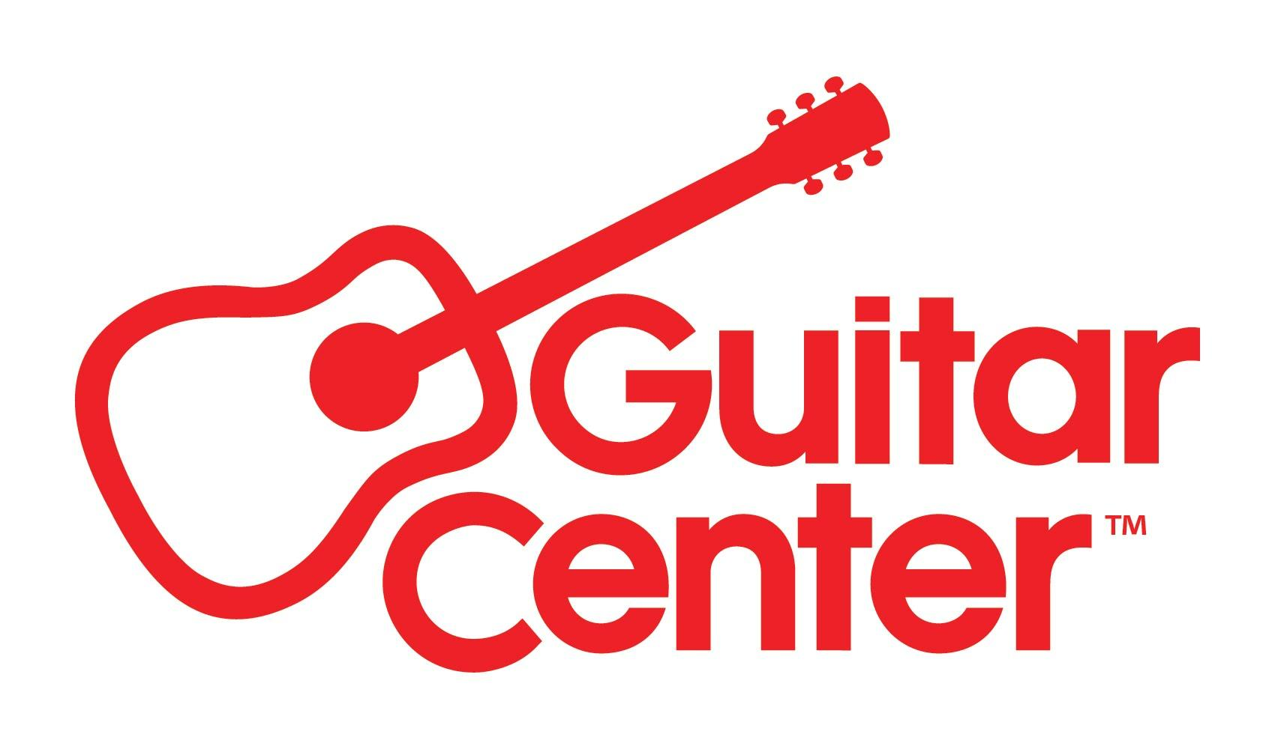

FOR IMMEDIATE RELEASE

82 Percent of Parents Want Their Kids to Learn to Play a Musical Instrument, According to New Survey Spearheaded by Guitar Center

In a poll conducted in coordination with World Music Day, several interesting facts emerge about music education, including instrument preferences of both parents and children themselves

Westlake Village, CA, August 7, 2022 – Guitar Center, the world’s largest musical instrument retailer, has shared the results of a survey on music education conducted in coordination with World Music Day. The survey found that 82% of current and would-be parents think it’s important that their child learn to play an instrument, with the most popular preferences being piano (18%), drums (17%) and violin (16%). But the top instrument kids actually want to learn is the electric guitar, according to their parents (22%).

The study, conducted by OnePoll on behalf of Guitar Center, also showed that 29% of respondents think music education should be required or prioritized in schools, and another 26% believe that music education should be encouraged, for a total of 55% showing support for an increase in music education as part of school curriculum.

“Music education creates lifelong benefits that can enrich a child’s life, including increased social skills to higher levels of confidence and self-esteem,” said Donny Gruendler, VP of Education at Guitar Center. “From the guitar to the drums, it doesn’t matter what instrument a child learns to play— the experience will allow them to cultivate their identity and kindle a life-long passion for learning.”

The survey also suggests that only one out of every four Americans (24%) can play an instrument — although 17% have picked one back up during the pandemic, and 13% would be interested in learning piano. Out of those surveyed with prior music experience, 37% said they don’t currently play anything, implying that they may have given up on their instrument of choice.

Compared to their adult counterparts, children today seem even more agreeable to the idea of learning instruments; according to parents polled, only 9% haven’t yet expressed any interest. “The survey further substantiates that people have a desire to learn music, and this desire is so powerful that they even want their child to learn,” said Gruendler. Learning to play an instrument doesn’t have to be boring or intimidating, especially if you’re learning your favorite songs at your own pace with instructors who are personalizing each of your lessons.”

For information on Guitar Center’s Lessons program and the benefits of learning to play an instrument, visit Guitarcenter.com/Services/Lessons.

Survey methodology:
This random double-opt-in survey of 1,000 general population Americans and 1,000 who’ve played instruments was commissioned by Guitar Center between June 6 and June 8, 2022. It was conducted by market research company OnePoll, whose team members are members of the Market Research Society and have corporate membership to the American Association for Public Opinion Research (AAPOR) and the European Society for Opinion and Marketing Research (ESOMAR).

###

Photo file 1: Survey_infographic.JPG
Photo caption 1: An overview of some of the results of the new survey polling 2,000 Americans about their thoughts on music education

About Guitar Center:
Guitar Center is a leading retailer of musical instruments, lessons, repairs and rentals in the U.S. With nearly 300 stores across the U.S. and one of the top direct sales websites in the industry, Guitar Center has helped people make music for more than 50 years. Guitar Center also provides customers with various musician-based services, including Guitar Center Lessons, where musicians of all ages and skill levels can learn to play a variety of instruments in many music genres; GC Repairs, an on-site maintenance and repairs service; and GC Rentals, a program offering easy rentals of instruments and other sound reinforcement gear. Additionally, Guitar Center’s sister brands include Music & Arts, which operates more than 200 stores specializing in band & orchestral instruments for sale and rental, serving teachers, band directors, college professors and students, and Musician’s Friend, a leading direct marketer of musical instruments in the United States. For more information about Guitar Center, please visit www.guitarcenter.com.

FOR MORE INFORMATION PLEASE CONTACT:
Clyne Media | pr@clynemedia.com
Guitar Center| media@guitarcenter.com

