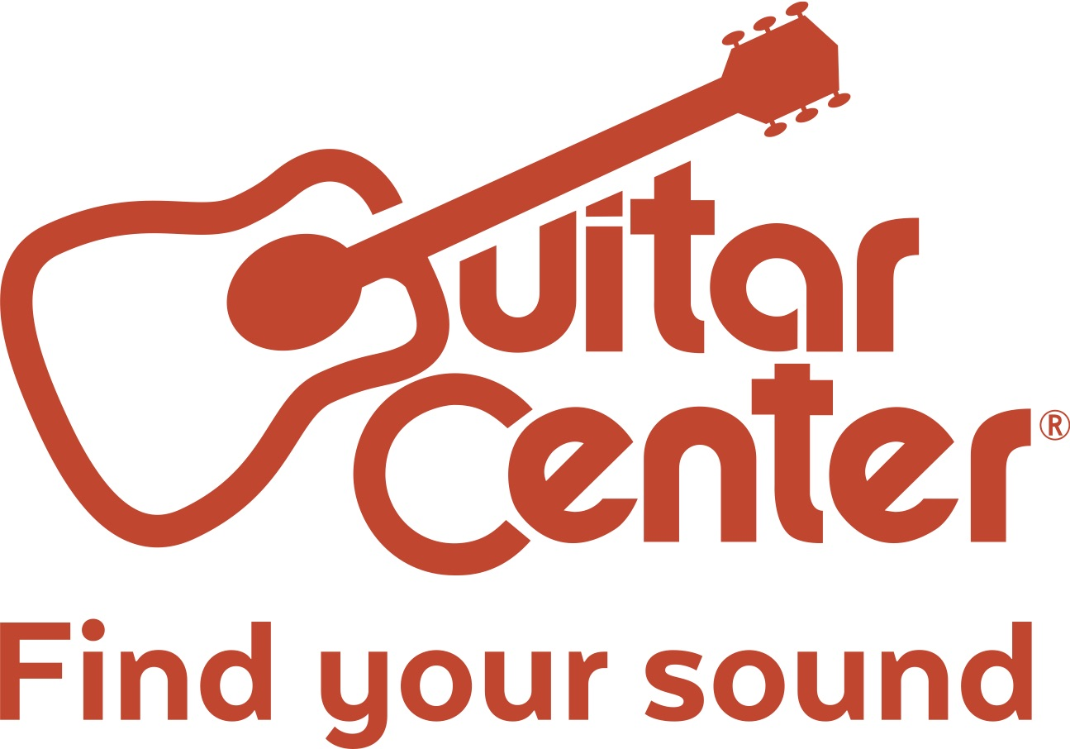

Guitar Center Opens in Laurel, MD, and the Willowbrook District of Houston, TX

The new locations offer services such as on-site lessons, repairs, free workshops, and more to meet any music-related need

Westlake Village, CA (Monday, October 2) – Guitar Center, the world’s largest instrument retailer, recently opened its latest retail locations – a 15,325-square-foot facility in the Willowbrook area of Houston, Texas (21503 Hwy 249, Houston, TX 77070), and a 12,000-square-foot facility in Laurel, Maryland (14804 Baltimore Ave., Laurel, MD 20707). Both stores offer an expansive set of services and gear to serve the music needs of their respective communities. Both grand openings took place on Thursday, September 21.

These new stores feature modern showrooms equipped with the latest products for musicians — from guitars, amplifiers, percussion instruments and keyboards to live sound, DJ, lighting and recording equipment. Customer services include Guitar Center Lessons (in-house, state-of-the-art music academies for players of all ages and skill levels), GC Repairs (on-site maintenance and repairs service), GC Rentals (offering easy rentals of instruments and other gear) and Guitar Center Workshops (offering free introductory classes and instruction on guitar, ukulele, and recording). Willowbrook and Laurel shoppers are also able to enjoy Guitar Center’s multi-channel “endless aisle,” which gives customers the ability to combine in-store, online and phone options to purchase music equipment from anywhere.

Guitar Center Willowbrook and Laurel both have the same store and studio hours:
Monday – Friday 10:00 a.m. – 9:00 p.m.
Saturday 10:00 a.m. – 8:00 p.m.
Sunday 11:00 a.m. – 7:00 p.m.

About Guitar Center:
Guitar Center is the world’s largest retailer of guitars, amplifiers, drums, keyboards, recording, live sound, DJ and lighting equipment. With more than 280 stores across the U.S. and one of the top direct sales websites in the industry, Guitar Center has helped people make music for more than 50 years. Guitar Center also provides customers with various musician based services, including Guitar Center Lessons, where musicians of all ages and skill levels can learn to play a variety of instruments in many music genres; GC Repairs, an on-site maintenance and repairs service; and GC Rentals, a program offering easy rentals of instruments and other sound reinforcement gear. Additionally, Guitar Center’s sister brands include Music & Arts, which operates more than 150 stores specializing in band & orchestral instruments for sale and rental, serving teachers, band directors, college professors and students, and Musician’s Friend, a leading direct marketer of musical instruments in the United States. With an unrivalled in-store experience, an industry-leading online presence and passionate commitment to making gear easy-to-buy, Guitar Center is all about enabling musicians and non-musicians alike to experience the almost indescribable joy that comes from playing an instrument. For more information about Guitar Center, please visit www.guitarcenter.com.

FOR MORE INFORMATION PLEASE CONTACT:
Robert Clyne | Clyne Media, Inc. | 615-662-1616 | Robert@clynemedia.com
Marisa Bettencourt | Praytell Agency | 925.817.0596 | GCPR@praytellagency.com
Syvetril Perryman | Guitar Center | 818.735.8800 | media@guitarcenter.com

