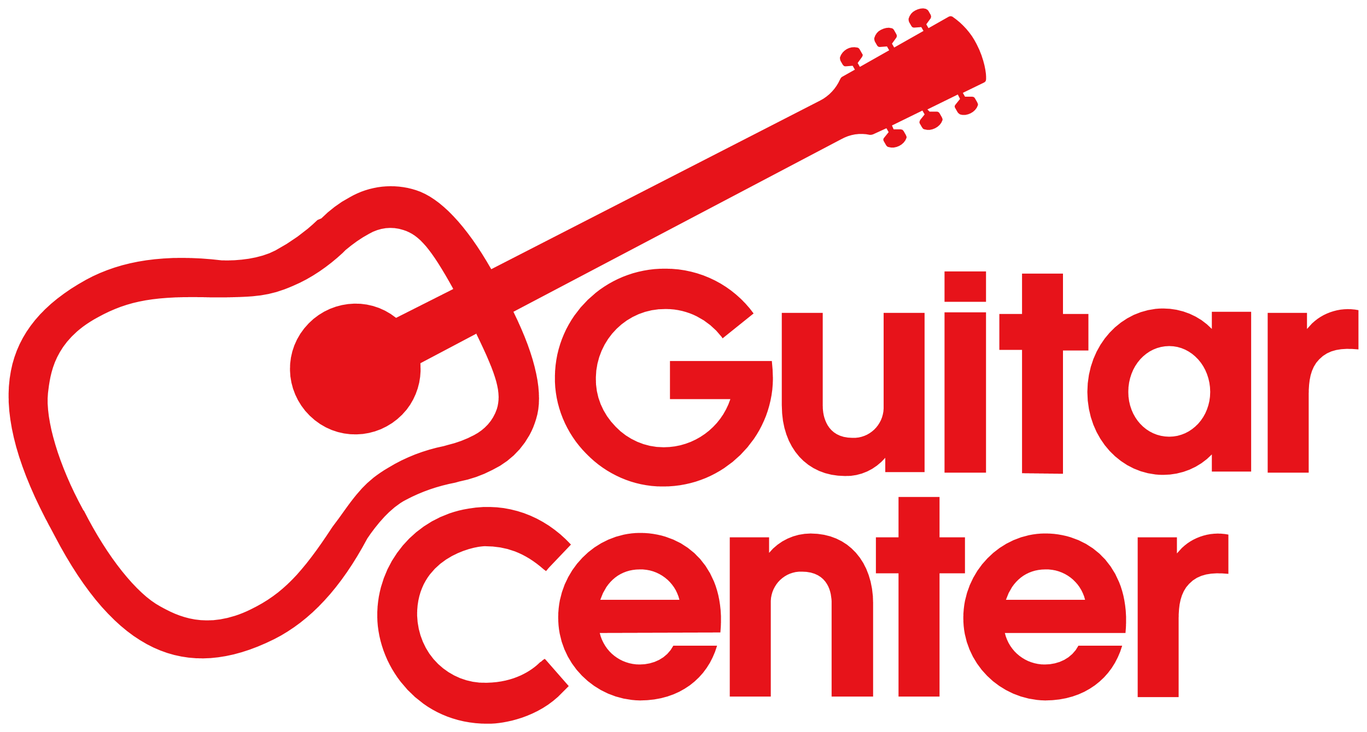

**From the desk of Gabe Dalporto, CEO of Guitar Center**

Like many of you, I’m heartbroken by the widespread devastation caused by the wildfires in Los Angeles. I also know that rebuilding will take time and will require an army of support, compassion, and unity from not just from the LA community, but from caring people across the country and across the globe.

At Guitar Center, we are committed to standing with our colleagues and their communities every step of the way to be a catalyst to keep the music going.  So, here’s what we’re doing:

* Collaborating with and coordinating contributions from the Guitar Center Music Foundation (GCMF), NAMM, and nearly 20 leading instrument brands to help bring free replacement instruments and other aid to local musicians and music programs.
* Amplifying our collective impact by launching a Round Up campaign through March 31, whereby musicians can round up their purchase at all Guitar Center stores, and online to the nearest dollar, and donations will go toward assisting affected LA communities.
* Providing easy ways for Guitar Center customers to make additional contributions to help musicians in need.

If you’d like to help in the relief effort, donations can also be made directly to the Foundation [HERE](https://communications.guitarcenter.com/PoliteMail/default.aspx?page=bsvklUQHdEWbOYbN97rwEw&ref_id=lCYkQ1yFiUugi-0LOnvuFA). Select “Disaster Relief” to properly designate the funds.

For more details and how to apply for a grant, please visit <http://guitarcenterfoundation.org/fires/>.

We encourage everyone to help spread the word to people impacted by the fires about the grants and replacement instrument program.

Together, we will work to help rebuild the LA music community, replace what has been lost, and provide strength to those who need it most. It’s truly inspiring to see our industry come together to help people in need.

With heartfelt gratitude, 

**Gabe Dalporto**

CEO, Guitar Center