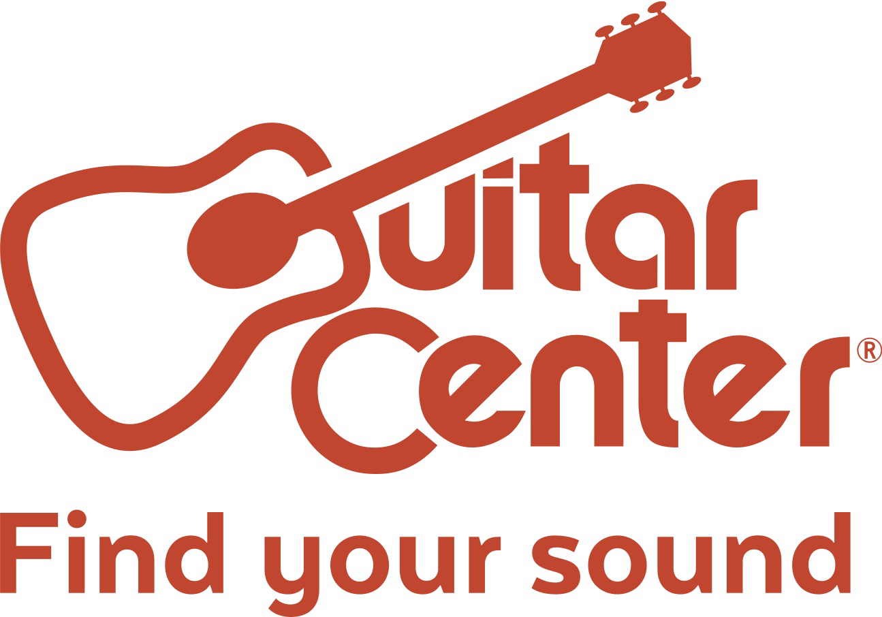

Guitar Center Announces Inaugural Partnership with the 2020 Winter Music Conference and Miami Music Week

World's largest musical instrument retailer launches electronic music marketing initiative with signature popup store, rental program and more.

Westlake Village, CA (January 14, 2020) – Guitar Center, the world’s largest musical instrument retailer, announces its partnership with the 2020 Winter Music Conference (WMC) and Miami Music Week (MMW), as the official music instrument retailer of the world-renowned electronic music conference and event series.

The 35th Annual Winter Music Conference returns this March 16-19 to Miami's Faena District Resort, and Guitar Center will be bringing its signature popup store to Miami (at the Faena Forum), allowing guests to review, demo, and purchase the latest DJ equipment and products from brands such as Pioneer, Roland, Korg, Native Instruments, Denon, and several others. Following product announcements at The NAMM Show this January 16-19 in Los Angeles, Winter Music Conference will be the first opportunity for fans to purchase the latest DJ and production equipment/software to hit the market. WMC badge-holders will be able to experience the popup store before anyone else, with an exclusive window prior to the store opening up to the public. Guitar Center will also sponsor Winter Music Conference's official opening party on Monday, March 16.

Guitar Center will also partner with the 10th Annual Miami Music Week’s new Oasis at the Miami Generator just steps away from the main hub of WMC. The MMW Oasis is a five-day industry retreat taking place from March 16-20, hosting exclusive pool parties, label showcases, an artist gifting and media lounge, workshops, yoga, daytime barbecues, and more. The MMW Oasis will be open to WMC badge holders and by invitation only.

Jeannine Davis D'Addario, Guitar Center's Chief Marketing and Communications Officer, says, “We’re excited to partner with both the Winter Music Conference and Miami Music Week for the first time this year. As a premier Omni-channel resource for the latest gear for electronic music artists, we are thrilled to debut the industry's top DJ music production equipment and software all week to music producers, artists, and fans at the country’s leading electronic music industry conference.”

David Ireland, Executive Director for Winter Music Conference, says, “We are extremely excited to be working with Guitar Center for the 35th edition of the WMC and the 10th year of MMW. Our badge holders will be getting exclusive access to some of the best new DJ and production gear on the market, along with cutting edge educational programming and events with some of today’s most exciting talent. This partnership will provide a one-of-a-kind experience for our attendees that perfectly reflects the new vision of the Winter Music Conference.”

In addition, Guitar Center will provide a local DJ equipment and lighting rental service, allowing venues, promoters and artists to rent gear from Guitar Center’s South Florida locations in Hallandale Beach and South Miami.

To manage event attendance and data retention, Guitar Center has partnered with leading global ticketing company See Tickets to power RSVP and ticketing for Guitar Center’s experiential activations and week-long sponsored events and showcases.

Guitar Center’s overall program in Miami is developed by North American entertainment marketing & PR firm UG Strategies, and in addition to managing all experiential and sponsorship activations, UGS will lead artist relations, creative direction, and publicity for the brand.

###

FOR MORE INFORMATION PLEASE CONTACT:

Edelman | GuitarCenter@edelman.com
Clyne Media | Robert Clyne | Robert@clynemedia.com
Guitar Center | media@guitarcenter.com
UGS | Parag Bhandari | parag@ugstrategies.com
Winter Music Conference | Kelsi Ring | kelsi@infamouspr.com

ABOUT GUITAR CENTER:
Guitar Center is a leading retailer of musical instruments, lessons, repairs and rentals in the U.S. With nearly 300 stores across the U.S. and one of the top direct sales websites in the industry, Guitar Center has helped people make music for more than 50 years. Guitar Center also provides customers with various musician-based services, including Guitar Center Lessons, where musicians of all ages and skill levels can learn to play a variety of instruments in many music genres; GC Repairs, an on-site maintenance and repairs service; and GC Rentals, a program offering easy rentals of instruments and other sound reinforcement gear. Additionally, Guitar Center’s sister brands include Music & Arts, which operates more than 200 stores specializing in band & orchestral instruments for sale and rental, serving teachers, band directors, college professors and students, and Musician’s Friend, a leading direct marketer of musical instruments in the United States. For more information about Guitar Center, please visit http://guitarcenter.com.

ABOUT WINTER MUSIC CONFERENCE:
Hailed as the longest-running conference of its kind, Winter Music Conference (WMC) will celebrate its 35th Anniversary in 2020, returning to Miami Beach's Faena District after a successful 2019 relaunch. WMC was acquired in 2018 by Ultra Worldwide, the world's most successful independent, international music festival brand. Taking a progressive approach to curating the most important conversations and cutting-edge activations in electronic music, WMC aims to bring a new generation of industry professionals and music consumers together under its four pillars: Music, Technology, Education, and Culture. Additionally, in 2020, WMC will expand its programming with the Miami Music Week (MMW) Oasis at the Generator hotel for five days of poolside parties, cocktail hours, yoga sessions, workshops, and industry networking events. The MMW Oasis is open to guests and WMC badge holders only. For more information, please visit: http://wintermusicconference.com.

ABOUT SEE TICKETS:
Founded more than 20 years ago, See Tickets is one of the leaders in the Global ticketing market, with a strong presence in Europe and the United States. See Tickets sold more than 20 million tickets in 2018 for 8,000 clients including the legendary Glastonbury Festival, Tomorrowland, White Oak Music Hall, LA Pride, BeautyAmericanaFest, Disco Donnie Presents, the Château de Versailles, CountryFest and the Queen Mary. Currently 460 people are united under the See Tickets brand in Los Angeles, Nashville, London, Paris, Berlin, Amsterdam, Madrid and others around the world. The group is a subsidiary of Vivendi, the European Media group with a global reach in content, media and communication. For more information, please visit: https://explore.seetickets.us.

