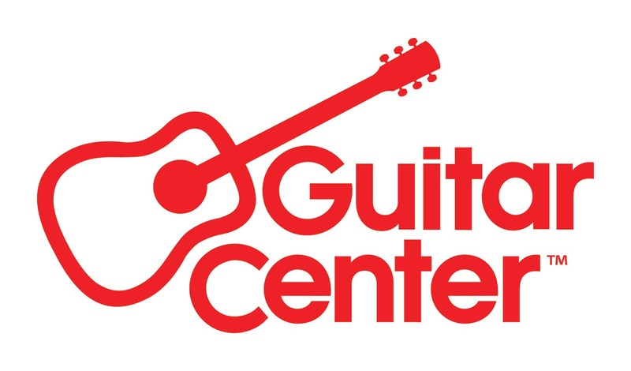

***MEDIA ALERT FOR THURSDAY, FEB 20, AND SATURDAY, FEB 22***

Guitar Center and Yamaha to host two Florida workshops with legendary rock drummer Tommy Aldridge, Feb. 20 (Orlando) and Feb. 22 (Hallandale Beach)

WHO: Guitar Center and Yamaha to partner together for two exclusive drum events with legendary hard rock and heavy metal drummer Tommy Aldridge (known for his work with Black Oak Arkansas, Pat Travers Band, Ozzy Osbourne, Gary Moore, Whitesnake, Ted Nugent, Thin Lizzy, Vinnie Moore, Yngwie Malmsteen and more).

WHAT: The events will feature conversation, hands-on demos, Q&A, autograph signing, and exclusive deals on Yamaha gear.

More about Tommy Aldridge:
Tommy Aldridge’s signature style is a rare combination of power, technique, and feel. His performing and recording credits include Black Oak Arkansas, Pat Travers, Vinnie More, Gary Moore, Ozzy Osbourne, and Whitesnake. In 1988, he was voted best rock drummer in the Modern Drummer Reader's Poll. Tommy remains very active as a clinician discussing everything from the basic fundamentals of rock drumming to the double bass fills and solos that made him famous. With his hard-hitting style, flair, and showmanship, Tommy continues to be a major influence in hard rock and heavy metal drumming.

WHEN: Orlando event: Thursday, Feb 20, 6:00 PM EST
Hallandale Beach event: Saturday, Feb 22, 3:00 PM EST

WHERE: Guitar Center Orlando
12402 S Orange Blossom Trl Suite 1
Orlando, FL 32837

Guitar Center Hallandale
1101 W Hallandale Beach Blvd
Hallandale Beach, FL 33009

Contact media@guitarcenter.com to RSVP and for additional media queries.

FOR MORE INFORMATION PLEASE CONTACT:
Clyne Media | pr@clynemedia.com
Guitar Center | media@guitarcenter.com

###

About Guitar Center:
Guitar Center is the leading retailer of musical instruments, lessons, repairs, and rentals in the U.S. With more than 300 stores across the U.S. and one of the top direct sales websites in the industry, Guitar Center has helped people make music for more than 50 years. Guitar Center also provides customers with various musician-based services, including Guitar Center Lessons, where musicians of all ages and skill levels can learn to play a variety of instruments in many music genres, GC Repairs, an on-site maintenance and repairs service, and GC Rentals, a program offering easy rentals of instruments and other sound reinforcement gear. Additionally, Guitar Center’s sister brands include Music & Arts, which operates more than 250 stores specializing in band & orchestral instruments for sale and rental, serving teachers, band directors, college professors, parents and students, and Musician’s Friend, a leading direct marketer of musical instruments in the United States. For more information about Guitar Center, please visit guitarcenter.com.

