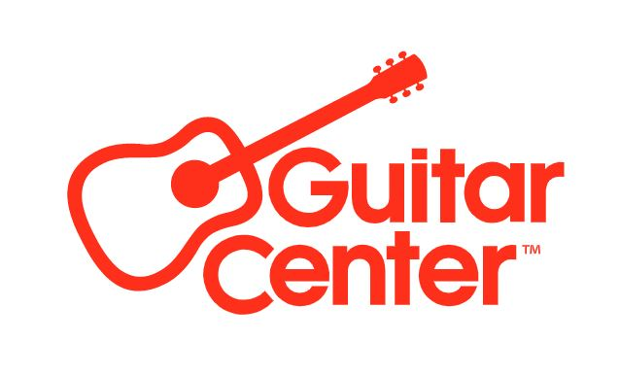

***MEDIA ALERT***

Guitar Center Lake Forest to host in-store session with Styx drummer Todd Sucherman on Wednesday, July 26

WHO: Guitar Center Lake Forest (23811 El Toro Rd A, Lake Forest, CA 92630) is hosting an in-store performance and educational event with drummer Todd Sucherman (Styx, 10-time Modern Drummer Readers Poll winner, session drummer, educator, and author).

WHAT: Mark your calendar for a special in-store event with drummer Todd Sucherman. Best known as the percussionist of legendary rock band Styx since 1996, Sucherman has performed or recorded with various artists from Brian Wilson to Spinal Tap, as well as his 2020 solo album Last Flight Home. Join Guitar Center for a performance of select songs and solos, balanced with education, stories from his exciting decades-long career in rock & roll, and a Q&A session. Sucherman will also be available to sign merchandise and meet with fans and fellow drummers. Sucherman is an endorser of the percussion brands Sabian, Remo, Pearl and ProMark, and all four brands are co-sponsoring the event.

WHEN: Wednesday, July 26, 6 pm – 9 pm PDT (Clinic from 6 – 8 pm and Q&A and photos from 8 – 9 pm)

WHERE: Guitar Center Lake Forest
23811 El Toro Rd A
Lake Forest, CA 92630
Store phone number: (949) 609-0055

###

About Guitar Center:
Guitar Center is the leading retailer of musical instruments, lessons, repairs and rentals in the U.S. With more than 300 stores across the U.S. and one of the top direct sales websites in the industry, Guitar Center has helped people make music for more than 50 years. Guitar Center also provides customers with various musician-based services, including Guitar Center Lessons, where musicians of all ages and skill levels can learn to play a variety of instruments in many music genres, GC Repairs, an on-site maintenance and repairs service, and GC Rentals, a program offering easy rentals of instruments and other sound reinforcement gear. Additionally, Guitar Center’s sister brands include Music & Arts, which operates more than 250 stores specializing in band & orchestral instruments for sale and rental, serving teachers, band directors, college professors, parents and students, and Musician’s Friend, a leading direct marketer of musical instruments in the United States. For more information about Guitar Center, please visit guitarcenter.com.

FOR MORE INFORMATION PLEASE CONTACT:
Clyne Media | pr@clynemedia.com
Guitar Center | media@guitarcenter.com

