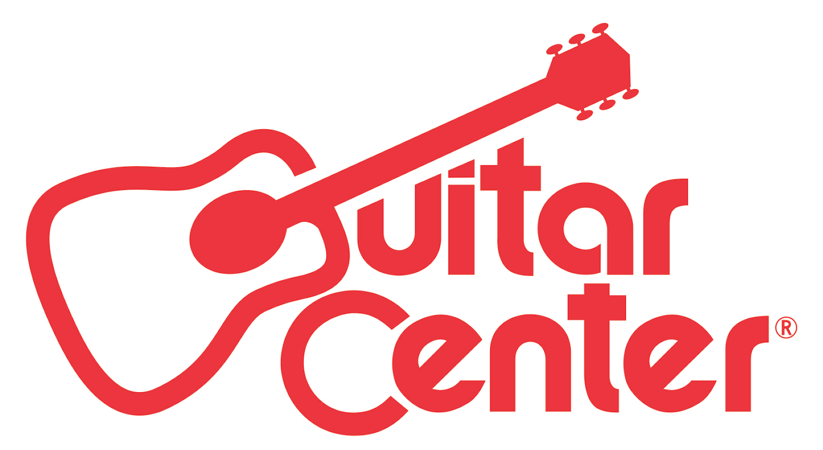

FOR IMMEDIATE RELEASE

Guitar Center Partners with Studio Automatic

ANNOUNCEMENT HIGHLIGHTS:
- Guitar Center is now the exclusive retail affiliate of Studio Automatic, a full-service online recording studio and production operation that can produce professional-quality recordings of any song submission, quickly and at affordable prices.
- Guitar Center continues to evolve, becoming the comprehensive resource for all musicians.

Los Angeles, CA (April 7, 2016): As part of its ongoing efforts to offer its customers the widest range of services possible, Guitar Center announces a new partnership with Nashville-based company Studio Automatic, a full-service online recording studio and production operation. This is the first time that Guitar Center has signed on as the exclusive retail affiliate with such a service, and it represents a new initiative for the company and expanded opportunities for its loyal customers.

With Studio Automatic, users can send in song ideas in any form (DAW or GarageBand session, iPhone recording, voice memo, etc.) and receive in return a professional-quality recording of their song at an affordable price within 5-7 business days.

Studio Automatic was created by Nashville musician, singer, songwriter and producer Zac Maloy. After 20 years in the music business (including as a founding member of iconic 90s alt-rock band The Nixons), Maloy has experienced virtually every music venture scenario imaginable. He has recorded over one hundred songs by major label artists, including Carrie Underwood, Tim McGraw, Blake Shelton, Halestorm, Daughtry, Barenaked Ladies, The Jonas Brothers and many more. The other professionals working behind-the-scenes alongside Maloy include the industry’s best music producers, session musicians, recording engineers, and audio mixing and mastering engineers, who have worked on major label albums with years of professional experience.

“Studio Automatic provides you access to top producing talent and instrumentalists – all working diligently on a polished version of YOUR song. Guitar Center is giving us an even larger platform to reach more people, and we cannot wait to help these individuals create a version of their song they can truly be proud of. We are passionate about Studio Automatic and the work we do, and we are pleased to have a stamp of approval from Guitar Center.”
– Zac Maloy, Founder of Studio Automatic

“Guitar Center continues to evolve and expand the scope of what we offer our customers. Obviously, we source instruments, tools and gear to beginners and professionals and everyone in between, and now we have moved into valuable services far beyond the basics – for example: lessons, repairs and support, and cutting-edge third-party services such as Studio Automatic. In other words, we aim to be THE comprehensive resource for all musicians, and the addition of Studio Automatic is another step in that direction. We look forward to many of our talented customers taking advantage of this powerful service.”
– Michael Amkreutz, Guitar Center Executive Vice President, Merchandising, Marketing and E-Commerce

To learn more about Studio Automatic and for a summary of production packages, visit http://www.guitarcenter.com/pages/studio-automatic.

-30-

Photo file 1: ZacMaloy_Studio.JPG
Photo caption 1: Zac Maloy, Founder of Studio Automatic, hard at work on a mix.

Photo file 2: ZacMaloy_Guitar.JPG
Photo caption 2: Zac Maloy, Founder of Studio Automatic, pictured in his studio space.

About Studio Automatic:
Studio Automatic is a full service online recording studio that allows musicians/songwriters to get a professional-quality recording of their song. Created by Nashville musician, singer, songwriter and producer, Zac Maloy, and business partner, Fred Rush III, Studio Automatic is for songwriters who want to take their music to the next level without sacrificing valuable time, money, or quality. With 20 years in the music business, Zac has lived through virtually every music business scenario imaginable. He has over one hundred songs cut by major label artists, including Carrie Underwood, Tim McGraw, Blake Shelton, Halestorm, Daughtry, Barenaked Ladies, The Jonas Brothers, Hanson, Bowling for Soup, Jake Owen and many more. The other professionals working behind the scenes alongside Zac Maloy include the industry’s best music producers, musicians, recording engineers, and audio mixing and mastering engineers, who have worked on major label albums with years of professional experience.

About Guitar Center:
Guitar Center is the world’s largest retailer of guitars, amplifiers, drums, keyboards, recording, live sound, DJ, and lighting equipment. With more than 270 stores across the U.S. and one of the top direct sales websites in the industry, Guitar Center has helped people make music for more than 50 years. In addition, Guitar Center’s sister brands includes Music & Arts, which operates more than 140 stores specializing in band & orchestral instruments for sale and rental, serving teachers, band directors, college professors and students, and Musician’s Friend, a leading direct marketer of musical instruments in the United States. With an unrivaled in-store experience, an industry-leading online presence and passionate commitment to making gear easy-to-buy, Guitar Center is all about enabling musicians and non-musicians alike to experience the almost indescribable joy that comes from playing an instrument. For more information about Guitar Center, please visit www.guitarcenter.com.

You can visit our press room at http://www.guitarcenter.com/pages/press-room and send media inquiries to media@guitarcenter.com.

FOR MORE INFORMATION PLEASE CONTACT:
Natania Reed | ANTHEMIC Agency | 323.464.4745 x 806 | natania@anthemicagency.com
Robert Clyne | Clyne Media, Inc. | 615.662.1616 | Robert@clynemedia.com
Syvetril Perryman | Guitar Center | 818.735.8800 | media@guitarcenter.com

