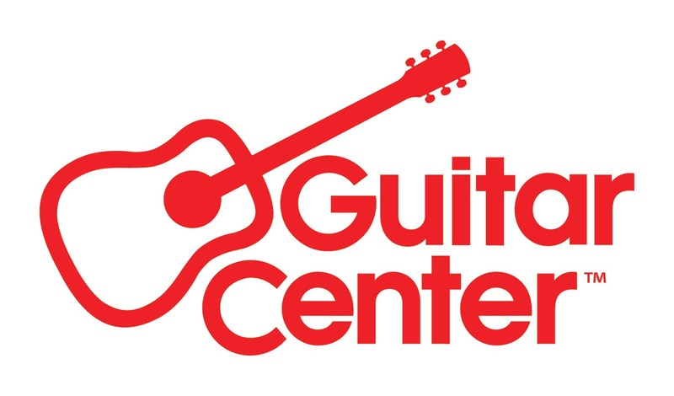

***MEDIA ALERT ***

RSVP now: Guitar Center and She Is The Music to celebrate Women’s History Month with “Women on Record” panel event at GC Hollywood on Tuesday, March 25, 2025

RSVP now at https://www.guitarcenter.com/She-Is-The-Music.gc

WHO: She Is The Music and Guitar Center hosting panel featuring Ann Mincieli (GRAMMY®-winning engineer & producer, Jungle City Studios owner & She Is The Music cofounder), TOKiMONSTA (GRAMMY-nominated producer, genre-blending DJ & founder of Young Art Records) and NOVA WAV (the GRAMMY-winning production and songwriting duo of Blue June & Chi), with a special guest moderator to be announced.

WHAT: In honor of Women’s History Month and the trailblazing musicians who are reshaping the industry with innovation and fresh perspectives, Guitar Center, in partnership with She Is The Music, proudly presents Women on Record—a special event dedicated to celebrating female-identifying artists and professionals in the recording arts. This exclusive panel discussion will be held at Guitar Center’s flagship Hollywood location on Tuesday, March 25, 2025, bringing together a distinguished lineup of industry leaders, recording engineers, producers, and artists who are redefining the sound and culture of modern music. Through an engaging and thought-provoking conversation, the event will spotlight their creative journeys, challenges, and triumphs, offering invaluable insights and inspiration to the next generation of music makers. Additionally, the Guitar Center Music Foundation will be providing a $5,000.00 musical instrument grant to She Is The Music in support of their mission and music education.

WHEN: Tuesday, March 25, 2025, 6:00 PM PDT

WHERE: Guitar Center Hollywood
7425 Sunset Blvd
Los Angeles, CA 90046

Space is limited: RSVP now at https://www.guitarcenter.com/She-Is-The-Music.gc. Contact media@guitarcenter.com for additional media queries.

FOR MORE INFORMATION PLEASE CONTACT:
Clyne Media | pr@clynemedia.com
Guitar Center | media@guitarcenter.com

###

About She Is The Music:

SITM is a 501c3 nonprofit organization founded by Alicia Keys, Jody Gerson, Ann Mincieli and Sam Kirby Yoh to increase the number of women working in music – songwriters, engineers, producers, artists and industry professionals.

We are an independent, global network that operates as a unifying organization for women from across the industry, creating strength and impact on a global scale. As an umbrella nonprofit, we also provide resources and support for women-focused initiatives that are working to create meaningful change – both through our own programs, as well as external efforts around the world.

Our programs include global all-women songwriting sessions, mentorship and education programs, and the largest industry database of women creators. Our initiatives serve women in the industry today while fostering the development of future generations.

www.sheisthemusic.org

About Guitar Center:
Guitar Center is the leading retailer of musical instruments, lessons, repairs, and rentals in the U.S. With more than 300 stores across the U.S. and one of the top direct sales websites in the industry, Guitar Center has helped people make music for more than 50 years. Guitar Center also provides customers with various musician-based services, including Guitar Center Lessons, where musicians of all ages and skill levels can learn to play a variety of instruments in many music genres, GC Repairs, an on-site maintenance and repairs service, and GC Rentals, a program offering easy rentals of instruments and other sound reinforcement gear. Additionally, Guitar Center’s sister brands include Music & Arts, which operates more than 250 stores specializing in band & orchestral instruments for sale and rental, serving teachers, band directors, college professors, parents and students, and Musician’s Friend, a leading direct marketer of musical instruments in the United States. For more information about Guitar Center, please visit guitarcenter.com.

PDF file: GC_SITM_WomensPanel_Mar25.pdf
PDF caption: Promotional graphics for Guitar Center and She Is The Music’s “Women on Record” panel event at GC Hollywood on Tuesday, March 25, 2025.

