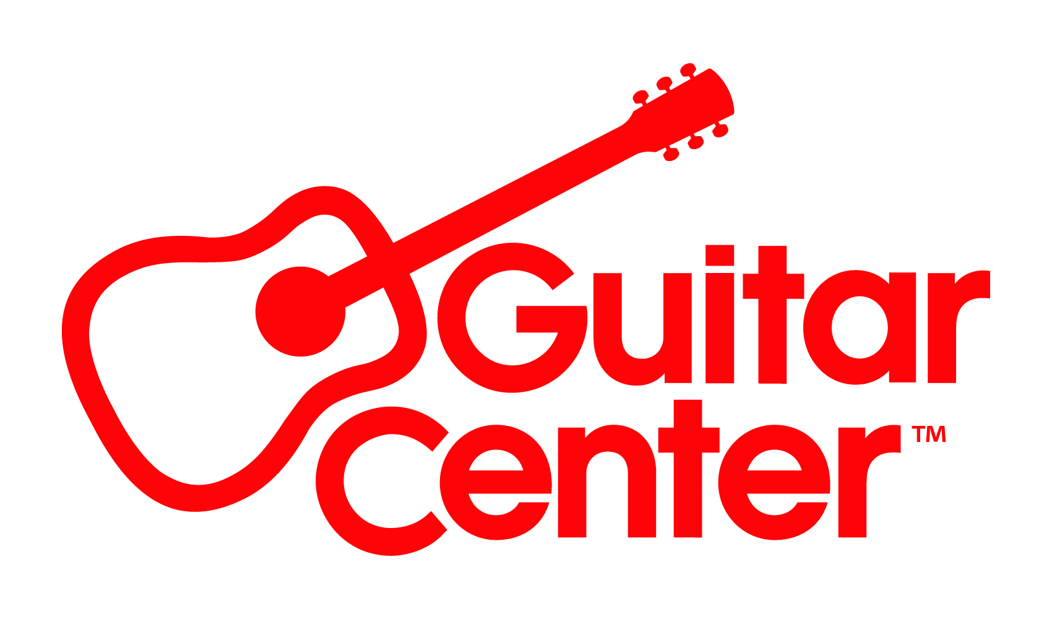
Guitar Center Appoints Rich Hoalst Executive Vice President and Chief Customer Officer

Newly created position realigns marketing and eCommerce into one administrative team

Westlake Village, CA (August 17, 2022) – Guitar Center, the world’s largest musical instrument retailer, announces the appointment of Rich Hoalst to the position Executive Vice President and Chief Customer Officer. As a member of the Management Committee, Hoalst will report directly to Ron Japinga, President and CEO. This newly created position represents an organizational realignment for Guitar Center Inc., in which all marketing and eCommerce activities will be combined into one administrative team. The appointment furthers Guitar Center’s ongoing endeavors toward assembling highly effective executive teams while ensuring the market is receiving one unified message.

In his new role, Hoalst will oversee Guitar Center corporate marketing and public relations; CRM for all brands company-wide; performance marketing; brand marketing and creative for Guitar Center and Musician’s Friend; eCommerce and contact center operations for Musician’s Friend and Guitar Center; and the refinement and maintenance of the seamless consumer journey for Guitar Center and Musician’s Friend.

Hoalst joins the company with more than 25 years’ experience as a global, multi-channel executive with an extensive background in retail merchandising and eCommerce across iconic brands. He brings a highly successful track record of creating elevated retail experiences, both physical and digital, in ways that serve consumers and drive financial performance. Most recently, Hoalst was Senior Vice President – Pharmacy, Drugstore, Beauty, General Merchandise, Health & Wellness, at H-E-B, a privately held supermarket chain with stores throughout Texas and northeast Mexico. Here he reinvented the non-food businesses and created a successful health & wellness strategy. Prior to H-E-B, Hoalst was Vice President/General Manager, eCommerce, Nike, Inc., North America, where he was responsible for the full digital commerce across all devices and apps for Nike, Jordan, Converse and Hurley. Earlier in his career, he held positions with Kohls and Fred Meyer.

“I am incredibly excited to join such a great organization and learn from everyone to help continue to move the business forward. I find great enjoyment in guiding organizations to the next level of growth, efficiency, and profitability,” said Hoalst. “Throughout my career, I have prided myself in leading teams that work to serve the ever-changing needs of the customer, take risks, and pursue innovations and will utilize this expertise further as we continue to grow Guitar Center.”

“We are thrilled to add Rich to our executive team and combine the marketing and eCommerce departments into one super task force with a unified message,” said Japinga. “Rich has the perspective and deep experience to grow the brand and help our organization navigate the future and I look forward to serving the industry and our customers together.”

For more information, visit GuitarCenter.com or Guitar Center on Facebook, Twitter, Instagram and YouTube.

###

Photo file: RichHoalst.JPG
Photo caption: Rich Hoalst, Guitar Center Executive Vice President and Chief Customer Officer

About Guitar Center:
Guitar Center is a leading retailer of musical instruments, lessons, repairs and rentals in the U.S. With nearly 300 stores across the U.S. and one of the top direct sales websites in the industry, Guitar Center has helped people make music for more than 50 years. Guitar Center also provides customers with various musician-based services, including Guitar Center Lessons, where musicians of all ages and skill levels can learn to play a variety of instruments in many music genres; GC Repairs, an on-site maintenance and repairs service; and GC Rentals, a program offering easy rentals of instruments and other sound reinforcement gear. Additionally, Guitar Center’s sister brands include Music & Arts, which operates more than 200 stores specializing in band & orchestral instruments for sale and rental, serving teachers, band directors, college professors and students, and Musician’s Friend, a leading direct marketer of musical instruments in the United States. For more information about Guitar Center, please visit www.guitarcenter.com.

FOR MORE INFORMATION PLEASE CONTACT:
Clyne Media | pr@clynemedia.com
Guitar Center | media@guitarcenter.com
Edelman | GuitarCenter@edelman.com

