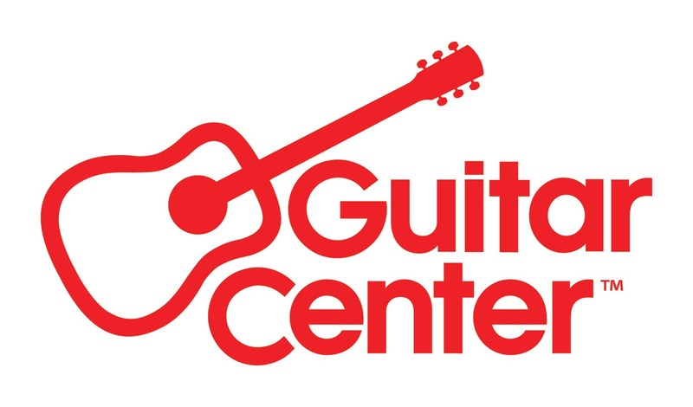

***MEDIA ALERT FOR FRIDAY, JULY 18, 2025 ***

Guitar Center and Pearl Drums to present in-store clinic with KORN drummer Ray Luzier at the Nashville Guitar Center store on July 18

WHO: Ray Luzier, drummer for KORN, appearing in person at Guitar Center Nashville, co-presented by Pearl Drums.

Ray Luzier (pronounced “Lose Ear”) has been the drummer for KORN since October 2007. Prior to joining KORN, Luzier played with Army of Anyone, featuring Robert and Dean DeLeo of Stone Temple Pilots and Richard Patrick of Filter, and spent eight years (1997–2005) touring and recording with the David Lee Roth Band. Over his career, he has collaborated with a wide range of artists including Billy Sheehan, The Nixons, Jake E. Lee, Doug Pinnick, John 5, James LoMenzo, Rafael Moreira, Slash, Seal, Kirk Hammett, Zakk Wylde, and others. Luzier is also an experienced educator and clinician, having taught at the University of Pittsburgh from 1992 to 2001 and releasing a well-regarded instructional drum DVD.

WHAT: Timed to coincide with the Music City Drum Show (July 19-20), this special event features an artist-led clinic, live performance, audience Q&A, and autograph signing with renowned KORN drummer Ray Luzier. Presented in collaboration with Nashville-based Pearl Drums and the Berry Hill neighborhood Guitar Center, the evening will also include exclusive gear demos showcasing the drum kits and equipment Luzier personally uses on stage and in the studio.

WHEN: Friday, July 18, 2025, 6:00 PM to 9:00 PM CDT

WHERE: Guitar Center Nashville
721 Thompson Lane
Nashville, TN 37204

Capacity in-store is limited, so RSVP here to reserve a spot.

Contact media@guitarcenter.com for additional media queries.

FOR MORE INFORMATION PLEASE CONTACT:
Clyne Media | pr@clynemedia.com
Guitar Center | media@guitarcenter.com

###

About Guitar Center:
Guitar Center is the leading retailer of musical instruments, lessons, repairs, and rentals in the U.S. With more than 300 stores across the U.S. and one of the top direct sales websites in the industry, Guitar Center has helped people make music for more than 60 years. Guitar Center also provides customers with various musician-based services, including Guitar Center Lessons, where musicians of all ages and skill levels can learn to play a variety of instruments in many music genres, GC Repairs, an on-site maintenance and repairs service, and GC Rentals, a program offering easy rentals of instruments and other sound reinforcement gear. Additionally, Guitar Center’s sister brands include Music & Arts, which operates more than 250 stores specializing in band & orchestral instruments for sale and rental, serving teachers, band directors, college professors, parents and students, and Musician’s Friend, a leading direct marketer of musical instruments in the United States. For more information about Guitar Center, please visit guitarcenter.com.

Photo file 1: GC_RayLuzier_Nashville.JPG
Photo caption 1: Guitar Center and Pearl Drums to present in-store clinic with KORN drummer Ray Luzier at the Nashville Guitar Center store on July 18

