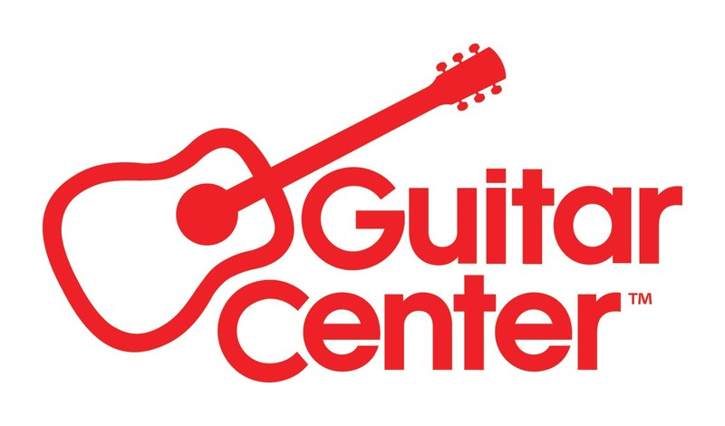

***MEDIA ALERT FOR TUESDAY, AUGUST 27***

Guitar Center to host workshop with acclaimed drummer Nate Smith at GC Hollywood on Tuesday, Aug. 27

WHO: Acclaimed drummer, songwriter and producer Nate Smith (Pat Metheny, Dave Holland, Brittany Howard, Van Hunt, The Fearless Flyers, Norah Jones, Somi) and Guitar Center to partner together for an exclusive workshop event on Tuesday, Aug. 27.

WHAT: This workshop event will feature Nate Smith demonstrating his technique and gear from brands Ludwig, Vic Firth, Zildjian, and Evans. The event will feature playthroughs, demos, Q&A, and autograph signing. It will also be livestreamed on Guitar Center’s YouTube Channel.

WHEN: Tuesday, August 27, 2024, 6:00 PM PDT

WHERE: Guitar Center Hollywood
7425 Sunset Blvd
Los Angeles, CA 90046

Members of the media can RSVP to media@guitarcenter.com.

More about Nate Smith:
Nate Smith is a drummer, composer, & producer from Chesapeake, Virginia. His visceral, instinctive, and deep-rooted style of drumming has led to three GRAMMY® nominations and work with esteemed artists, including: Pat Metheny, Dave Holland, Brittany Howard, Van Hunt, The Fearless Flyers, Norah Jones, and Somi. Smith fuses his original compositions with an eclectic mix of music, including everything from jazz to R&B to hip-hop to pop. His latest album, Kinfolk 2: See The Birds (released September 2021 on Edition Records) is the highly-anticipated follow up to his 2017 GRAMMY® Award-nominated album, Kinfolk: Postcards From Everywhere. In recent years, Smith’s viral videos have been viewed by millions of people, underscoring his popularity as one of the most influential drummers of his generation.

FOR MORE INFORMATION PLEASE CONTACT:
Clyne Media | pr@clynemedia.com
Guitar Center | media@guitarcenter.com
Edelman | GuitarCenter@edelman.com

###

About Guitar Center:
Guitar Center is the leading retailer of musical instruments, lessons, repairs, and rentals in the U.S. With more than 300 stores across the U.S. and one of the top direct sales websites in the industry, Guitar Center has helped people make music for more than 50 years. Guitar Center also provides customers with various musician-based services, including Guitar Center Lessons, where musicians of all ages and skill levels can learn to play a variety of instruments in many music genres, GC Repairs, an on-site maintenance and repairs service, and GC Rentals, a program offering easy rentals of instruments and other sound reinforcement gear. Additionally, Guitar Center’s sister brands include Music & Arts, which operates more than 250 stores specializing in band & orchestral instruments for sale and rental, serving teachers, band directors, college professors, parents and students, and Musician’s Friend, a leading direct marketer of musical instruments in the United States. For more information about Guitar Center, please visit guitarcenter.com.

Photo file: NateSmith_Hollywood.JPG

Photo caption: Promotional graphic for the upcoming Nate Smith workshop at Guitar Center Hollywood

