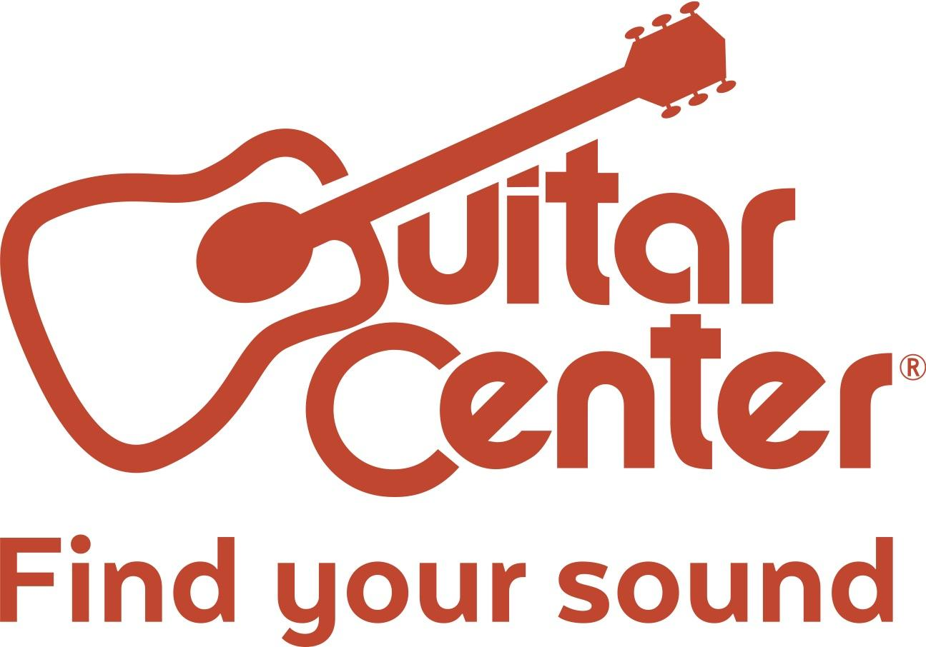

Guitar Center Launches New Free Mobile App, a Next-Generation Mobile Experience for Musicians

The musical instrument retailer debuts the newest way to shop, browse gear and gear reviews, build wish lists, and much more with its free mobile app

Westlake Village, CA (February 21, 2017) – Guitar Center, the world’s largest musical instrument retailer, debuts its free mobile app for musicians, granting them unlimited access to new and used gear from their favorite brands, anytime and anywhere. The Guitar Center mobile app is an intuitive retail app for musicians that allows consumers to shop on the go, get personalized notifications, explore product reviews while in the store and much more.

The Guitar Center mobile app features include the following:
● Used and Vintage Gear sections that help users easily locate exactly what they are looking for, from the country’s largest selection, at the right price.
● Wish Lists that allow users to build their dream gear list or scan a product in the store to add it directly.
● A Save Searches function that allows users to get notified when items arrive that match their specific search criteria.
● A Barcode Scanner that scans products in the store to bring up reviews and view additional content.
● A store locator that includes upcoming in-store events, workshops and local inventory.
● A social feed in the app that allows users to explore what Guitar Center customers are posting on social media and purchase products directly.

Through the ease and convenience of the new mobile app, Guitar Center is giving musicians access to all the gear they can ever imagine right in the palm of their hands, as well as many other invaluable services.

“We’re thrilled to be one of the first retailers in the musical instrument space to launch a mobile app and give our customers another convenient way to shop and be connected to the music community,” said Jeff Wisot, Vice President of Marketing and E-Commerce for Guitar Center. “We’re seeing a significant shift to mobile shopping, and we feel it is important to offer our customers these comprehensive tools.”

Guitar Center’s free mobile app is available now on the iOS App Store and Android Google Play with all the unique features musicians need to help find their sound.

About Guitar Center
Guitar Center is the world’s largest retailer of guitars, amplifiers, drums, keyboards, recording, live sound, DJ and lighting equipment. With more than 270 stores across the U.S. and one of the top direct sales websites in the industry, Guitar Center has helped people make music for more than 50 years. Guitar Center also provides customers with an in-house, state-of-the-art lesson facility through its GC Lessons programs in more than 100 stores, where musicians of all ages and skill levels can learn to play a variety of instruments in many music genres. Additionally, Guitar Center’s sister brands include Music & Arts, which operates more than 140 stores specializing in band & orchestral instruments for sale and rental, serving teachers, band directors, college professors and students, and Musician’s Friend, a leading direct marketer of musical instruments in the United States. With an unrivalled in-store experience, an industry-leading online presence and passionate commitment to making gear easy-to-buy, Guitar Center is all about enabling musicians and non-musicians alike to experience the almost indescribable joy that comes from playing an instrument. For more information about Guitar Center, please visit www.guitarcenter.com.

You can visit our press room at http://www.guitarcenter.com/pages/press-room, and send media inquiries to media@guitarcenter.com.

###

FOR MORE INFORMATION PLEASE CONTACT:
Marisa Bettencourt | Praytell Agency | 313.407.7571 | GCPR@praytellagency.com
Robert Clyne | Clyne Media | 615.662.1616 | pr@clynemedia.com
Syvetril Perryman | Guitar Center | 818.735.8800 x 2979 | media@guitarcenter.com

