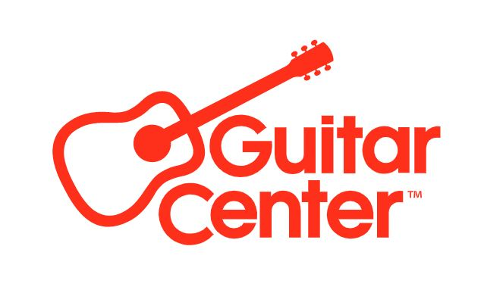

Jennifer Thayer Joins Music & Arts as President, Bringing Decades of Retail Leadership to the Guitar Center Company

Set to Lead Growth Across Lessons, Rentals, and Retail for the Nation’s Largest School Music Provider

Westlake Village, CA (June 2, 2025) — Guitar Center, the leading retailer of musical instruments, announced today the appointment of Jennifer Thayer as President of Music & Arts. Music & Arts is the nation’s largest provider of band and orchestra instruments, rentals, repairs, and music lessons that serve students, families, and educators nationwide. In this role, Thayer will lead the strategic direction, operations, and continued growth of Music & Arts’ more than 250 stores, over one million annual lessons, and the largest school instrument rental program in the country.

A results-driven executive with over 25 years of leadership experience, Thayer has held senior roles across retail, logistics, sales, and customer experience at companies including Harvia US, STG Logistics (through an acquisition of XPO), and Lowe’s Home Improvement. Known for driving performance, developing talent, and scaling complex organizations, she has led high-performing teams and delivered measurable results across large-scale, service-focused businesses.

“Jennifer brings incredible passion for Music & Arts’ mission of developing young musicians and helping them thrive,” said Gabe Dalporto, CEO of Guitar Center. “That passion is matched by an incredible track record of delivering outsized growth across multiple industries and companies. Her leadership reflects our ongoing investment in the future of music education and our long-term commitment to supporting musicians on every stage.”

Thayer’s connection to Music & Arts is both professional and personal. A former band and orchestra student herself, she played clarinet throughout her school years and recently began learning the saxophone. Her son is also a current student of Music & Arts, giving her a unique, firsthand perspective on the company’s important role in supporting young musicians and families nationwide.

“Music has had a lasting presence in my life, and I understand how powerful it can be in shaping young people’s futures,” said Jennifer Thayer, President of Music & Arts. “As we look ahead, I’m honored to build on Music & Arts’ legacy and help shape a new era that expands access, deepens our impact, and ensures music continues to inspire the next generation.”

As President, Thayer will help drive performance across Music & Arts’ retail, lessons, and rental channels; strengthen relationships with educators and schools; and advance the mission to expand access to music education through innovation and community engagement. She will also help identify growth opportunities and acquisitions that support the brand’s continued impact.

Headquartered in Frederick, Maryland, Music & Arts has grown from a single store in Bethesda to a nationwide leader in music education. With over 250 stores, 250+ affiliate partners, and more than 200 educational representatives, the brand is trusted by students, families, and schools for its comprehensive offering of band and orchestra instruments, private lessons, rentals, and repairs.

For more information about Music & Arts, visit MusicArts.com.

###

About Music & Arts:
The first Music & Arts opened in 1952. Today, Music & Arts has more than 450 retail and affiliate locations, partners with over 200 educational representatives, and teaches over one million lessons per year, making it one of the nation's largest school music retailers and instrument rental and lesson providers. Based in Frederick, MD, the company offers friendly service for everything musical in your life including instruments, lessons, rentals and repairs. Visit MusicArts.com for more information.

About Guitar Center:
Guitar Center is the leading retailer of musical instruments, lessons, repairs and rentals in the U.S. With more than 300 stores across the U.S. and one of the top direct sales websites in the industry, Guitar Center has helped people make music for more than 60 years. Guitar Center also provides customers with various musician-based services, including Guitar Center Lessons, where musicians of all ages and skill levels can learn to play a variety of instruments in many music genres, GC Repairs, an on-site maintenance and repairs service, and GC Rentals, a program offering easy rentals of instruments and other sound reinforcement gear. Additionally, Guitar Center’s sister brands include Music & Arts, which operates more than 250 stores specializing in band & orchestral instruments for sale and rental, serving teachers, band directors, college professors, parents and students, and Musician’s Friend, a leading direct marketer of musical instruments in the United States. For more information about the Guitar Center, please visit guitarcenter.com.

FOR MORE INFORMATION PLEASE CONTACT:
Clyne Media | pr@clynemedia.com
Guitar Center | media@guitarcenter.com

Photo file 1: JenniferThayer.JPG
Photo caption 1: Jennifer Thayer, President of Music & Arts

Photo file 2: MusicArtsLogo.JPG
Photo caption 2: Music & Arts logo

