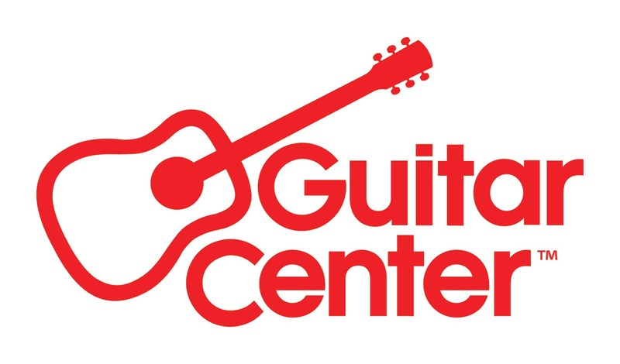

***MEDIA ALERT FOR APRIL 26, 2025***

Guitar Center and Jackson Guitars to present in-store clinic with Bring Me The Horizon guitarist Lee Malia at the San Francisco Guitar Center store on April 26

WHO: Lee Malia, guitarist for Bring Me The Horizon, appearing in person at Guitar Center San Francisco, co-presented by Jackson Guitars.

Lee Malia is the lead guitarist of the GRAMMY®-nominated, BRIT award winning, British rock band Bring Me The Horizon. The band recently released their critically acclaimed seventh studio album, POST HUMAN: NeX GEn via Sony®/RCA®, which has now been streamed over a billion times. As globally revered festival headliners, Bring Me the Horizon played their biggest show to date in São Paulo last year, selling out the 45,000-capacity Allianz Parque stadium. With a reputation for pushing genre-boundaries, their relentless energy and precision are mirrored in the Pro Series Signature Lee Malia LM-87, a high-performance guitar designed for players who want to wail effortlessly.

WHAT: Jackson Guitars and Guitar Center to partner together with Lee Malia of Bring Me The Horizon for exclusive event to celebrate the launch of the Jackson Pro Series Signature Lee Malia LM-87. The event will feature Malia and his gear in a clinic format with demos, discussion, Q&A and an autograph signing.

WHEN: Saturday, April 26, 2025, 6:00 PM PDT

WHERE: Guitar Center San Francisco
1645 Van Ness Ave
San Francisco, CA 94109

Capacity in-store is limited, so RSVP here to reserve a spot.

The Jackson Pro Series Signature Lee Malia LM-87 guitar is available for pre-order now at GuitarCenter.com.

Contact media@guitarcenter.com for additional media queries.

FOR MORE INFORMATION PLEASE CONTACT:
Clyne Media | pr@clynemedia.com
Guitar Center | media@guitarcenter.com

###

About Guitar Center:
Guitar Center is the leading retailer of musical instruments, lessons, repairs, and rentals in the U.S. With more than 300 stores across the U.S. and one of the top direct sales websites in the industry, Guitar Center has helped people make music for more than 60 years. Guitar Center also provides customers with various musician-based services, including Guitar Center Lessons, where musicians of all ages and skill levels can learn to play a variety of instruments in many music genres, GC Repairs, an on-site maintenance and repairs service, and GC Rentals, a program offering easy rentals of instruments and other sound reinforcement gear. Additionally, Guitar Center’s sister brands include Music & Arts, which operates more than 250 stores specializing in band & orchestral instruments for sale and rental, serving teachers, band directors, college professors, parents and students, and Musician’s Friend, a leading direct marketer of musical instruments in the United States. For more information about Guitar Center, please visit guitarcenter.com.

About Jackson:
Jackson began in the late 1970s when heavy music experienced a virtuosic resurgence in popularity and a small Southern California repair shop became the epicenter of a new level of excellence. When extravagant young guitarists needed more from their instruments, a small staff of highly skilled craftsmen answered the call with a new breed of high-performance custom guitars. From that point on, heavy metal history would be written with Jackson's guitars lauded as the industry's shred machines. Known for their distinctive style and formidable substance, Jackson® guitars have melded seamlessly with each and every sonic mutation across the metal genre allowing discerning guitarists everywhere to achieve an explosive sound. Over the years, Jackson has worked with some of the most influential and respected players in the world, and its roster of signature artists boasts guitarists whose impactful and game-changing contributions to heavy metal continue to inspire generations of musicians and fans. Today, Jackson is an owned brand under Fender Musical Instruments Corporation (FMIC) and with a foundation of premium state-of-the-art manufacturing facilities and the industry's finest team of seasoned builders, together they are poised for a new and transformative era. For more information, visit www.jacksonguitars.com.

Photo file 1: LeeMalia_Clinic_Graphic1.JPG
Photo caption 1: Promotional graphic #1 for Guitar Center/Jackson in-store clinic featuring Lee Malia

Photo file 2: LeeMalia_Clinic_Graphic2.JPG
Photo caption 2: Promotional graphic #2 for Guitar Center/Jackson in-store clinic featuring Lee Malia

