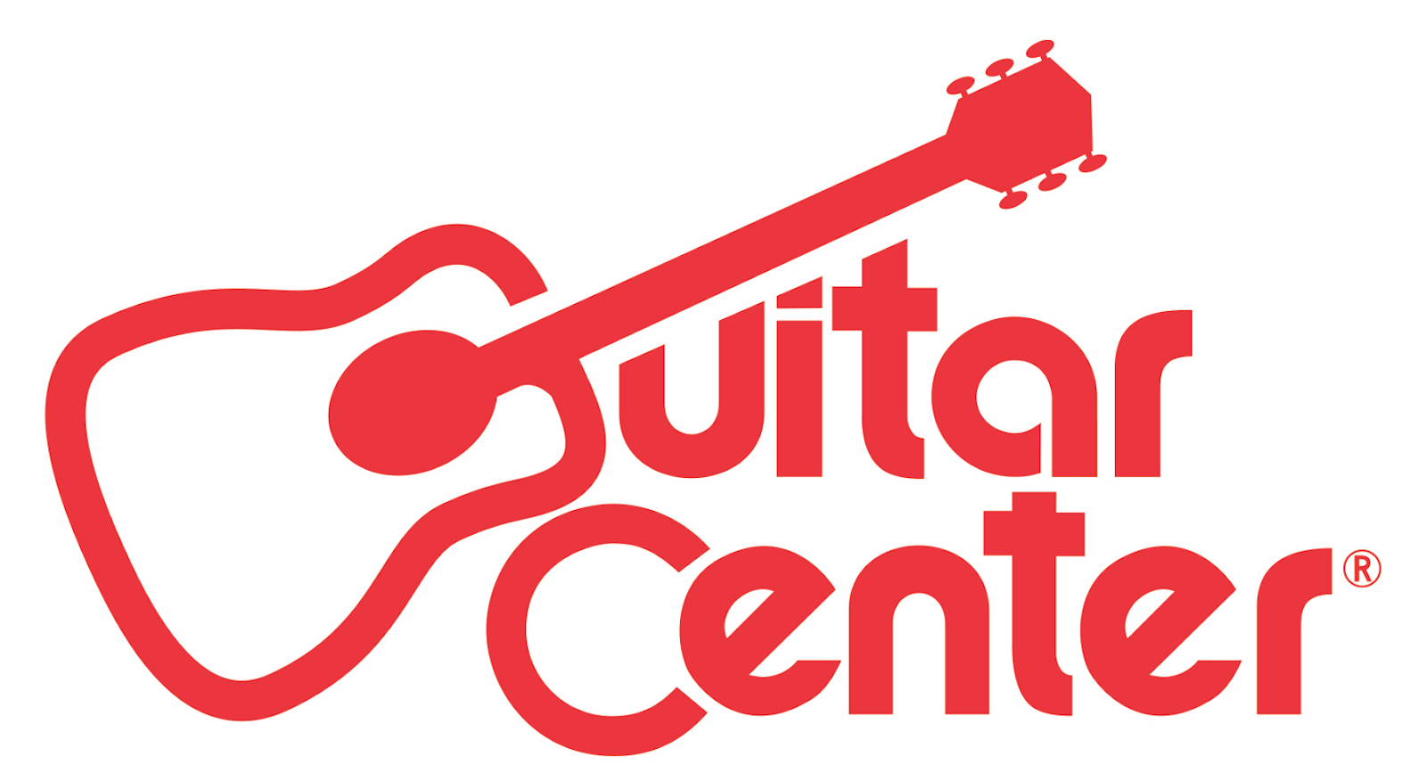

Guitar Center and Singer-Songwriter Colbie Caillat Partner with National Nonprofit Little Kids Rock to Donate Musical Instruments to a Deserving
New York Elementary School

Giving back to the music community is at the core of Guitar Center’s pursuit to provide musical instruments, lessons and resources to musicians at every point of their musical journeys

ANNOUNCEMENT HIGHLIGHTS:
- Guitar Center and Caillat are longtime supporters of Little Kids Rock, the nation’s leading nonprofit provider of free music instruction and instruments to public school children in under-served or underprivileged schools
- GRAMMY® Award-winning singer-songwriter Colbie Caillat stopped into PS 182 in New York for a special collaborative performance with the music students followed by a surprise generous donation of gear from Guitar Center

New York, NY (November 14, 2016) – On October 26, Guitar Center, the world’s largest instrument retailer and GRAMMY® award-winning singer-songwriter Colbie Caillat partnered with national nonprofit Little Kids Rock to bring a surprise live performance to the elementary school students of PS 182 located in Jamaica, Queens, New York followed by a generous donation of musical instruments to assist them along their musical journeys.

During this special event, Caillat participated in a collaborative performance her hit single, “Bubbly” with music students at the school and shared her journey and passion for music in an intimate Q&A. The event came to an exciting close, as Caillat revealed a generous donation of musical instruments from Guitar Center including electric and acoustic guitars, keyboards and more.

Through this event, Guitar Center continues its goal to fill the world with more music. Various nonprofit’s music programs like Little Kids Rock help Guitar Center reinforce these efforts at public schools across the country. Guitar Center, Little Kids Rock, and Colbie Caillat all believe that music transforms lives, and that everyone deserves the opportunity to unlock their inner music maker, particularly students who may not otherwise have the chance due to school budget restrictions or limited resources.

“Guitar Center prides itself in offering as many individuals as possible the invaluable experience of learning and playing a musical instrument,” said Guitar Center’s Vice President of Marketing, Brian Berman. “We’re honored that Colbie Caillat has joined us in this effort to expose more children to music, a cause close to all of our hearts.”

Colbie Caillat added, “I think every kid should have the creative outlet in the form of art and especially in music. Working with Guitar Center and Little Kids Rock to help these kids have an opportunity with these musical instruments makes me so happy.”

Guitar Center’s gear donation to the students at PS 182 included a variety of instruments from manufacturers such as Mitchell, Sound Percussion, Williams and many more. The school is also one of over 400 modern band programs established as a part of Amp Up NYC – a joint venture between Little Kids Rock and Berklee College of Music.

"At Little Kids Rock, we believe that all kids are innately musical – they just need to be inspired to unleash their inner music makers," said Little Kids Rock founder and CEO David Wish. "That is why it is so exciting that Colbie Caillat, an artist who resonates so deeply with children and adults alike, is taking the time to visit and inspire some of our students in an effort to help music programs thrive in our public schools."

For more information on how Guitar Center gives back, visit www.GuitarCenter.com.

###

Photo File 1: Colbie_Caillat.jpg
Photo Caption 1: GRAMMY® Award-winning singer-songwriter Colbie Caillat partnered with national nonprofit Little Kids Rock and stopped into PS 182 in New York for a special collaborative performance with the music students followed by a surprise generous donation of musical instruments from Guitar Center.

Photo File 2: Group_Shot.jpg
Photo Caption 2: Elementary school students of PS 182, located in Jamaica, Queens, New York, shown with GRAMMY® award-winning singer-songwriter Colbie Caillat, who partnered with national nonprofit Little Kids Rock to bring a surprise live performance to the school. This was followed by a generous donation by Guitar Center of musical instruments to assist them along their musical journeys.

About Guitar Center: Guitar Center is the world’s largest retailer of guitars, amplifiers, drums, keyboards, recording, live sound, DJ, and lighting equipment. With more than 270 stores across the U.S. and one of the top direct sales websites in the industry, Guitar Center has helped people make music for more than 50 years. In addition, Guitar Center’s sister brands include Music & Arts, which operates more than 140 stores specializing in band & orchestral instruments for sale and rental, serving teachers, band directors, college professors and students, and Musician’s Friend, a leading direct marketer of musical instruments in the United States. With an unrivalled in-store experience, an industry-leading online presence and passionate commitment to making gear easy-to-buy, Guitar Center is all about enabling musicians and non-musicians alike to experience the almost indescribable joy that comes from playing an instrument. For more information about Guitar Center, please visit www.guitarcenter.com.

You can visit our press room at http://www.guitarcenter.com/pages/press-room, and send media inquiries to media@guitarcenter.com.

About Colbie Caillat:
Colbie Caillat is a two time Grammy Award winning singer-songwriter who has sold over six million albums and ten million singles worldwide. Her breakthrough hit “Bubbly” remains "one of the best- selling digital tracks in history" and her multi-platinum debut COCO hit #5 on the Billboard Top 200 Albums chart upon release, while her sophomore set Breakthrough landed at #1. From 2011ʼs All of You, “Brighter Than The Sun” went platinum and enjoyed over twenty film and television placements, while seeing acclaim from People and NY Post. Sheʼs also played sold out venues everywhere alongside everybody from John Mayer to Sheryl Crow. Beyond music, sheʼs an avowed spokesperson and supporter for ASPCA, the Surfrider Foundation, Save The Music, Farm Sanctuary, and The Humane Society of the United States.
For the first time in her decade-long career, Colbie Caillat has made an album exactly the way she wanted. It’s also the first for her newly minted label, PlummyLou Records, distributed by RED.

Eschewing traditional recording studios, Caillat recorded The Malibu Sessions, out Oct. 7, over a two-month period in a rented house in Southern California’s beautiful Broad Beach.

The result is a sun-kissed collection of breezy, buoyant, yet often vulnerable, songs, with timeless harmonies, catchy melodies and a harmonious vibe that recalls classic ‘70s rock. For additional information visit www.colbiecaillat.com.

About Little Kids Rock:
Little Kids Rock is a national nonprofit dedicated to transforming lives by restoring, expanding, and innovating music education in our schools. The organization partners with public school districts to train teachers to run its innovative Modern Band curriculum, and donates all the accompanying instruments and resources necessary to teach popular music in a way that empowers students to experience instant achievement. What began as a single after-school guitar class has since exploded into a national movement that brings free, weekly music lessons to over 250,000 public school children through the efforts of more than 1,700 teachers in 124 school districts nationwide. To date, Little Kids Rock has served more than 500,000 students. More info at www.littlekidsrock.org

FOR MORE INFORMATION PLEASE CONTACT:
Praytell Agency | 925.817.0596 | GCPR@praytellagency.com
Robert Clyne | Clyne Media | 615.662.1616 | pr@clynemedia.com
Syvetril Perryman | Guitar Center | 818.735.8800 x 2979 | media@guitarcenter.com

