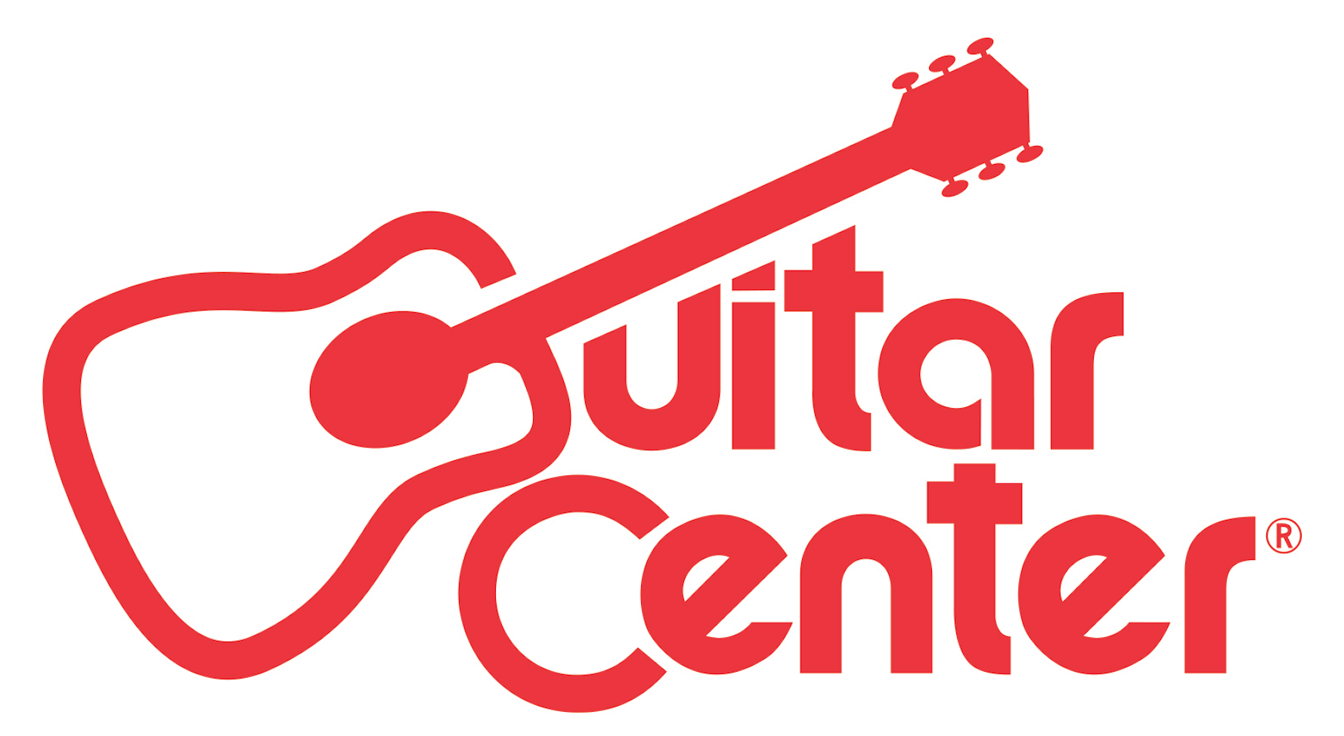
FOR IMMEDIATE RELEASE

Guitar Center “Singer-Songwriter 4” Winner Lanita Smith to Perform on Jimmy Kimmel Live!

GRAMMY® Award-winning producer Don Was handpicked Smith out of nearly 16,000 entries as winner of Guitar Center’s annual Singer-Songwriter program

ANNOUNCEMENT HIGHLIGHTS:
- Guitar Center gives Smith career-altering opportunities, including an E.P. produced by Don Was, a national television performance on Jimmy Kimmel Live! on Tuesday, January 26, and more
- Smith to release Don Was-produced E.P. titled Listen to Your Heartbeat on Tuesday, January 26
- Now in its fifth installment, Guitar Center’s Singer-Songwriter competition is one of multiptle programs designed by the retailer to support and inspire musicians

Los Angeles, CA (January 25, 2016): Guitar Center Singer-Songwriter 4 winner Lanita Smith will make her national television debut on prominent late night staple Jimmy Kimmel Live! on ABC at 11:35/10:35c on Tuesday, January 26, 2016. Smith will be performing material off of her latest E.P., Listen to Your Heartbeat, which was produced by GRAMMY® Award-winning producer Don Was and is also scheduled for release on Tuesday.

Out of nearly 16,000 entries in Guitar Center’s Singer-Songwriter annual program, judge and multi-GRAMMY® Award-winning producer Don Was chose Fayetteville, NC native Lanita Smith as the winner at the program’s finals on March 6, 2015. In addition to the Kimmel performance, Smith received a multifaceted career-boosting package including a four-song EP produced by Was, private mentoring session with Colbie Caillat, $25,000 cash, new gear, musical equipment, and more.

Was chose Smith as the winner after being impressed with her ability to enrapture everyone with her soulful songs and emotional delivery. To make an E.P. with the young artist, Was assembled a dream team to record with Smith at Hollywood's Henson Recording Studios, the birthplace of celebrated projects like Carole King's Tapestry and Joni Mitchell's Blue.

Watch the behind the scenes video of the making of Smith’s EP with Was here: https://youtu.be/bTA7Nv3lv_0

"As a singer songwriter I have gone through life trying to find a big break, but this competition came along and ended up being a game-changer for me. I will forever be grateful to Guitar Center for having a competition like this and even more for Don Was giving me a chance to share my music with the world on Jimmy Kimmel Live and not be afraid to be different and authentic!" - Lanita Smith, Winner of Guitar Center Singer-Songwriter 4

Catch Lanita's new music on Jimmy Kimmel Live!, and be the first to download her highly anticipated EP Listen to Your Heartbeat at www.lanitasmith.com.

About Guitar Center:
Guitar Center is the world’s largest retailer of guitars, amplifiers, drums, keyboards, recording, live sound, DJ, and lighting equipment. With more than 270 stores across the U.S. and one of the top direct sales websites in the industry, Guitar Center has helped people make music for more than 50 years. In addition, Guitar Center’s sister brands includes Music & Arts, which operates more than 140 stores specializing in band & orchestral instruments for sale and rental, serving teachers, band directors, college professors and students, and Musician’s Friend, a leading direct marketer of musical instruments in the United States. With an unrivaled in-store experience, an industry-leading online presence and passionate commitment to making gear easy-to-buy, Guitar Center is all about enabling musicians and non-musicians alike to experience the almost indescribable joy that comes from playing an instrument. For more information about Guitar Center, please visit www.guitarcenter.com.

You can visit our press room at http://www.guitarcenter.com/pages/press-room and send media inquiries to media@guitarcenter.com.

FOR MORE INFORMATION PLEASE CONTACT:

Natania Reed | ANTHEMIC Agency | 323.464.4745 x 806 | Natania@anthemicagency.com
Syvetril Perryman | Guitar Center | 818.735.8800 x 2979 | media@guitarcenter.com
Robert Clyne | Clyne Media, Inc. | 615-662-1616 | Robert@clynemedia.com

