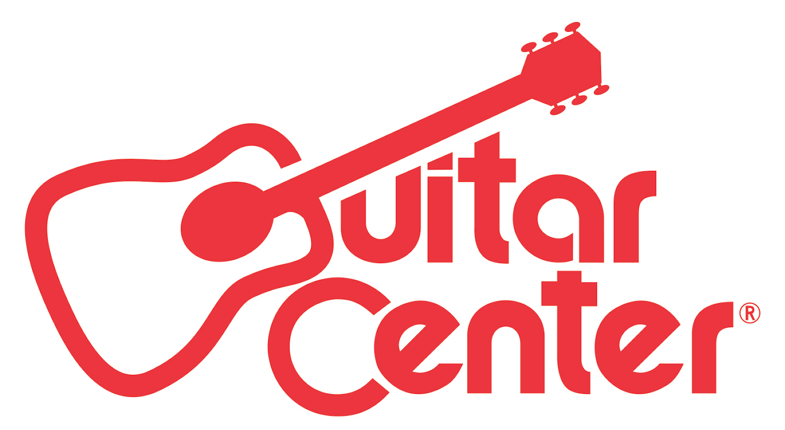

FOR IMMEDIATE RELEASE

Guitar Center Names Ron Japinga President

ANNOUNCEMENT HIGHLIGHTS:
- Guitar Center’s Ron Japinga assumes new leadership role
- Appointment further underscores GC’s ongoing growth and expansion

Los Angeles, CA (June 15, 2016): Guitar Center, the world’s largest musical instrument retailer, has appointed Ron Japinga to the position of President of Guitar Center, effective June 15, 2016. The announcement was made by Darrell Webb, Guitar Center Chief Executive Officer, and further underscores the company’s ongoing evolution and expansion.

In his new position, Japinga will oversee and manage all aspects of Guitar Center’s business and work closely with GC’s executive team to ensure Guitar Center’s long-term growth while better serving its customers’ needs and leveraging the depth of talent and resources that exist throughout the GC organization.

“Ron has done an exceptional job since joining our company in July of 2014 as Executive Vice President for Supply Chain and Private Brands,” stated Darrell Webb. “With 32 years of successful retail management and leadership experience at a variety of companies, Ron has accumulated a vast knowledge of retailing. He has proactively shared this expertise throughout our company, well beyond his official areas of responsibility, to positively influence Guitar Center’s performance. He is a man of tremendous integrity and work ethic, with strong values and a deep commitment to Guitar Center. We all look forward to working with Ron in this new position.”

Before joining Guitar Center as Executive Vice President of Inventory Management and Supply Chain, Japinga had an impressive 8-year career at West Marine where he was the Executive Vice President of Merchandising, Planning and Logistics. Prior to that, Ron was a VP-level executive with Kohl’s Department Stores.

Photo file: RonJapinga.JPG
Photo caption: Ron Japinga, Guitar Center President

About Guitar Center:
Guitar Center is the world’s largest retailer of guitars, amplifiers, drums, keyboards, recording, live sound, DJ, and lighting equipment. With more than 270 stores across the U.S. and one of the top direct sales websites in the industry, Guitar Center has helped people make music for more than 50 years. In addition, Guitar Center’s sister brands includes Music & Arts, which operates more than 140 stores specializing in band & orchestral instruments for sale and rental, serving teachers, band directors, college professors and students, and Musician’s Friend, a leading direct marketer of musical instruments in the United States. With an unrivalled in-store experience, an industry-leading online presence and passionate commitment to making gear easy-to-buy, Guitar Center is all about enabling musicians and non-musicians alike to experience the almost indescribable joy that comes from playing an instrument. For more information about Guitar Center, please visit www.guitarcenter.com.

You can visit our press room at http://www.guitarcenter.com/pages/press-room and send media inquiries to media@guitarcenter.com.

FOR MORE INFORMATION PLEASE CONTACT:
Robert Clyne | Clyne Media, Inc. | 615.662.1616 | robert@clynemedia.com
Sarah Chavey | Praytell Agency | 313.407.7571| GCPR@praytellstrategy.com
Syvetril Perryman | Guitar Center | 818.735.8800 | media@guitarcenter.com

