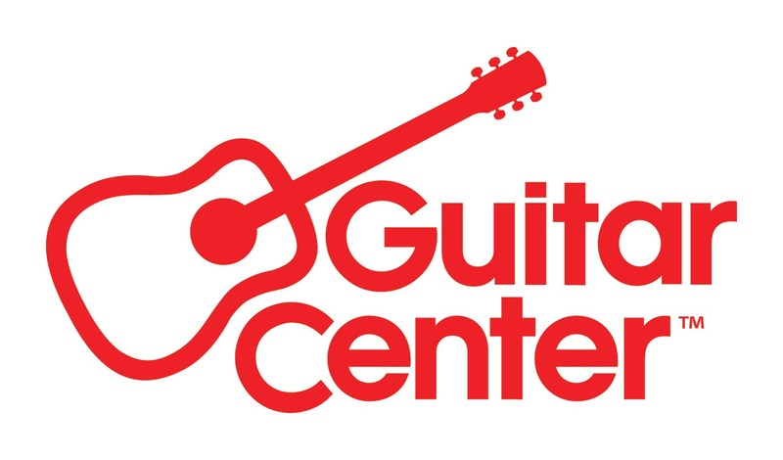

***MEDIA ALERT ***

Guitar Center to host Taylor Guitars 50th Anniversary Celebration at its flagship Hollywood, CA store on Saturday, September 21, 2024

WHO: Taylor Guitars and Guitar Center to partner together for an exclusive event to celebrate 50 Years of Taylor Guitars, along with special guest presenters and performers.

WHAT: Taylor Guitars 50th Anniversary Celebration will feature Bob Taylor (company founder) and Andy Powers (current Taylor CEO and Chief Guitar Designer), alongside Taylor artists, for a panel, discussion, and performances. Featured performers will include Molly Miller, Lisa Loeb, Elise Trouw, Steve Poltz and Ben Harper.

The artists will each get to share their Taylor story. Poltz and Loeb, in particular, both have highly personal anecdotes about times that the Taylor company was able to help them out individually.

WHEN: Saturday, September 21, 2024, 3:00 to 6:00 PM PDT

WHERE: Guitar Center Hollywood
7425 Sunset Blvd
Los Angeles, CA 90046

To RSVP or media queries can be directed to media@guitarcenter.com.

FOR MORE INFORMATION PLEASE CONTACT:
Clyne Media | pr@clynemedia.com
Guitar Center | media@guitarcenter.com
Edelman | GuitarCenter@edelman.com

###

About Guitar Center:
Guitar Center is the leading retailer of musical instruments, lessons, repairs, and rentals in the U.S. With more than 300 stores across the U.S. and one of the top direct sales websites in the industry, Guitar Center has helped people make music for more than 50 years. Guitar Center also provides customers with various musician-based services, including Guitar Center Lessons, where musicians of all ages and skill levels can learn to play a variety of instruments in many music genres, GC Repairs, an on-site maintenance and repairs service, and GC Rentals, a program offering easy rentals of instruments and other sound reinforcement gear. Additionally, Guitar Center’s sister brands include Music & Arts, which operates more than 250 stores specializing in band & orchestral instruments for sale and rental, serving teachers, band directors, college professors, parents and students, and Musician’s Friend, a leading direct marketer of musical instruments in the United States. For more information about Guitar Center, please visit guitarcenter.com.

PDF file: GC_Hollywood_Taylor_Sept21.pdf
PDF caption: Promotional graphic for the “50 Years of Taylor” celebration on Saturday, September 21, 2024, at Guitar Center Hollywood

