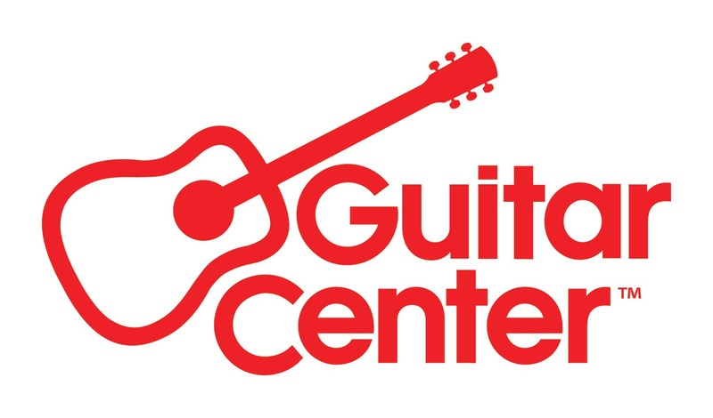

***MEDIA ALERT ***

Guitar Center to host event with legendary multi-GRAMMY® Award-winning, Rock & Roll Hall Of Fame producer/guitarist/songwriter Nile Rodgers celebrating 70 Years of the Fender Stratocaster at its flagship Hollywood, CA store on Friday, October 18, 2024

WHO: Guitar Center and Fender Guitars to partner together for an exclusive event to celebrate 70 Years of the Fender Stratocaster featuring legendary multi-GRAMMY® Award-winning, Rock & Roll/Songwriters Hall Of Fame producer/guitarist/songwriter Nile Rodgers.

WHAT: The event will feature conversations, demo, Q&A, and autograph signing by Nile Rodgers, and will be livestreamed to Guitar Center’s YouTube channel.

The co-founder of Chic, Nile Rodgers has written, produced, and performed on records that have sold more than 500 million albums and 75 million singles worldwide. He was recently placed #7 on Rolling Stone’s list of greatest guitarists of all time. As a four-time GRAMMY® Award-winning producer, songwriter, and studio collaborator, he is known for his work with David Bowie, Madonna, Daft Punk, Beyoncé, Diana Ross, INXS, Duran Duran, Lady Gaga, Grace Jones, Sister Sledge, Chic and countless others.

WHEN: Friday, October 18, 2024, 4:00 PM PDT

WHERE: Guitar Center Hollywood
7425 Sunset Blvd
Los Angeles, CA 90046

Visit here to RSVP. Contact media@guitarcenter.com for additional media queries.

FOR MORE INFORMATION PLEASE CONTACT:
Clyne Media | pr@clynemedia.com
Guitar Center | media@guitarcenter.com

###

About Guitar Center:
Guitar Center is the leading retailer of musical instruments, lessons, repairs, and rentals in the U.S. With more than 300 stores across the U.S. and one of the top direct sales websites in the industry, Guitar Center has helped people make music for more than 50 years. Guitar Center also provides customers with various musician-based services, including Guitar Center Lessons, where musicians of all ages and skill levels can learn to play a variety of instruments in many music genres, GC Repairs, an on-site maintenance and repairs service, and GC Rentals, a program offering easy rentals of instruments and other sound reinforcement gear. Additionally, Guitar Center’s sister brands include Music & Arts, which operates more than 250 stores specializing in band & orchestral instruments for sale and rental, serving teachers, band directors, college professors, parents and students, and Musician’s Friend, a leading direct marketer of musical instruments in the United States. For more information about Guitar Center, please visit guitarcenter.com.

About Nile Rodgers:
Nile Rodgers is a Rock & Roll Hall of Fame inductee, Songwriters Hall of Fame inductee and a multiple GRAMMY® Award-winning songwriter, composer, producer, arranger, and guitarist. In 2023 he became the first creator to be awarded a Lifetime Achievement Grammy for his legacy in the same year as being awarded a Grammy for his work with Beyoncé on the smash hit “Cuff It”. As the co-founder of CHIC, Rodgers pioneered a musical language that generated chart-topping hits like "Le Freak”, the biggest selling single in the history of Atlantic Records, and sparked the advent of hip-hop with "Good Times." His work in the CHIC Organization including “We Are Family” with Sister Sledge and “I’m Coming Out” with Diana Ross and his productions for artists like David Bowie (“Let’s Dance”), Madonna (“Like A Virgin”) and Duran Duran (“The Reflex”) have sold over 500 million albums and 100 million singles worldwide while his innovative, trendsetting collaborations with Daft Punk (“Get Lucky”), Daddy Yankee (“Agua”), and Beyoncé (“Cuff It”, “Leviis Jeans”) reflect the vanguard of contemporary hits. Nile Rodgers’ impact on music production is not only evident in his chart-topping hits but also in his ability to innovate and adapt to evolving musical trends. His contributions continue to inspire generations of musicians and producers, cementing his status as a true icon in the history of modern music.

PDF file: GC_Hollywood_NileRodgers_Fender_Oct18.JPG
PDF caption: Guitar Center to host event with legendary multi-GRAMMY® Award-winning Rock & Roll Hall Of Fame producer/guitarist/songwriter Nile Rodgers celebrating 70 Years of the Fender Stratocaster at its flagship Hollywood, CA store on Friday, October 18, 2024

