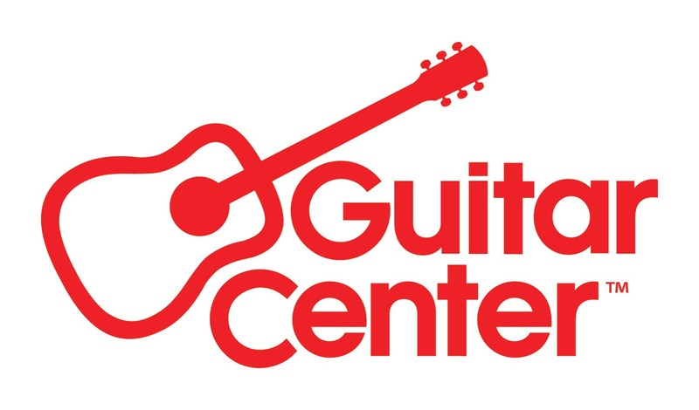

***MEDIA ALERT ***

Guitar Center to host in-store event with Periphery drummer Matt Halpern at its flagship Hollywood, CA store on Thursday, March 6, 2025

WHO: Matt Halpern, drummer for acclaimed progressive metal band Periphery, appearing live at Guitar Center Hollywood.

WHAT: Guitar Center Hollywood is set to host an exciting live in-store event in conjunction with its Big Bang drum promotional period, celebrating drumming and percussion gear. This special event will feature renowned drummer Matt Halpern, who will take the stage to showcase his gear through dynamic playthroughs and in-depth demonstrations. Attendees will have the opportunity to engage with Halpern during a Q&A session, where he will share insights into his techniques, equipment, and experiences as a professional musician. Fans will also have the chance to meet him in person during an autograph signing session. For those unable to attend in-store, the entire event will be livestreamed on Guitar Center’s YouTube Channel, ensuring a broader audience can experience the energy and expertise Halpern brings to the drumming community.

WHEN: Thursday, March 6, 2025, 6:00 PM PST

WHERE: Guitar Center Hollywood
7425 Sunset Blvd
Los Angeles, CA 90046

Capacity in-store is limited, so RSVP here to reserve a spot. Livestream link available upon request.

Contact media@guitarcenter.com for additional media queries.

FOR MORE INFORMATION PLEASE CONTACT:
Clyne Media | pr@clynemedia.com
Guitar Center | media@guitarcenter.com

###

About Matt Halpern:
Matt Halpern, the drummer for Periphery and co-founder of the software company GetGood Drums, is a dedicated educator with a deep passion for inspiring students and artists to channel their creativity into successful careers. He has received numerous accolades, including Best Clinician/Educator and Best Metal Drummer from Modern Drummer Magazine, along with many other honors.

About Guitar Center:
Guitar Center is the leading retailer of musical instruments, lessons, repairs, and rentals in the U.S. With more than 300 stores across the U.S. and one of the top direct sales websites in the industry, Guitar Center has helped people make music for more than 50 years. Guitar Center also provides customers with various musician-based services, including Guitar Center Lessons, where musicians of all ages and skill levels can learn to play a variety of instruments in many music genres, GC Repairs, an on-site maintenance and repairs service, and GC Rentals, a program offering easy rentals of instruments and other sound reinforcement gear. Additionally, Guitar Center’s sister brands include Music & Arts, which operates more than 250 stores specializing in band & orchestral instruments for sale and rental, serving teachers, band directors, college professors, parents and students, and Musician’s Friend, a leading direct marketer of musical instruments in the United States. For more information about Guitar Center, please visit guitarcenter.com.

PDF file: GC_MattHalpern_BigBangWrkshp.PDF
PDF caption: Promotional graphic for upcoming event featuring Matt Halpern, drummer for acclaimed progressive metal band Periphery, appearing live at Guitar Center Hollywood on Thursday, March 6, 2025.

