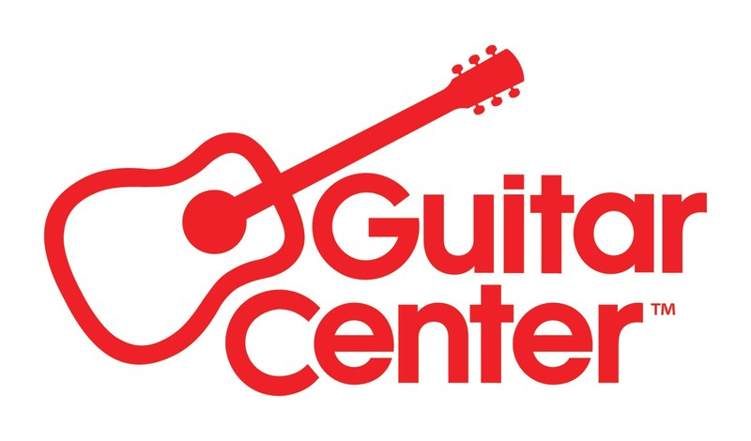

***MEDIA ALERT ***

Guitar Center to host event featuring guitar sensation Cory Wong and Electro-Voice products at Guitar Center Hollywood on Thursday, September 26

WHO: Electro-Voice and Guitar Center to partner for an exclusive in-store event and live stream to support the EV product ecosystem through the lens of guitarist Cory Wong, “Building a Modeling Rig for Stage & Studio with Cory Wong.”

WHAT: Cory Wong is among the most acclaimed guitarists working today, with music encompassing funk, jazz, rock and much more. He is known for his collaborations with Vulfpeck and Jon Batiste, his solo work and as a member of The Fearless Flyers, and his dynamic live sets. This event will highlight how Cory authentically utilizes key EV products and will feature solo performances, demos, Q&A, and autograph signing. A moderated conversation will encompass both rig- and product-specific questions and broader performing/songwriting questions.

The event will be livestreamed to Guitar Center’s YouTube channel.

WHEN: Thursday, September 26, 2024, 6:00 PM PDT

WHERE: Guitar Center Hollywood
7425 Sunset Blvd
Los Angeles, CA 90046

Additional media queries and RSVP’s can be directed to media@guitarcenter.com.

FOR MORE INFORMATION PLEASE CONTACT:
Clyne Media | pr@clynemedia.com
Guitar Center | media@guitarcenter.com
Edelman | GuitarCenter@edelman.com

###

About Guitar Center:
Guitar Center is the leading retailer of musical instruments, lessons, repairs, and rentals in the U.S. With more than 300 stores across the U.S. and one of the top direct sales websites in the industry, Guitar Center has helped people make music for more than 50 years. Guitar Center also provides customers with various musician-based services, including Guitar Center Lessons, where musicians of all ages and skill levels can learn to play a variety of instruments in many music genres, GC Repairs, an on-site maintenance and repairs service, and GC Rentals, a program offering easy rentals of instruments and other sound reinforcement gear. Additionally, Guitar Center’s sister brands include Music & Arts, which operates more than 250 stores specializing in band & orchestral instruments for sale and rental, serving teachers, band directors, college professors, parents and students, and Musician’s Friend, a leading direct marketer of musical instruments in the United States. For more information about Guitar Center, please visit guitarcenter.com.

