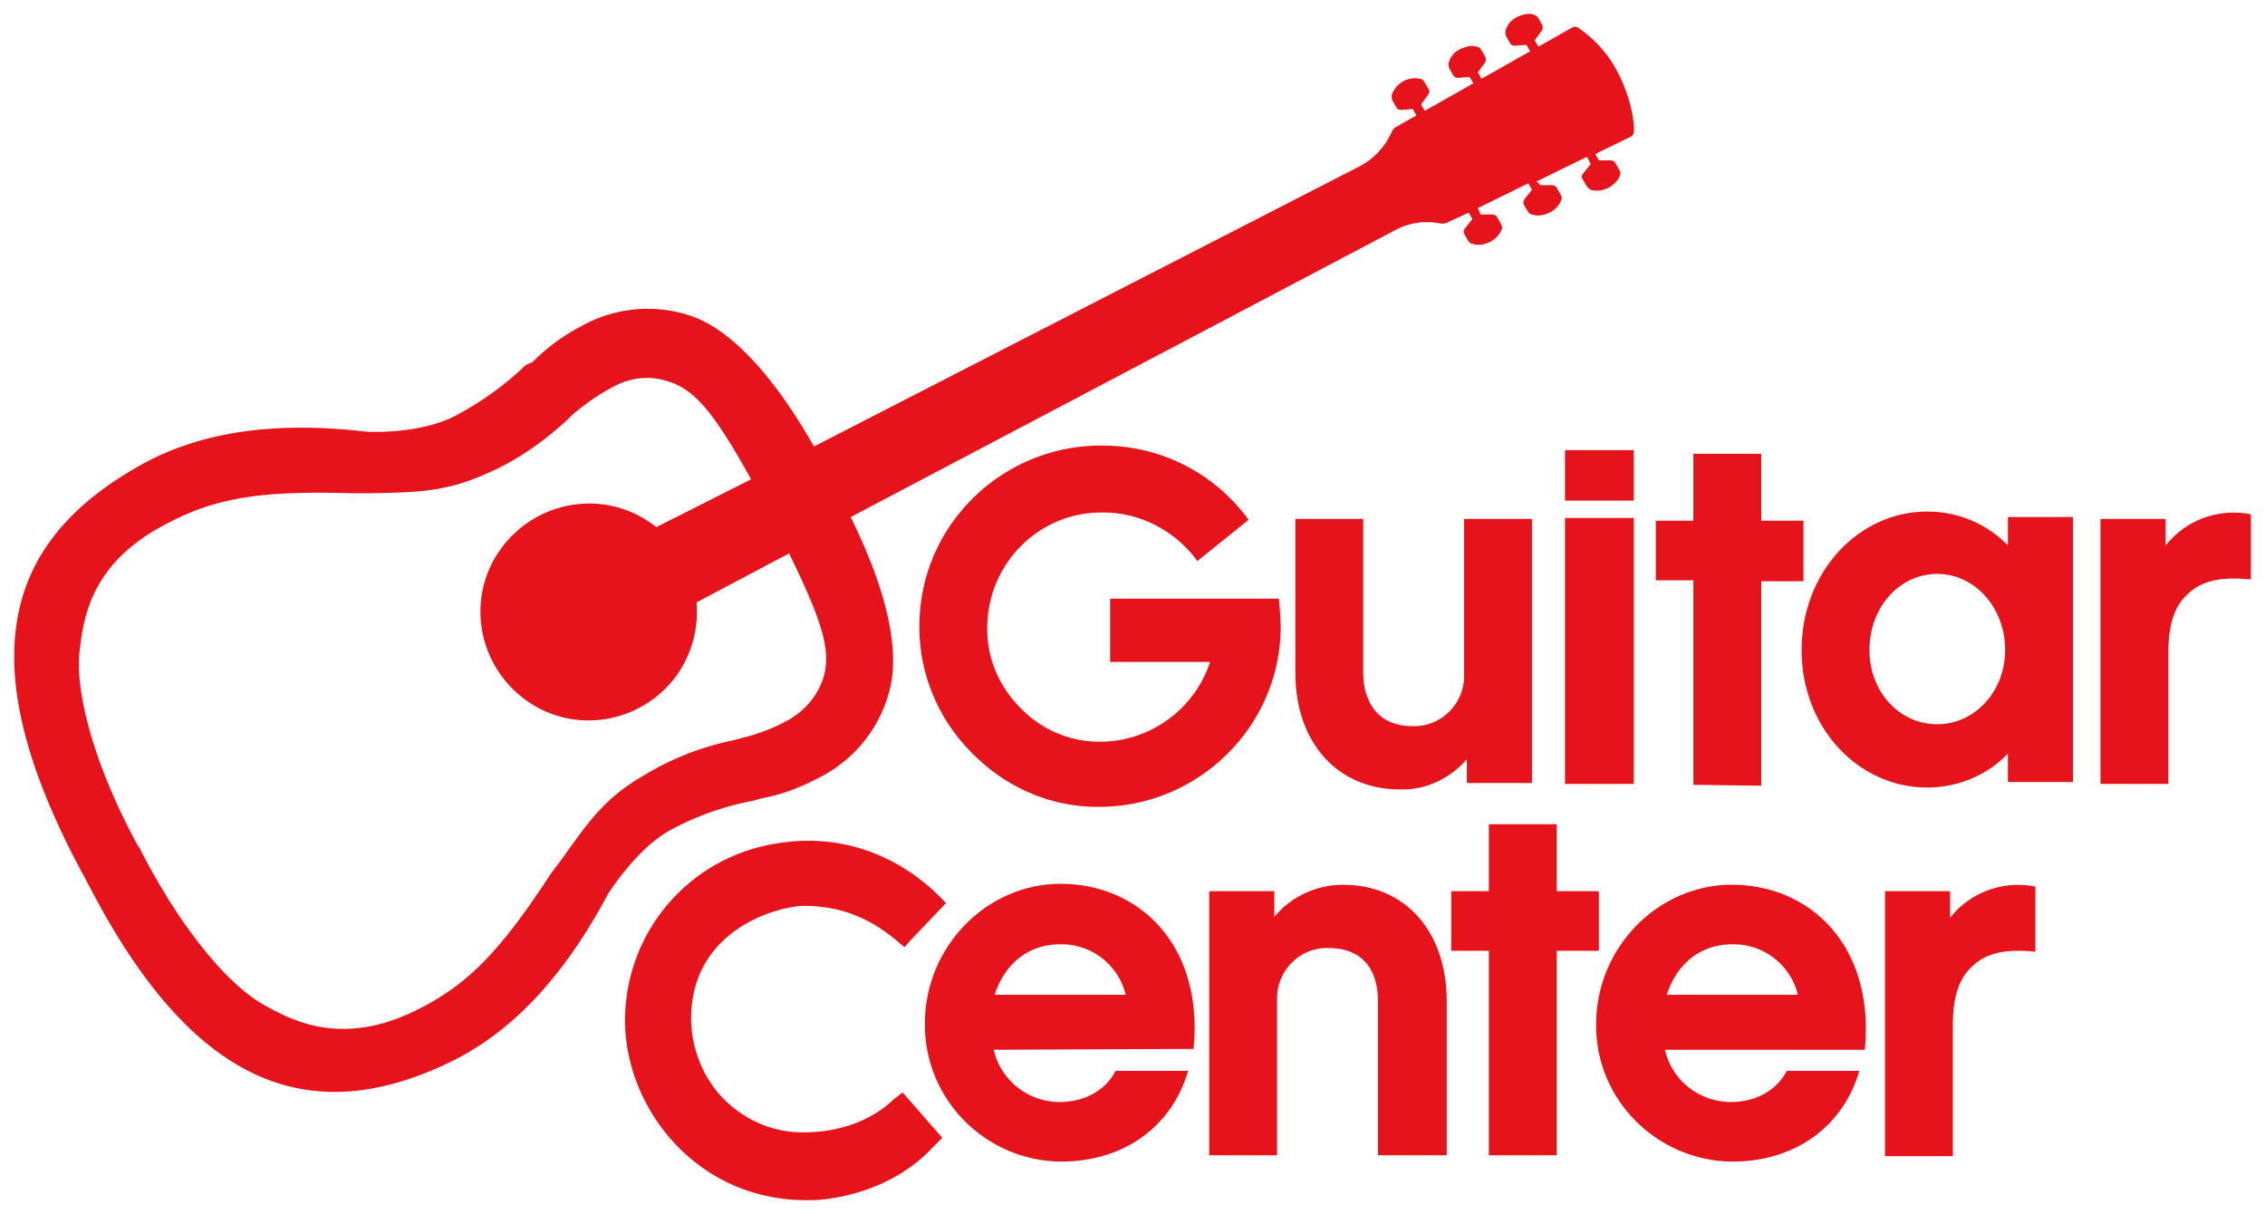

FOR IMMEDIATE RELEASE

**GUITAR CENTER, INC. REPORTS STRONG HOLIDAY AND PROGRESS TOWARDS**

**REJUVENATION STRATEGY**

**Westlake Village, CA** (January 22, 2025) **— Guitar Center, Inc.** (the “Company”) today announced preliminary sales results for the November and December holiday season and progress towards strategic initiatives.

“We couldn’t be more pleased with our results during the holiday season, with a strong 6.6% sales growth at our Guitar Center business. We’ve been gaining momentum all year, with each quarter better than the last, culminating with our strongest holiday in years,” said Gabe Dalporto, Chief Executive Officer, who joined the company at the end of October 2023. “This performance was the result of the strategy we put in place to reinvigorate our brand by focusing on the serious musician.”

Dalporto added the new Guitar Center strategy, which is focused around winning the serious musician, has four main pillars:

* Transform the assortment by expanding highly desirable premium gear as well as rapidly growing traffic-driving used and vintage product.
* Unleash the stores, creating a Disneyland-like experiential environment along with foundational elements like better organization and cleanliness.
* Invest in the sales team, building product knowledge and improving customer service skills.
* Overtaking digital, being everywhere customers are, and providing a seamless interface between web, mobile and stores.

“While we have a lot of work to do, our customers are seeing the transformation happen in real-time, they’re talking about it, they’re experiencing it, and ultimately they are preferring it,” Dalporto continued. “The amount of time customers spend in store is up over 20% in the fourth quarter. They’re playing more. They’re loving the access to new and premium products. And we’re just getting started.”

The first product category transformation that was completed was electric and acoustic guitars. Growth in that category meaningly outperformed other categories that had not yet received the assortment refresh. Next up, the company is actively working on re-assorting keyboards, DJ, accessories, and other categories.

On the experiential side, the company is rolling out innovative interactive displays like a series of massive experiential guitar pedal boards and making it easier to access and play the industry’s best premium instruments and gear. These efforts contributed to the 20% lift in customer time-in-store during Q4.

Additionally, aligned to the second and third pillars, consumers surveyed ranked the company much higher in terms of friendliness, availability and knowledge compared to the prior year.

Finally, the company has implemented an entirely new CRM system and established a phone-based concierge sales team located in Kansas City in order to establish long-term relationships with serious musicians.

“Taken together, these initiatives had a major impact on our peak holiday season, and we expect even more significant customer centric improvements heading into 2025,” remarked Dalporto. “I grew up spending hours in Guitar Center stores in complete awe of the gear and the throngs of serious musicians there. My greatest mission is to deliver an environment that musicians are proud of, and we’re well on our way to recapturing that magic.”

###

**About Guitar Center:**

Guitar Center is the leading retailer of musical instruments, lessons, repairs, and rentals in the U.S. With more than 300 stores across the U.S. and one of the top direct sales websites in the industry, Guitar Center has helped people make music for more than 50 years. Guitar Center also provides customers with various musician-based services, including Guitar Center Lessons, where musicians of all ages and skill levels can learn to play a variety of instruments in many music genres, GC Repairs, an on-site maintenance and repairs service, and GC Rentals, a program offering easy rentals of instruments and other sound reinforcement gear. Additionally, Guitar Center’s sister brands include Music & Arts, which operates more than 250 stores specializing in band & orchestral instruments for sale and rental, serving teachers, band directors, college professors, parents and students, and Musician’s Friend, a leading direct marketer of musical instruments in the United States. For more information about Guitar Center, please visit [guitarcenter.com](http://www.guitarcenter.com/).

**Forward-Looking Statements:**

This press release contains certain “forward-looking statements,” including, without limitation, statements regarding our preliminary estimates and results and the effects and implementation of our strategic plan. Forward-looking statements can generally be identified by the use of words such as “anticipate,” “believe,” “continue,” “could,” “estimate,” “expect,” “forecast,” “intend,” “may,” “plan,” “project,” “potential,” “seek,” “should,” “think,” “will,” “would” and similar expressions, or they may use future dates. All of the forward-looking statements contained in this press release are subject to assumptions, risks and uncertainties that may change at any time, including, without limitation, general market and economic conditions and impact of any new tariffs on goods that we import, and readers are therefore cautioned that actual results could differ materially from those expressed in any forward-looking statements. We base these forward-looking statements or estimates on our current expectations, plans and assumptions that we have made in light of our experience in the industry, as well as our perceptions of historical trends, current conditions, expected future developments and other factors we believe are appropriate under the circumstances. In addition, the preliminary estimates included in this press release are not a comprehensive statement of our financial results as of the period indicated and additional adjustments may be identified as part of our quarterly closing and review process, which adjustments could be material, and certain other factors, including market conditions and other events outside of our control, may have an impact on our actual results. For these or other reasons, actual results for this period may differ from these preliminary estimates. We undertake no obligation to update any forward-looking statements and preliminary estimates as a result of new information, future developments or otherwise, except as expressly required by law. All forward-looking statements and preliminary estimates included in this press release are qualified in their entirety by this cautionary statement.

**FOR MORE INFORMATION PLEASE CONTACT:**

Clyne Media | [pr@clynemedia.com](mailto:pr@clynemedia.com)

Guitar Center | [media@guitarcenter.com](mailto:media@guitarcenter.com)   
Addo | [guitarcenter@addo.com](mailto:guitarcenter@addo.com)