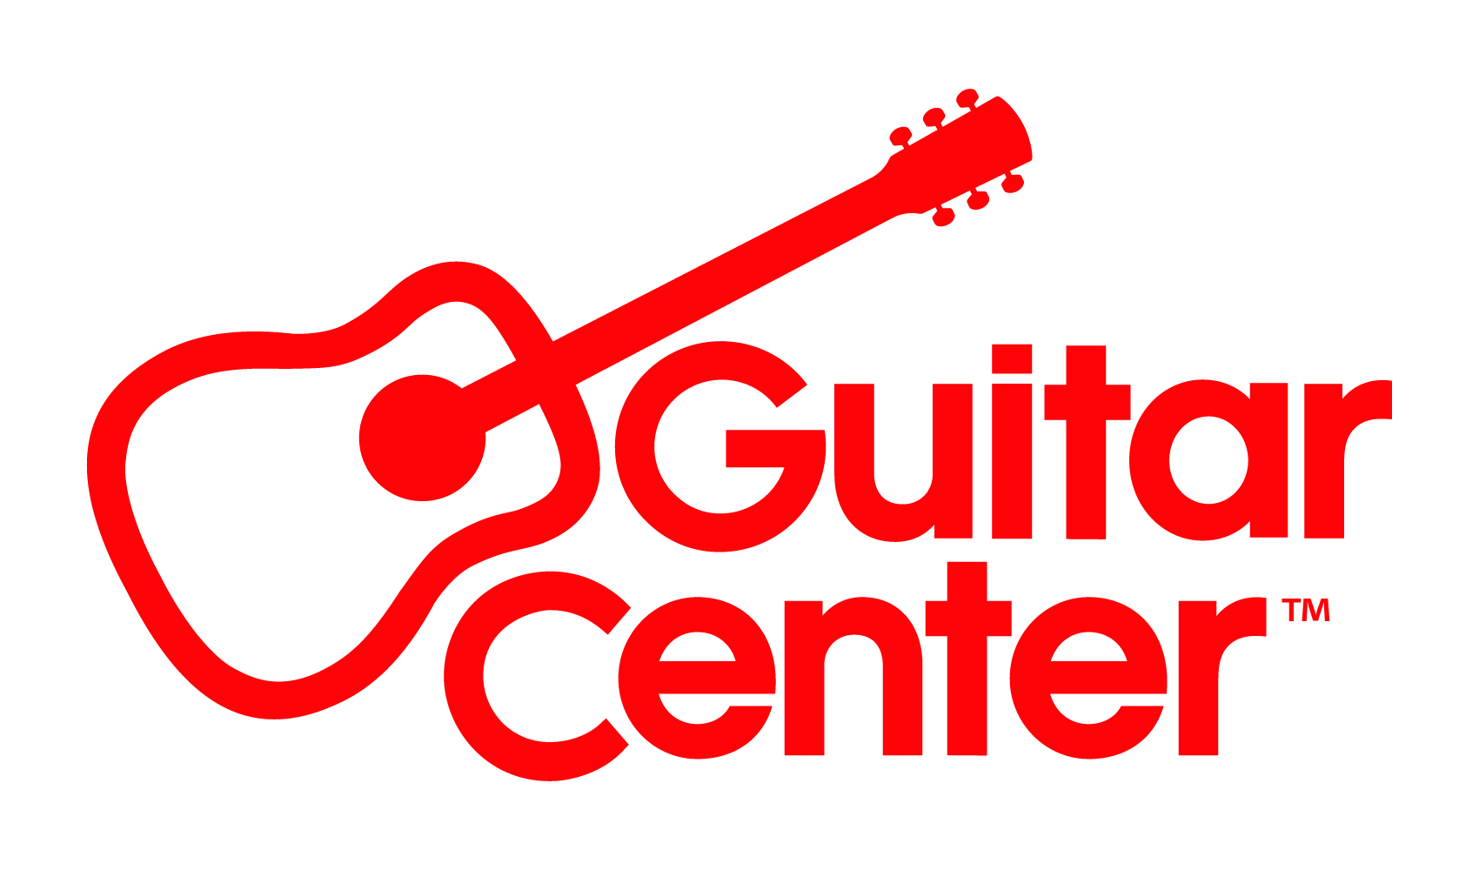
Andrew Watt Partners with Guitar Center to Celebrate Guitar-A-Thon 2022

Guitar Center kicks off twice-yearly guitar sales event, featuring exclusive deals for musicians of all ages and skill levels, by spotlighting guitarist, songwriter and producer Andrew Watt.

Westlake Village, CA (October 6, 2022) – Guitar Center announces Fall Guitar-A-Thon 2022, the iconic guitar event from world’s largest musical instrument retailer, with exclusive deals on guitars, amps, accessories and more. Artists and musicians, from beginner to professional, can find the best deals online and in Guitar Center stores nationwide from now until October 26.

Partnering with Guitar Center this Fall for the “Greatest Guitar Sale on Earth” is multi-platinum selling, GRAMMY®-Award winning music producer and guitarist Andrew Watt, who gives fans a look inside his workflow and what inspires him. In an exclusive conversation for Guitar-A-Thon, he reflects on how his guitar playing informs his production work, the importance of collaboration when making music, and his experiences working with the biggest names in the music industry.

Watt’s diverse array of credits includes work with Justin Bieber, Post Malone, Elton John, Ed Sheeran, Miley Cyrus, Dua Lipa, Ozzy Osbourne and more. In 2021 he was honored with the GRAMMY Award for Producer of the Year, Non-Classical, and recently produced Ozzy Osbourne’s #1 Billboard Chart-topping album Patient Number 9, as well as the single “Hold Me Closer,” the highly anticipated hit collaboration by Britney Spears and Elton John. At the top of 2022, Watt produced the entirety of Eddie Vedder’s critically acclaimed solo release Earthling, and in February, he landed two genre-bending hits on the Hot 100 in The Kid LAROI’s “Thousand Miles” and Ed Sheeran and Lil Baby’s “2step.” Beyond his producing and songwriting, Watt had the honor of joining Eddie Vedder on tour as part of his all-star side project, The Earthlings.

Guitar is fundamental to Watt’s creative process and workflow. “Starting from day one, [the] guitar is how I wrote songs. I write a riff, write a chord progression, and the song grows out of that. Melody comes. Melody sounds like words. The words start coming,” said Watt. “If I’m in a session where I’m writing a song, there’s a guitar in my hands.”

Watt reflects on how lucky he has been to work with artists across eras and genres: “What’s so amazing about getting to be a producer is that I get to work on so many different types of music with so many different types of artists and ages of artists. I’ve worked with 17-year-olds, and I’ve worked with 75-year-olds. It’s different every single way, and it keeps it very inspiring,” said Watt.

As the face of this year’s Guitar-A-Thon, Watt will be featured in the retailer’s television spots and video interviews. Watch Andrew Watt and Guitar Center’s new Guitar-A-Thon longform video here.

During the retailer’s Fall Guitar-A-Thon, musicians will find special offerings from top manufacturers such as Bose, Breedlove, D’Addario, Electro-Voice, Fender, Gibson, Martin, PRS, Taylor, Washburn and more. These instruments sit alongside great deals on vintage and used gear and the full power of Guitar Center’s multi-channel “endless aisle,” which gives customers the ability to combine in-store, online and phone options to purchase music equipment from anywhere at any time. Additionally, during the sale from October 6 – October 26, new customers who sign up for Guitar Center’s Lessons program will receive 25% off their first month of lessons. With 1-on-1 instruction available both in-store and online, from guitar (electric and acoustic) to drums to DJ’ing, Guitar Center Lessons are available for everyone, no matter the age or skill level.

“Artists like Andrew Watt continue to redefine the music industry,” says Rich Hoalst, Executive Vice President & Chief Customer Officer at Guitar Center. “From his recognition and skills as a producer and songwriter, to his love for playing and collecting guitars, Andrew proves that creating music is so much more than just playing an instrument. Artists and musicians inspired by him can find a variety of gear and products to produce new music at Guitar Center with variety of price points and features, allowing them to get hands-on the materials and tools they need to springboard to their creativity.”

For more information, visit GuitarCenter.com or Guitar Center on Facebook, Twitter, Instagram and YouTube.

###

Photo file: GC_GAT2022_AndrewWatt.jpg
Photo caption: Guitar Center has kicked off its twice-yearly guitar sales event Guitar-A-Thon by spotlighting guitarist, songwriter and producer Andrew Watt

About Guitar Center:
Guitar Center is a leading retailer of musical instruments, lessons, repairs and rentals in the U.S. With nearly 300 stores across the U.S. and one of the top direct sales websites in the industry, Guitar Center has helped people make music for more than 50 years. Guitar Center also provides customers with various musician-based services, including Guitar Center Lessons, where musicians of all ages and skill levels can learn to play a variety of instruments in many music genres; GC Repairs, an on-site maintenance and repairs service; and GC Rentals, a program offering easy rentals of instruments and other sound reinforcement gear. Additionally, Guitar Center’s sister brands include Music & Arts, which operates more than 200 stores specializing in band & orchestral instruments for sale and rental, serving teachers, band directors, college professors and students, and Musician’s Friend, a leading direct marketer of musical instruments in the United States. For more information about Guitar Center, please visit www.guitarcenter.com.

FOR MORE INFORMATION PLEASE CONTACT:
Clyne Media | 615.662.1616 | pr@clynemedia.com
Guitar Center | 818.735.8800 | media@guitarcenter.com
Edelman | GuitarCenter@edelman.com

