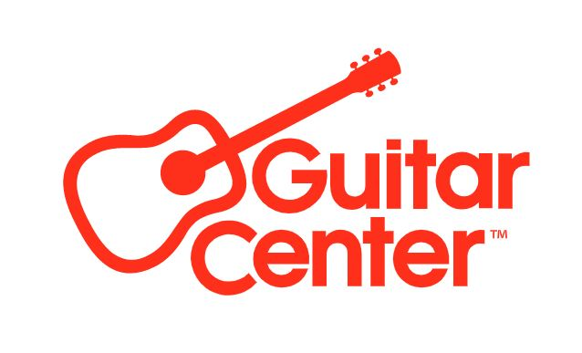
*** MEDIA ALERT ***

Guitar Center to open new retail store in Brooklyn, NY, on Thursday, January 30

The world’s largest musical instrument retailer to host grand opening celebration of its first store opening in 2025 on Thursday, January 30, 2025, with a live set from hip-hop icon DJ Funkmaster Flex

Guitar Center, the world’s largest musical instrument retailer, will celebrate the opening of a new store in Brooklyn, New York, on Thursday, January 30, 2025. The celebration will include a ribbon-cutting ceremony, complimentary t-shirts for the first 500 customers, raffle giveaways and more.

Guitar Center Brooklyn will be a destination music store featuring more than 19,000 square feet of guitars, drums, keyboards, live sound, DJ equipment and recording gear. The new store hosts 75 linear feet of guitar wall, a dedicated acoustic room, drum area with cymbal room, and interactive DJ displays. The store’s wide array of gear will help any musician find their sound – whatever their skill level or preferred price point, and wherever they are on their musical journey. In addition to carrying the latest products, the new store will also feature a hands-on electronic music experience, rentals, repairs and a contemporary lessons academy that’s well-suited for today’s musician.

The Brooklyn store is Guitar Center’s 13th location in New York and marks the company’s first store opening in 2025.

WHAT: The Guitar Center Brooklyn store opening celebration will begin at 10:00 am.

WHO: The new store’s general manager, Nick Chalas, will be available for interviews to discuss the grand opening event and what musicians can expect from the new store.

To celebrate, Guitar Center will host a weekend of festivities and specials, including special offers on lessons and gear, and a special live set by legendary DJ, radio personality and hip-hop icon Funkmaster Flex on January 30. Widely recognized as one of the pioneers of modern DJing and a key figure in the development of hip-hop culture, Funkmaster Flex is known for his innovative techniques, dedication to breaking new talent, and unwavering love for the art form, making him a true pioneer in the DJ world.

View Funkmaster Flex’s event preview on Instagram here.

WHERE: Guitar Center Brooklyn
536 Fulton Street
Brooklyn, NY 11201 (The Paxton)
(718) 230-5025

Store Hours: Mon. – Fri.: 11am – 9pm | Sat.: 10am – 9pm | Sun.: 11am – 7pm
Website: www.GuitarCenter.com

WHEN: Thursday, January 30, starting at 10:00 am.

Offer Highlights include:
  - REPAIRS: Free Signature Setup with a guitar purchase of $999 or more. (valid dates: 01/30/25 - 02/2/25)
  - FINANCING: Gear Card holders get 10% off their first purchase!
  - LESSONS: 25% off your first lesson + Free registration and get a free Epiphone electric guitar pack for the first 50 people who sign up in-store for their first month of lessons. (valid dates: 01/30/25 - 02/2/25)
- Special events and offers: Don't miss out on exclusive events and promotions:
  - Big savings on Grand Opening Doorbuster Deals!
Grand Opening Events (01/30/25 only):
- Pioneer Funkmaster Flex DJ Set
- BRIC Media & Arts Station
- Guitar Center Music Foundation Station

Media attendance welcome. Please RSVP here: Media@guitarcenter.com

###

