FOR IMMEDIATE RELEASE
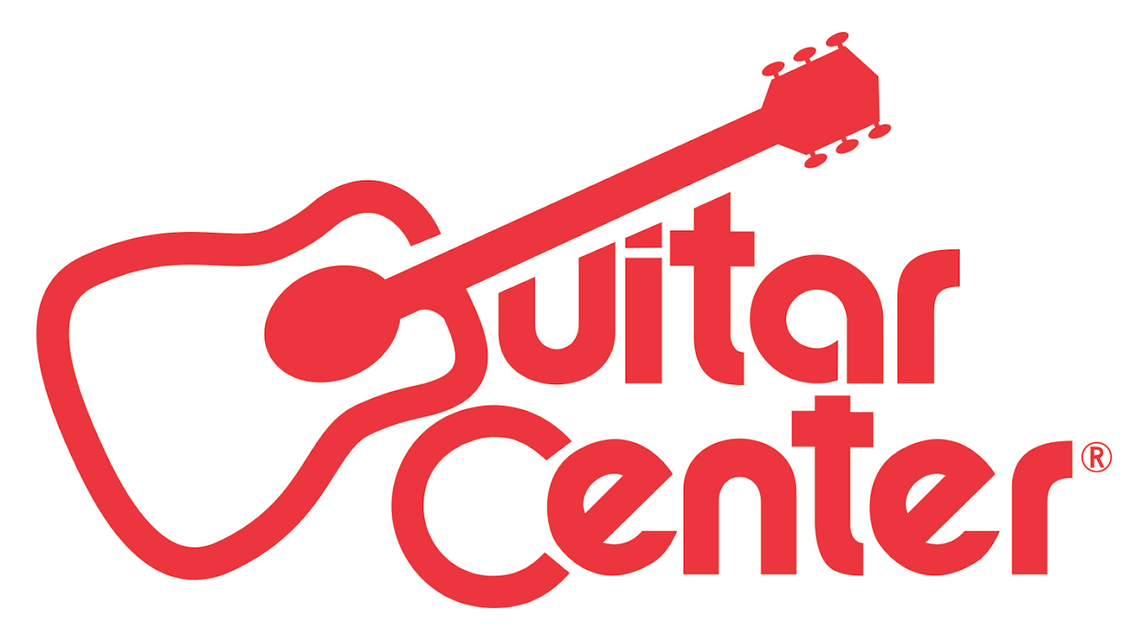

Guitar Center Expands National Presence with New Store Grand Openings

The new locations in Alexandria, VA, and Goodlettsville, TN, give area residents one-stop shops for all of their music needs, from instruments and on-site lessons to guitar repairs and rental services

Los Angeles, CA (January 21, 2017) – Guitar Center, the world’s largest instrument retailer, has been expanding its presence nationwide with recent store grand openings in Alexandria, VA (January 12), and Goodlettsville, TN (January 19). These grand openings further underscore Guitar Center’s ongoing expansion and its commitment to serving growing music communities across the country.

The Alexandria store, covering 15,425 square feet, is located at 3155 Duke St. Alexandria, VA 22314 in the Alexandria Commons Shopping Center. The Goodlettsville location, an 11,000-square-foot facility, will further serve the wider Nashville community and can be found at 1000 Rivergate Pkwy Goodlettsville, TN 37072 in the RiverGate Mall.

Both stores feature modern showrooms equipped with the latest products for musicians — from guitars, amplifiers, percussion instruments and keyboards to live sound, DJ, lighting and recording equipment. Customer services include Guitar Center Lessons, an in-house, state-of-the-art music academy for players of all ages and skill levels, GC Repairs, an on-site maintenance and repairs service, GC Rentals, easy rentals of instruments and other gear, and Guitar Center Workshops, offering free introductory classes and instruction on guitar, ukulele, and recording.

Shoppers at these locations are also able to enjoy Guitar Center’s multi-channel “endless aisle,” which gives customers the ability to combine in-store, online and phone options to purchase music equipment from anywhere.

Guitar Center Alexandria Store and Lessons Hours:
Monday – Friday 10:00 a.m. – 9:00 p.m.
Saturday 10:00 a.m. – 8:00 p.m.
Sunday 11:00 a.m. – 7:00 p.m.

Guitar Center Goodlettsville Store and Studio Hours
Monday – Friday 10:00 a.m. – 9:00 p.m.
Saturday 10:00 a.m. – 8:00 p.m.
Sunday 11:00 a.m. – 7:00 p.m.

Photo file 1: GC_Alexandria_Storefront.JPG
Photo caption 1: The storefront of Guitar Center’s new retail location in Alexandria, VA.

Photo file 2: GC_Alexandria_Employees.JPG
Photo caption 2: The employee team at Guitar Center’s new retail location in Alexandria, VA.

Photo file 3: GC_Alexandria_Showroom.JPG
Photo caption 3: The showroom of Guitar Center’s new retail location in Alexandria, VA.

Photo file 4: GC_Goodlettsville_Storefront.JPG
Photo caption 4: The storefront of Guitar Center’s new retail location in Goodlettsville, TN.

Photo file 5: GC_Goodlettsville_Employees.JPG
Photo caption 5: The employee team at Guitar Center’s new retail location in Goodlettsville, TN.

Photo file 6: GC_Goodlettsville_Showroom.JPG
Photo caption 6: The showroom of Guitar Center’s new retail location in Goodlettsville, TN.

About Guitar Center:
Guitar Center is the world’s largest retailer of guitars, amplifiers, drums, keyboards, recording, live sound, DJ, and lighting equipment. With more than 270 stores across the U.S. and one of the top direct sales websites in the industry, Guitar Center has helped people make music for more than 50 years. In addition, Guitar Center’s sister brands include Music & Arts, which operates more than 140 stores specializing in band & orchestral instruments for sale and rental, serving teachers, band directors, college professors and students, and Musician’s Friend, a leading direct marketer of musical instruments in the United States. With an unrivalled in-store experience, an industry-leading online presence and passionate commitment to making gear easy-to-buy, Guitar Center is all about enabling musicians and non-musicians alike to experience the almost indescribable joy that comes from playing an instrument. For more information about Guitar Center, please visit www.guitarcenter.com.

You can visit our press room at http://www.guitarcenter.com/pages/press-room, and send media inquiries to media@guitarcenter.com.

FOR MORE INFORMATION PLEASE CONTACT:
Sarah Chavey | Praytell Agency | 313.407.7571 | GCPR@praytellagency.com
Robert Clyne | Clyne Media | 615.662.1616 | pr@clynemedia.com
Syvetril Perryman | Guitar Center | 818.735.8800 x 2979 | media@guitarcenter.com

