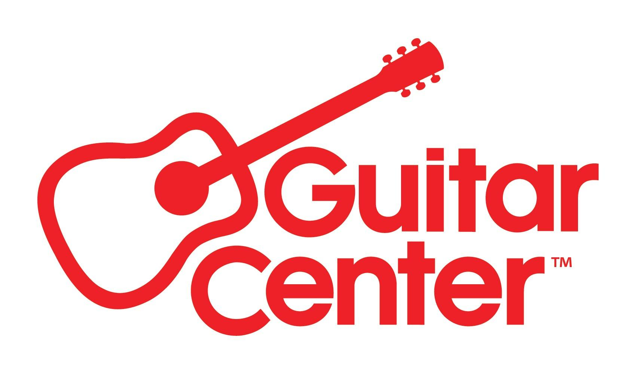

Guitar Center Business Solutions Continues to Expand with the Acquisition of Cutting Edge Systems

— Cutting Edge Systems, a leading New England technology integrator, is the latest addition to Audio Visual Design Group (AVDG), an arm of Guitar Center Business Solutions, as part of its long-term strategic business plan —

Westlake Village, CA (August 1, 2022) – Guitar Center, Inc., is pleased to announce that its Business Solutions division has acquired Cutting Edge Systems Corporation, a premier technology installation firm in New England as a part of its aggressive growth strategy for the company’s Business Solution Group. The acquisition brings Cutting Edge’s comprehensive integration services under the umbrella of the Audio Visual Design Group (AVDG), a leading commercial and residential audiovisual system integrator that has operated as an arm of Guitar Center Business Solutions since 2017, further extending its reach throughout the Northeast United States.

Founded in 1992, Cutting Edge Systems is an established regional leader in audio-visual and automation solutions, serving commercial and residential clients throughout New England. Headquartered in Westford, MA, Cutting Edge has built a reputation for excellence over three decades, mastering all spheres of technology installation, including audio, video, lighting control, motorized shading, climate control, video conferencing and IT networking. The company’s projects have been featured in numerous industry publications, including Electronic House, New England Home, Boston Design Guide, CE Pro, Builder/Architect and Architectural Digest.

“We are excited to welcome Cutting Edge Systems and its talented teams to the Guitar Center family,” said Mohit Parasher, President of Guitar Center’s Business Solutions. “Cutting Edge is well known for its audio-visual expertise throughout New England and Greater Boston. Their experience, skillsets and values are a perfect match for AVDG as we continue to expand in the Northeast and build upon the award-winning technology integration services that AVDG is known for nationally.”

Cutting Edge Systems is an HTA-Certified installer whose factory-trained technicians hold certifications with numerous technology brands, including Crestron, Lutron, Control4, Digital Projection, Sony, Marantz, Pakedge, Harman Luxury Audio and others. The company has been recognized nationally for its system designs and installations in commercial and residential environments.

Additionally, the acquisition of Cutting Edge Systems represents the second major expansion in the Northeast for AVDG, which acquired New England-based Maverick Integration Corp. in 2020 and currently has offices in Waltham, MA, and Nashua, NH.

“Customers of Cutting Edge Systems can expect the same great service and expertise that they’ve always received, backed by the industry-leading innovation and streamlined processes that AVDG has been perfecting for more than two decades,” said Parasher. “As we bring these two leaders together as one unified company, we continue to improve upon the technology services, exceptionalism, and proficiency that have made AVDG a trusted AV partner and an industry authority.”

Earlier this year, AVDG was also ranked #7 out of 100 in the annual list of the top technology integrators in North America, compiled by CE Pro magazine. The CE Pro 100 is one of the industry’s most acclaimed rankings of the top-performing custom electronics integrators in North America. AVDG moved up two spots from its ranking in 2021.

For more information about AVDG, visit https://avdg.com.

###

About Guitar Center:
Guitar Center is a leading retailer of musical instruments, lessons, repairs and rentals in the U.S. With nearly 300 stores across the U.S. and one of the top direct sales websites in the industry, Guitar Center has helped people make music for more than 50 years. Guitar Center also provides customers with various musician-based services, including Guitar Center Lessons, where musicians of all ages and skill levels can learn to play a variety of instruments in many music genres; GC Repairs, an on-site maintenance and repairs service; and GC Rentals, a program offering easy rentals of instruments and other sound reinforcement gear. Additionally, Guitar Center’s sister brands include Music & Arts, which operates more than 200 stores specializing in band & orchestral instruments for sale and rental, serving teachers, band directors, college professors and students, and Musician’s Friend, a leading direct marketer of musical instruments in the United States. For more information about Guitar Center, please visit www.guitarcenter.com.

About Audio Visual Design Group (AVDG)
Now part of the Guitar Center Business Solutions group, Audio Visual Design Group (AVDG), celebrating its 25th anniversary, was originally founded in 1996 and is an established leader in the design and installation of audiovisual systems. AVDG is a premier commercial and residential audiovisual system integrator. AVDG is able to meticulously design and engineer systems, provide expert technology design services, professional installation, and world-class service across the U.S. AVDG empowers end users to operate systems effortlessly, improve connectivity, and position their investment for maximum, long-term success. AVDG maintains and secures the success of their technologies through their extensive Simplicity service programs.

FOR MORE INFORMATION PLEASE CONTACT:
Guitar Center | media@guitarcenter.com
Clyne Media | pr@clynemedia.com
AVDG | Genesis Alegria | genesis.alegria@avdg.com

