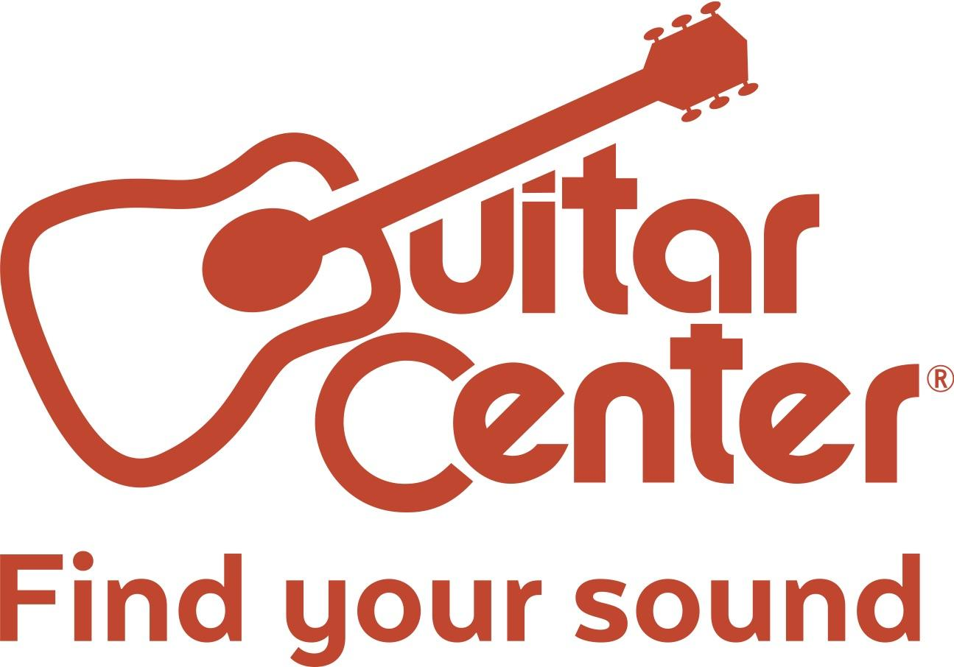

Mark Pacpaco Crowned Guitar Center's 28th Annual Drum-Off Champion

Legendary musicians, world renowned drummers and more helped celebrate the nation’s top undiscovered drummers at the most anticipated event in the drum community

Westlake Village, CA (January 19, 2017) – Guitar Center, the world’s largest instrument retailer, announced Mark Pacpaco from West Covina, CA, as the winner of Guitar Center's 28th Annual Drum-Off on Saturday, January 14, 2017, at the Novo in Downtown Los Angeles. As the retailer’s longest running artist discovery program, Guitar Center’s Drum-Off has unearthed some of today’s top emerging drum talent and has become one of the most highly anticipated events in the drum community.

Since the launch of the competition back in August 2016, thousands of undiscovered drummers from across the country signed up to compete at more than 200 regional Guitar Center stores nationwide. From a pool of over 5,000 participants, five talented drummers were chosen to move on to Guitar Center’s Drum-Off Finals at The Novo in Los Angeles for a chance to win the coveted grand title. Ultimately, Mark Pacpaco was chosen as the winner of a prize package including endorsement deals, gear and cash valued at nearly $50,000.

West Covina native, Mark Pacpaco was drawn to the drums at the early age of 7. His passion for drumming developed at his local church. He recalls sitting in awe at the drum set at his church even before he could touch the pedal. Recently, Mark turned to YouTube to showcase his talent to the world, and now, he’ll use this opportunity as a platform to launch his career in music and reach a larger audience. As the winner, Mark will join an esteemed group of talented drummers who have gone on to play for the likes of Prince, Beyoncé, Jay-Z and more.

“Drum-Off is a great competition. I learned so much from my loss last year in the quarter-finals. I saw it as a way to get stronger. Now that I’ve won, everything has changed. Guitar Center paved the way for me and I don't think I can stop at this point. I hope that my journey continues.” - Mark Pacpaco, winner of Guitar Center’s 28th Annual Drum-Off

Watch Mark Pacpaco’s Winning Performance Here: https://youtu.be/wAhEMZsepxY

As the winner of Guitar Center’s 28th Annual Drum-Off, Pacpaco will receive:
- $25,000
- High-end drum kit by DW, Tama, Pearl, Gretsch or Yamaha
- Complete set of Sabian, Meinl or Zildjian cymbals
- Drum, stick, cymbal and drumhead endorsement deals
- VIP Experience at the NAMM Show 2017
- Feature in Modern Drummer Magazine
- A Roland TD-50KV Electronic Drum Kit and the SPD-SX
- GoPro Music Bundle
- Performance on Drum Channel
- $500 Guitar Center Gift Card
- Clinic at Winner’s Local Guitar Center

This year’s program also included show-stopping performances by Sheila E. and Pete Escovedo, complete with a surprise jam with two unsuspecting audience members, collaborative performances by Larnell Lewis (of GRAMMY® Award-winning ensemble Snarky Puppy) and Rashid Williams (John Legend), and a special Rockwalk Induction honoring legendary James Brown drummers John “Jab’o” Starks and Clyde Stubblefield. Ultimately, the evening came to a thrilling peak as the five Drum-Off finalists battled it out on stage in front a live audience full of fans and a panel of celebrity judges including Venzella Joy (Beyoncé), Tony Royster Jr. (Charlie Puth, Jay-Z), Queen Cora Coleman (Dave Chappelle, Beyoncé, Prince) and many more.

The sponsors of Guitar Center’s 28th annual Drum-Off of are among the most respected brands in the music industry, including DW, Drum Channel, Evans, GoPro, Gretsch, LP, Meinl, Modern Drummer, Pearl, Pro-Mark, Remo, Roland, Sabian, Tama, Vic Firth, Yamaha and Zildjian.

For more information on the winner of Guitar Center’s 28th Annual Drum-Off, visit Drumoff.GuitarCenter.com.

Photo file 1: DrumOff2017_Photo1_Pacpaco.JPG
Photo caption 1: Guitar Center Drum-Off Winner Mark Pacpaco, at Guitar Center's 28th Annual Drum-Off Finals Event at The Novo by Microsoft on January 14, 2017 in Los Angeles, California. (Photo credit: Ryan Hunter, Guitar Center)

Photo file 2: DrumOff2017_Photo2_SheilaE_Pacpaco_Escovedo.JPG
Photo caption 2: Pictured L-R: Legendary drummer/percussionist Sheila E., Guitar Center Drum-Off Winner Mark Pacpaco, and legendary percussionist Pete Escovedo, at Guitar Center's 28th Annual Drum-Off Finals Event at The Novo by Microsoft on January 14, 2017 in Los Angeles, California. (Photo credit: Ryan Hunter, Guitar Center)

Photo file 3: DrumOff2017_Photo3_Stubblefield_Starks.JPG
Photo caption 3: Pictured L-R: legendary James Brown drummers Clyde Stubblefield and John “Jabo” Starks, being honored at a special Rockwalk Induction at Guitar Center’s 28th Annual Drum-Off. (Photo by Phillip Faraone/Getty Images for Guitar Center)

About Guitar Center:
Guitar Center is the world’s largest retailer of guitars, amplifiers, drums, keyboards, recording, live sound, DJ, and lighting equipment. With more than 270 stores across the U.S. and one of the top direct sales websites in the industry, Guitar Center has helped people make music for more than 50 years. In addition, Guitar Center’s sister brands include Music & Arts, which operates more than 140 stores specializing in band & orchestral instruments for sale and rental, serving teachers, band directors, college professors and students, and Musician’s Friend, a leading direct marketer of musical instruments in the United States. With an unrivalled in-store experience, an industry-leading online presence and passionate commitment to making gear easy-to-buy, Guitar Center is all about enabling musicians and non-musicians alike to experience the almost indescribable joy that comes from playing an instrument. For more information about Guitar Center, please visit www.guitarcenter.com.

You can visit our press room at http://www.guitarcenter.com/pages/press-room, and send media inquiries to media@guitarcenter.com.

FOR MORE INFORMATION PLEASE CONTACT:
Sarah Chavey | Praytell Agency | 313.407.7571 | GCPR@praytellagency.com
Robert Clyne | Clyne Media | 615.662.1616 | pr@clynemedia.com
Syvetril Perryman | Guitar Center | 818.735.8800 x 2979 | media@guitarcenter.com

###

