FOR IMMEDIATE RELEASE
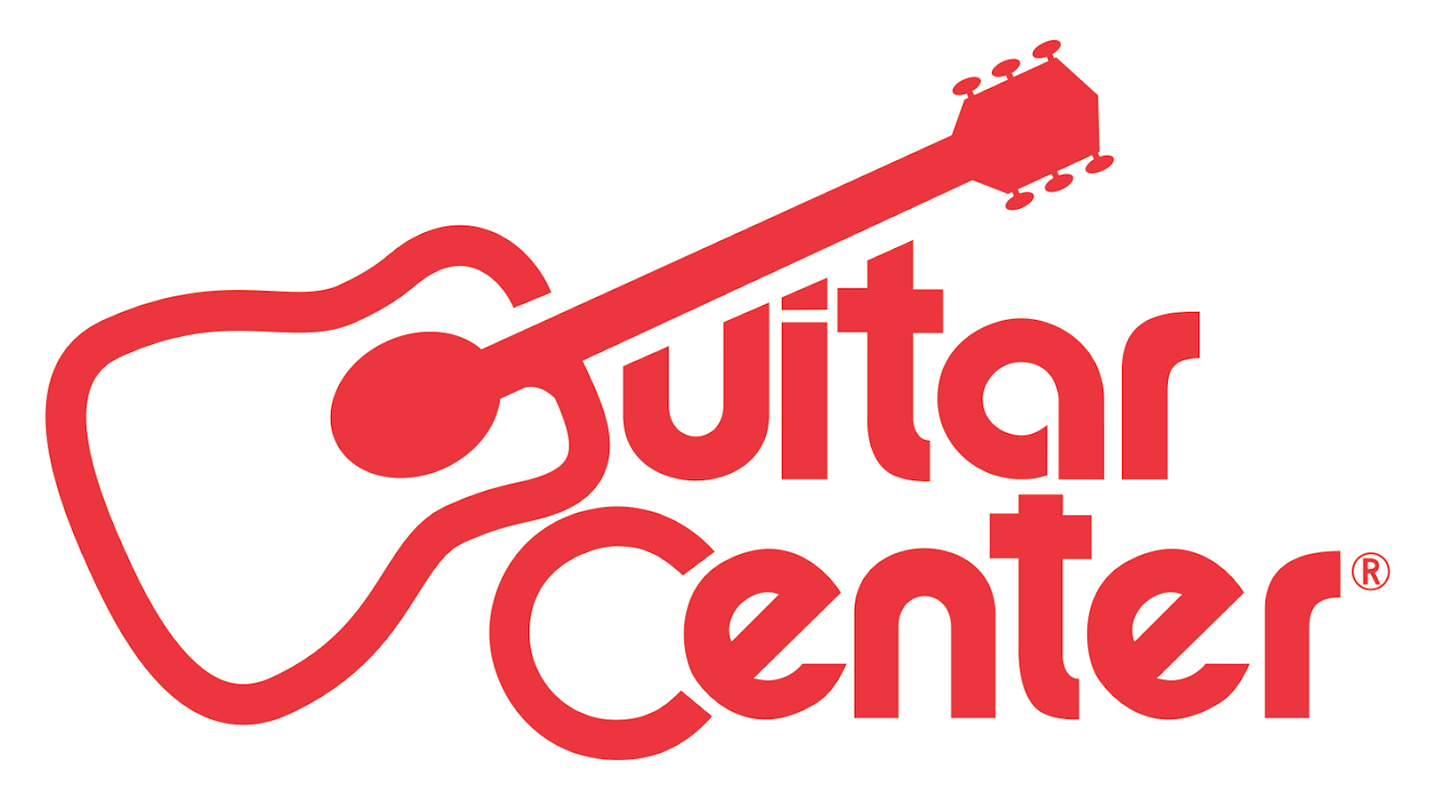

Guitar Center’s 28th Annual Drum-Off Continues to Build Momentum Toward the Grand Finals

ANNOUNCEMENT HIGHLIGHTS:

- Guitar Center’s annual celebration of drums, hailed as the world’s premier drum competition, prepares for Semifinals on Nov. 15, leading up to the Grand Finals on January 14, 2017, at The Novo in Los Angeles
- Tickets for the Grand Finals go on sale starting November 1
- Drum-Off continues to bring together thousands of up and coming drummers to showcase their talent, compete for incredible prizes, and the national recognition of being crowned Drum-Off Champion

Westlake Village, CA (November 2, 2016) – Excitement has been building around Guitar Center’s 28th Annual Drum-Off, the retailer’s annual search for the top undiscovered drummer. Drummers across the country began competing over three months ago at Guitar Center stores nationwide, among a pool of over 4,000 participants. Following several rounds of competition, the top 30 drummers (six at each location), in five select GC locations: Hollywood, Chicago (Arlington Heights), Houston, NYC Times Square and Memphis, will compete in the Semifinals on November 15, 2016, at 7 p.m. local time for a chance to move on to the national Grand Finals.

Additionally, the Semifinals will feature a special Roland percussion showcase and exclusive artist performances from Venzella Joy (Beyoncé) at the Hollywood store, ’03 Drum-Off champion Eric Moore (Suicidal Tendencies) at Chicago Arlington Heights, ’11 Drum-Off champion JP Bouvet at the Houston store, ’07 Drum-Off champion Donnie Marple (Lee Brice) in Memphis and last year’s Drum-Off champion Tony Taylor Jr. at Times Square.

“Winning Drum-Off has definitely been the launching pad for my career as a professional drummer. It’s connected me with a larger audience and also been an incentive to continue to work on my craft,” said 27th annual Drum-Off champion, Tony Taylor Jr. “I’m truly thankful to Guitar Center and everyone else involved with Drum-Off who believes in supporting drummers in pursuit of their musical aspirations.”

The Grand Finals will take place on January 14, 2017 (the Saturday before The NAMM Show), at The Novo in Los Angeles, featuring the five Semifinalists vying for a chance to be crowned Drum-Off Champion, together with icons and emerging drum talent across multiple genres of music. A special RockWalk induction honoring a legendary drummer will be announced in the coming weeks along with this year’s line-up. Tickets for the Grand Finals will be available at axs.com starting November 1, 2016.

“Drum-Off has become one of the most highly anticipated events in the drum community,” said Maria Brown, manager of music and entertainment marketing for Guitar Center, and who has been involved in Drum-Off for the past 11 years. “Each year Drum-Off gives emerging artists the platform and encouragement to grow as musicians while bringing the drum industry together to highlight the gear drummers need to take their skills to the next level.”

As Guitar Center’s longest running artist discovery program, Drum-Off continues to unearth some of today’s top emerging drum talent and provide an unrivaled platform for exposure. Past Drum-Off winners have gone on to play with Beyoncé and Prince (Cora Coleman-Dunham), The Mars Volta and Trash Talk (Thomas Pridgen), Jay-Z (Tony Royster Jr.) and many more.

For manufacturers and other program sponsors, Drum-Off is also a valuable resource for highlighting the gear drummers need to take their craft to the next level – a unique event bringing together multiple brands in the drum community with the goal of supporting and celebrating all drummers at various stages of their journey.

This year’s Drum-Off sponsors are among the most respected brands in the music industry, which include: DW, Drum Channel, Evans, GoPro, Gretsch, LP, Meinl, Modern Drummer, Pearl, Pro-Mark, Remo, Roland, Sabian, Tama, Vic Firth, Yamaha and Zildjian.

Guitar Center’s Drum-Off Grand Prize Winner Will Receive:

- $25,000 Cash
- Roland Electronic Drum Kit
- High-End Drum Kit by DW, Gretsch, Pearl, Tama, or Yamaha (Winner’s Choice)
- Full set up of drum sticks, cymbals, and drumheads (Winner’s Choice)
- Endorsement Deals from the top drum manufacturers (Winner’s Choice)
- VIP Experience at NAMM 2017
- Feature in a Guitar Center Buyer’s Guide

For more information on rules and regulations, please visit: http://guitarcenter.com/drumoff.

In years past, some of the world’s most renowned drummers have participated in and supported Guitar Center’s Drum-Off, including: Questlove, Terry Bozzio (Frank Zappa, Missing Persons), Aaron Spears (Usher, Lady Gaga), Chad Smith (Red Hot Chili Peppers), Steve Gadd (Steely Dan), Travis Barker (Blink-182), Tommy Lee (Motley Crüe), Taylor Hawkins (Foo Fighters), Steve Smith (Journey), Billy Cobham (Miles Davis), Stephen Perkins (Jane’s Addiction), Danny Carey (Tool), Brann Dailor (Mastodon), Steve Ferrone (Tom Petty & The Heartbreakers), and more .

Photo file 1: TonyTaylorJr_Photo1.JPG
Photo caption 1: Guitar Center’s 27th Annual Drum-Off champion Tony Taylor Jr.

Photo file 2: TonyTaylorJr_Photo2.JPG
Photo caption 2: Guitar Center’s 27th Annual Drum-Off champion Tony Taylor Jr.

Photo file 3: 28thDrumOff_Semifinals.JPG
Photo caption 3: Guitar Center’s 28th Annual Drum-Off semifinals graphic

About Guitar Center:
Guitar Center is the world’s largest retailer of guitars, amplifiers, drums, keyboards, recording, live sound, DJ, and lighting equipment. With more than 270 stores across the U.S. and one of the top direct sales websites in the industry, Guitar Center has helped people make music for more than 50 years. In addition, Guitar Center’s sister brands include Music & Arts, which operates more than 140 stores specializing in band & orchestral instruments for sale and rental, serving teachers, band directors, college professors and students, and Musician’s Friend, a leading direct marketer of musical instruments in the United States. With an unrivalled in-store experience, an industry-leading online presence and passionate commitment to making gear easy-to-buy, Guitar Center is all about enabling musicians and non-musicians alike to experience the almost indescribable joy that comes from playing an instrument. For more information about Guitar Center, please visit www.guitarcenter.com.

You can visit our press room at http://www.guitarcenter.com/pages/press-room, and send media inquiries to media@guitarcenter.com.

FOR MORE INFORMATION PLEASE CONTACT:
Robert Clyne | Clyne Media | 615.662.1616 | pr@clynemedia.com
Syvetril Perryman | Guitar Center | 818.735.8800 x 2979 | media@guitarcenter.com

